

ACCREDITATION
FOCUSED MIDTERM REPORT

GLENDALE COMMUNITY COLLEGE DISTRICT
1500 North Verdugo Road
Glendale, California 91208-2894

Submitted to the:

Accrediting Commission for Community and Junior Colleges
of the Western Association of Schools and Colleges

March 2007

TABLE OF CONTENTS

Cover Letter Page 3

Statement of Report Preparation Page 4

Recommendation Compliance Overview Page 8

Response to Team Recommendations - Areas of Special Emphasis

Recommendation 2 Page 10

Recommendation 5 Page 13

Recommendation 6 Page 15

Recommendation 7 Page 16

Other Recommendations

Recommendation 1 Page 17

Recommendation 3 Page 19

Recommendation 4 Page 21

Recommendation 8 Page 22

Recommendation 9 Page 23

Recommendation 10 Page 25

List of Attachments Page 26

Commission Action Letter Page 27

Response to Self-identified Issues Page 30

February 9, 2007

Dr. Barbara Beno, President
Accrediting Commission for Community
and Junior Colleges
10 Commercial Boulevard, Suite 204
Novato, CA 94949

Dear Dr. Beno:

It is a pleasure to submit to you Glendale Community College’s Focused Midterm Report.

As a little background, I came on board as the Superintendent/President in July 2006. I followed the tenure of Dr. John Davitt, who retired after having been in this leadership role for twenty-one years. Immediately following the 2004 Accreditation visit, the College organized a task force to develop a linkage plan for budget, planning and program review. In Spring 2005, in preparation for the Midterm report, the College planning team brought in Dr. Robert Gabriner to conduct a workshop on the old versus the new Accreditation standards. Work began on the Educational Master Plan in Fall 2005.

Since then, the Accreditation team has worked diligently to address the recommendations. Although not fully addressed, the College has made significant progress. We are committed to addressing the completion of the remaining recommendations before the conclusion of this academic year. I think that it is to this institution’s credit that various College committees are not just doing the task as a requirement, but instead they have taken on the charge with energy, passion and sincerity. I am confident that the tasks slated to be completed by 2007 will be addressed in stellar fashion.

The materials include all of the items requested and have gone through many layers of review. The participation on this task is outlined in the report; and you will note the widespread involvement and interest.

Glendale Community College is an institution that takes pride in its accomplishments. To that end, one of the things that we are the proudest of is our success with our financial aid program. Our default rate is only 5.6%.

As you read through this report, please feel free to contact me at 818-551-5105 should you have any questions.

Sincerely,

Dr. Audre Levy
Superintendent/President

AL:sh

STATEMENT OF REPORT PREPARATION

In January 2006, Steve White, Vice President of Instructional Services asked Peggy Renner, a faculty member and Jill Lewis, an instructional manager to co-chair the 2007 Focused Midterm Accreditation Report team. These three set up a core team to work on this task.. The team outlined tasks, identified key people, departments and committees to be involved, and set a timeline for required tasks to be completed.

Midterm Accreditation Team:
Co-chairs:
- Dr. Peggy Renner History Professor, current Planning Coordinator, past Academic
Senate President
- Jill Lewis Instructional Services Manager, 2004 Accreditation Co-chair,
Program Review Co-chair, Adjunct Instructor-Business Dept.

- Dr. Kathy Flynn ESL Division Chair, ESL Professor, 2004 Accreditation Co-chair
- Dr. Ed Karpp Director of Research and Planning
- Dr. Audre Levy Superintendent/President
- Dr. Dawn Lindsay Vice President, Instructional Services (new)
- Carol Paxton Math Professor, Program Review Coordinator
- Scot Spicer Associate Dean of Instructional Services, District Accreditation
Liaison, Adjunct Instructor-Social Science Dept.
- Steve White Vice-President, Instructional Services (retired): past Social Science
Division Chair, Economics Assist. Professor, Guild President

The following individuals and groups participated in the preparation of this report:

Recommendation 1
- Larry Serot Vice President, Administrative Services
- Steve White Vice President, Instructional Services
- Sharon Combs Vice President, College Services
- Ed Karpp Director of Research and Planning
- Peggy Renner Master Plan Coordinator
- Carol Paxton Program Review Coordinator
- Jill Lewis Instructional Services Manager
- Dave Roswell Interim Dean, Information Technology
- Lew Lewis Director of Facilities
- Dan Padilla Assistant Director of Facilities
- Bill Taylor Director of Business Services
Groups:
Campus Development Committee
Campus Computer Coordinating Committee
Information Technology Department
Strategic Master Plan Committee

Recommendation 2
- Ed Karpp Director of Research and Planning
- Sharon Combs Vice President, College Services
- Dave Roswell Interim Director, Information Technology
- Linda Winters Associate Dean, Library & Learning Resources
- Shereen Allison Associate Dean, Instructional Technology
Groups:
Campus Computer Coordinating Committee

Recommendation 3
- Steve White Vice President, Instructional Services
- Vicki Nicholson Associate Vice President of Human Resources
- Peggy Renner Master Plan Coordinator
- Lynn McMurray Staff Development Coordinator
- Valicia Dantzler Employee Services Manager
Groups:
Strategic Master Plan-Team A

Recommendation 4
- Audre Levy Superintendent/President
- Vicki Nicholson Associate Vice President of Human Resources
- Kathy Flynn past Accreditation and Planning Coordinator
- Valicia Dantzler Employee Services Manager
Groups:
CSEA (Classified School Employee Association)
Guild (faculty union)

Recommendation 5
- Vicki Nicholson Associate Vice President, Human Resources
- Kathy Flynn Past Accreditation and Planning Coordinator
Groups:
Academic Senate
Cultural Diversity Committee
Faculty Diversity Task Force
Office of Human Resources
Student Equity Committee
Faculty Internship Planning Committee

Recommendation 6
- Steve White Vice President, Instructional Services
- Sharon Combs Vice President, College Services
- Peggy Renner Master Plan Coordinator
- Kathy Flynn Past Accreditation and Planning Coordinator
Groups:
Academic Affairs Committee
Academic Senate
Administrative Affairs Committee
Budget Committee
Campus Computer Coordinating Committee
Deans and Associate Deans of College Services
Division Chairs
Strategic Master Plan Committee
Student Affairs Committee

Recommendation 7
- Larry Serot Vice President, Administrative Services
- Ron Nakasone Controller
Groups:
Employee Health & Welfare Committee (GCC)
Total Compensation Systems, Inc.

Recommendation 8
- Larry Serot Vice President, Administrative Services
- Jill Lewis Instructional Services Manager
Group: The Budget Committee

Recommendation 9
- Audre Levy Superintendent/President
- Jill Lewis Instructional Services Manager
Groups: The Board of Trustees

Recommendation 10
- Vicki Nicholson Associate Vice President, Human Resources
- Jill Lewis Instructional Services Manager
Groups:
Board of Trustees Community College Search Services
Board of Trustees Advisory Hiring Committee Cultural Diversity Committee
Campus Computer Coordinating Committee Office of Human Resources
College Services Deans and Associate Deans Student Equity Committee

Report Preparation Process
In March 2006, the two team co-chairs outlined the requirements for the focused midterm report with the Accrediting Commission for Community and Junior Colleges-WASC. An outline of the 2004 Evaluation Team recommendations was made and the status and key people responsible for progress in those areas were identified. The Vice President and co-chairs collaborated and the core team was formed and met through the next few months to discuss plans for the midterm report. In July 2006, the team presented an outline of progress to the new Superintendent/President, and the group agreed on the process, plans and direction of the effort. The team members divided up the preliminary tasks associated with gathering information and met several more times over the following months. The co-chairs produced a draft document and continued to work with various campus entities to provide current status on all recommendations and requirements of the report.
The co-chairs took over the task of revising the document and with the assistance of the core team as resources for information. Throughout this effort the co-chairs and the Superintendent/President worked with the ACCJC to clarify the requirements.

Campus Review of Document
The document has been made available to the campus electronically on the accreditation web page: http://www.glendale.edu/accreditation/index.htm and as a link in two of the bi-weekly newsletters sent by the President and also presented at a faculty meeting and as a study session at the Board of Trustees meeting in January 2007. The following campus groups also reviewed the document:

Academic Affairs
Academic Senate
Administrative Affairs
Board of Trustees
Budget Review Committee
Cabinet
Campus Computer Coordinating Committee
Classified School Employees Association
Executive Cabinet
Guild (faculty union)
Senior Staff
Student Affairs

The final version of the report was taken to the Board for approval on February 12, 2007.

__________________________
Dr. Audre Levy
Superintendent/President
RECOMMENDATION COMPLIANCE

Definition of Terms
Met | We have evidence that we have completed the recommendation.
Significant Progress | We have made major strides toward completion of the recommendation and have outlined the responsible party(s) and timeline for completion.
Ongoing | Ongoing continuous process

 | Met | Significant | Ongoing | Responsibility / Timeline
 |  | Progress
FOCUSED RECOMMENDATIONS:
Recommendation 2
Technology Plan |  | X |  | IT department to complete plan April 2007
Learning Resources |  | X |  | College Services to complete plan April 2007
Linkage of plans to budget |  | X |  | Implementation of pilot process May 2007
Recommendation 5
Staff Diversity Plan |  | X |  | HR to complete plan April 2007
Staff Diversity |  |  | X
Recommendation 6
EMP | X
Linkage to facilities | X
Linkage to budget | X |  |  | Implementation of pilot process May 2007
Recommendation 7
Actuarial Study | X |  |  | Budget Committee will address funding May 2007
REMAINING RECOMMENDATIONS:
Recommendation 1
Facilities Master Plan |  | X |  | Administrative Services to complete plan April 2007
Technology Plan |  | X |  | IT to complete plan April 2007
Departmental Plan (EMP) | X
Recommendation 3
Restore lost positions |  | X |  | Senior Staff plan spring 2007
Staff Development |  | X
Recommendation 4
Evaluation timeline |  | X |  | Cabinet to monitor all groups monthly
Evaluation of management |  | X |  | Cabinet to monitor all groups monthly
Recommendation 8
Restore Reserves | X
Expenditures/Revenues | X |  |  | Implementation 2010
Recommendation 9
Evaluate CEO |  | X |  | Board to evaluate May 2007
Evaluate Board |  | X |  | Board to self-evaluate May 2007
Evaluate Governance |  |  | X | Governance Review Committee
Evaluate Governance  Process | X |  |  | Governance Review Committee
Recommendation 10
CEO Hiring Process | X |  |  | 2005-2006
Transition Plan | X |  |  | 2006

OVERVIEW OF CAMPUS PLANS

Educational Master Plan | Also known as the EMP. Completed in 2006 and includes departmental plans at the division level and also learning resources.
Facilities Master Plan | Also known as the FMP. Historically this was a plan to build out the campus and does not currently address plans for maintenance of facilities or secondary effects and reallocation of space.
Information Technology Plan | Also known as the IT Plan. This document was originally written in 1998 and updated in 2003.
Strategic Master Plan | Also known as the SMP (2003-2009) and previously referred to as the College Master Plan.
Diversity Plan
Governance Review Plan
Post Retirement Funding Plan
Staff Development Plan
FOCUS OF MIDTERM REPORT: Recommendations 2, 5, 6, 7

RECOMMENDATION 2

The team strongly recommends that the College address the previous team’s commendation by moving quickly to implement long-range planning in Information and Technology Services and Learning Resources that is linked to budget allocations. (Standard 6.5)

The response to Recommendation 2 is divided into three parts:
2A. Information and Technology Services
2B. Learning Resources
2C. Linkage

2A. Information and Technology Services

Status 2004
In 1998, the college developed and approved the Information Technology Plan (IT Plan.) This plan, adopted by the Board of Trustees in 1998, articulated the college’s goals in five areas related to information technology: 1) student technological literacy, 2) student learning,
3) teaching, 4) student services, 5) management. The scope of the plan included hardware, software, network infrastructure, facilities, user assistance, and auxiliary services required to meet the college’s goals. The plan was funded by the sale of college property and a bond measure in 2002. The plan was revised in 2003 to include a new phone system and revised the Enterprise Resource Planning (ERP) system.

Progress & Analysis 2006-2007
For the past eight years the college has worked to implement the 1998 Information Technology Plan was developed as part of the Educational Master Plan (EMP), now called the Strategic Master Plan (SMP). (For discussion of this work see response to Recommendations 1 and 6.) Considerable work has been accomplished. In 2003 the IT Plan was revised to include a phone system, the new ERP system, and an upgrade of the network infrastructure.
Many elements of the long-range plan which was revised in 2003 have been implemented.
The Oracle ERP system was purchased in 2004. Installation of the Oracle finance and human resources modules were completed in 2005 and the employee self-service module was installed in 2006. A new Voice-over IP telephone system was installed in 2005 and the campus network was completely upgraded in 2006. In addition, wireless access is now available to all areas of the campus, including the Garfield site.

In 2005-2006, the Dean of Information Technology Services, who had extensive technology planning experience in the K-12 sector, began work updating the 1998/2003 IT Plan. The Dean resigned in spring 2006 to take a position at another college and the new Interim Dean was asked to revise the IT Plan. This effort is progressing slowly as we do not have an administrator dedicated to this task. The college is currently recruiting and has upgraded this position to Associate Vice President of Information Technology to be filled by June 2007

The Interim Dean is working developing the new technology plan to complete all of the remaining elements of the 1998 plan which include: a computer cascading policy, a security policy, a disaster recovery plan, and an update of the network plan. This plan will be revised, expanded, and updated when the new dean is hired. In addition, information technology planning is being integrated into the overall college planning process. A tentative planning timeline for this task is in Attachment 2B.

Results

Despite the lack of a Dean for over a year, much has been completed. A computer/ hardware inventory, computer replacement plan, a new Oracle system and a new voice-over IP (telephone) system. This work is evidenced in the Informational Technology Plan Update, February 2007. (See Attachment 2A).

2B. Learning Resources

Status 2004
In the 2004 Accreditation Self-Study, Standard 6, the college noted and the accreditation evaluation team confirmed that we need plans and strategies for improving, expanding and integrating the college’s many learning resources and services. It was also highlighted that these plans needed to be tied to the budget process.

Progress & Analysis 2006-2007
To date we have made significant progress toward including learning resources into the budget planning process. In last years’ budget process well over 150 requests were made to augment learning resources on campus. Unfortunately, due to limited resources we were only able to fund only 44.3% of these requests.

Results
The Vice President of College Services, the Associate Dean of the Library, the Associate Dean of Instructional Technology, and the Interim Dean of Information Technology have coordinated and updated their respective plans. These plans will work through the shared governance process and be tied to the 2007-2008 budget process.

2C. Linkage of Information Technology Plan & Learning Resources to
the Budget Process

Status 2004
The link between planning and budgeting at the college was at a minimal level and needed to be strengthened.

Progress & Analysis
In the last two years the college has made great strides in developing plans and linking these plans to the budget process. In 2005-2006, every request for new funds had to be tied to a plan. On the budget request form, the requestor was asked to identify the goal(s) from the Strategic Master Plan or any other plan. While this effort was applaudable, it was clear to the budget committee and the college that planning needed to be more conclusive and complete and that priorities needed to be set.

Results
In 2006, the college began working on a more refined process for the 2007-2008 budget cycle. The Master Planning Committee approved a one-year pilot of a new system to better integrate planning with budgeting. (See Attachment 2C - Concept for Integrated Budget and Planning.) According to this system, the Master Planning Committee and the Superintendent/President set annual planning priorities for the next budget year during the fall semester. Budget requests must address the annual priorities; the alignment of requests with priorities is reviewed by the Program Review Committee and a subcommittee of the Master Planning Committee. This system is designed to align budget requests with the college’s annual priorities and planning documents.

RECOMMENDATION 5:

It is recommended that the College complete a staff diversity plan that helps to establish effective programs and opportunities that would result in greater equity and diversity among all employee groups, especially academic administration and full-time faculty.

Status 2004
While the college has been attentive to issues of diversity for our students by establishing a graduation requirement focused on diversity, by developing curriculum, and offering a range of programs; the college did not have a diversity plan for hiring faculty, staff and administrators. (See Attachment 3B)

Progress and Analysis 2006-2007
When the California Community College Chancellor’s Office completed its Model Plan for Diversity for Community Colleges in June, 2006, the college began developing its Diversity Plan, as did many other colleges.

The college’s Staff Diversity Plan will establish programs and opportunities to create greater equity and diversity among all employee groups, especially academic administration and full-time faculty. The college is implementing this plan.

Results
The college has made tremendous strides with the Staff Diversity Plan. Historically, college statistics on the diversity of students and employees reflects ethnic categories as designated by the California Community College System Office. Glendale Community College’s population is not adequately represented by those categories. The Armenian population is not reported as an underrepresented minority. The college serves a very ethnically diverse population and it is difficult to match the employee population with our student population. GCC employees typically stay for many years—most until retirement. The chart below outlines the ethnicity of Glendale Community College’s students, faculty and staff.

ETHNICITY RATIOS as of 2005-2006
Ethnicity | Students | Classified and Management Employees | Full-time  Faculty
White/Armenian* | 33% | 63% | 76%
White/Not Armenian | 17% | 63% | 76%
Latino Hispanic | 24% | 22% | 9%
Asian/Pacific Islander | 11% | 6% | 7%
Filipino | 6% | 4% | 2%
Black/African American | 3% | 5% | 3%
Other/Unknown | 6% | 0% | 3%
*This category has not traditionally been tracked and is not reported to the CCCSO (see Results above). The 2005 Campus Profile tracked the White/Armenian category (the 2006 report has not been published as of this writing). Human Resources does not have any statistics for this employee category at this time.

The college is making every attempt to employ individuals who reflect our student population, as vacancies and funding for new positions occur. Our commitment to this process is ongoing. In 2006-2007, the college hired 24 new full-time faculty including: 5 Armenians,
8 Anglo (white), and 11 from underrepresented groups.

RECOMMENDATION 6

The College should develop a comprehensive Educational Master Plan that identifies program needs, strengths and weaknesses, and new proposed programs; the program review process, the facilities plan and the budget process should be revised so that there is a clear linkage between the planning processes and the resource allocation process.

Status 2004
The college had completed a Strategic Master Plan (SMP) in 2003-2004 (see Attachment 1A.), which provided the college community with an over-arching plan for growth and improvement across the whole campus including: curriculum and instruction, student services, facilities, technology, etc. The accreditation evaluation team mentioned that the college had not completed focused departmental plans.

Progress and Analysis 2006-2007
The college’s comprehensive Educational Master Plan (EMP) was developed in 2005 and supports the goals of the Strategic Master Plan. The EMP was developed in response to a list of questions for each instructional department and college service unit: a clearly articulated department/unit mission, a demographic analysis inclusive of current and proposed trends, growth trends and projections and 3 year to 5 year program goals that address the needs for additional fiscal, human and facility resources (See Attachment 6A.). For a detailed explanation of the process used to develop this plan (see Attachment 6B-Summary: Development of the Educational Master Plan). The questionnaires used to develop the EMP are outlined in Attachment 6C).

Oversight of the writing for the EMP was tasked to a committee comprised of two senior faculty members and one administrator. Input was attained from each department chair, in consultation with their faculty, and divisional dean. Final writing and responsibility of the plan was granted to the Vice President of Instructional Services.

Results
The EMP was prepared for the time period of the 2006-2011 academic years and will be reviewed and amended on an annual basis. Annual review, by each department, will be the responsibility of the Vice President of Instructional Services and will be facilitated through department chairs to ensure a transparent process representative of all constituent groups.

One of the objectives of the EMP is to connect academic planning with budget and allocation decisions. The new planning/resource linkage process described is being piloted this year and will

be evaluated and revised as needed until the ideal linkage is achieved. The Program Review process and the EMP include information concerning facilities needs for the various user groups. At this time Program Review Committee and the EMP Coordinator are strategizing to develop a plan for linkage. For further explanation see Recommendation 1.

RECOMMENDATION 7

An actuarial study should be performed to quantify the outstanding liability of the College’s post retirement benefits. (Standard 9C.1)

Status 2004
Although the college had covered the year-by-year costs for the retirement benefits, it had not completed an actuarial study to establish the full depth of the obligation for retirees.

Progress & Analysis 2006-2007
The college’s Post Retirement Benefit Study was completed by Total Compensation Systems, Inc. in July 2006. The Board of Trustees reviewed and accepted the study on post-retirement costs on September 19, 2006. The District does not have to be in compliance with the provisions of GASB 45 on the reporting and funding of post retirement benefits until the 2008 fiscal year. The joint Employee Health and Welfare Committee has been given the task of recommending a plan to fund the post-retirement benefits.

Results
The college completed the Actuarial Study and a plan has been developed to fund the post-retirement costs. (See Attachment 7A). The plan will be sent through the governance channels for approval and then presented to the Board of Trustees for acceptance no later than December 2007. This schedule will allow for consideration, during the 2008-2009 budget process.

REMAINDER of Recommendations: 1, 3, 4, 8, 9, 10

RECOMMENDATION 1

A facilities plan, a technology plan and focused department plans should comprise the action plans that emerge from the strategies and key performance indicators in the 2003-2009 Master Plan to ensure accountability.
(Standards 3B.2, 3B.3, 4D.1, 8.5, 9A.1)

The response to Recommendation 1 is divided into three parts:
1A. Facilities Master Plan
1B. Technology Plan
1C. Focused department plans (Educational Master Plan)

Status 2004
In 2004, the college revised its facilities plan and reviewed its technology plan. The (2003-2009) Master Plan was renamed the Strategic Master Plan (SMP), see Attachment 1A.

1A. Facilities Master Plan

Status 2004
The Facilities Master Plan (FMP), revised in 2004 (see Attachment 1B), is a plan for the placement of additional physical resources on the main campus and at the Garfield Campus. However, the FMP did not include a plan for ongoing maintenance of the facilities and the secondary effects of building. (See Attachment 1B)

Progress and Analysis 2006-2007
The 2004, the FMP was used for planning new facilities and as a result we have a new Health Sciences Building, Central Plan, and a six story parking structure to be completed by August 2007. The college is in the process of expanding the FMP to include a maintenance plan and a plan for the reallocation of space as areas of older building are vacated.

Results
A Facilities Maintenance and Operations section will be added to the FMP and will identify staffing requirements, scheduled maintenance and also preventative maintenance. The new Secondary Effects section will assign and define the use for vacated space. The Facilities Director and Assistant Director are working on theses new sections and will have a draft by the end of February 2007. The Director of Business Services and the Vice President of Administrative Services will review the plan with the writers. The goal is to have the plan in place for the 2007-2008 budget augmentation process and for review by the Campus Development Committee and through the governance process by June 2007. The plans will include actions, timelines and Key Performance Indicators (KPIs).

1B. Technology Plan

Status 2004
The Information Technology Plan (IT Plan) written in 1998 was revised in 2003, to include a new telephone system, the Enterprise Resource Planning (ERP) system, and campus network upgrades. (See response to Recommendation 2)

Progress and Analysis 2006-2007
The Interim Dean of Information Technology Services is reviewing and revising the 1998/2003 IT Plan to include action plans and KPIs.(See Recommendation 2) The revised plan will also include a computer cascading policy, a security policy, and a network development plan.

Results
The college anticipates completion of the revised technology plan in spring 2007.

1C. Focused Department Plans

Status 2004
The college did not have a formal process for producing department level educational plans. The previous focus has been on the Program Review process which asked programs to document their five-year plans. This became the basis for the Educational Master Plan (EMP), and priority was given to its development. (See attachment 6A.) The EMP is under review as it does not consistently address actions and KPIs currently outlined in the Strategic Master Plan. Efforts are being made to integrate actions and KPIs into the EMP.

Progress & Analysis 2006-2007
In 2005 departments developed and then analyzed plans. In 2006, mid-level plans were completed and compiled into a document titled the EMP which is planning at the department/area and division levels. (See Attachment 6B)

Results
The college has completed its version of the departmental plans which are part of the EMP. The college has taken steps to integrate the findings of the EMP into facilities and technology plan processes.

RECOMMENDATION 3

It is recommended that the College establish planning priorities to guide the restoration of lost positions and hiring of new employees. A strong effort should be made to restore and maintain an adequate level of staff development opportunities leading to professional growth of staff.

The response to Recommendation 3 is divided into two parts:
3A. Restoration of Lost Positions
3B. Staff Development

3A. Restoration of Lost Positions and Hiring of New Employees

Status 2004
The budget crisis of 2003 forced the college to reduce salaries for permanent employees and to lay off twenty-eight classified positions.

Progress and Analysis 2006-2007
In 2005, the college began a recovery process. The first step in the process of addressing this issue was to reassign classified personnel to offices and labs that were short staffed and expanded the scope of their duties for many others. Temporary staff members were hired in some classifications, such as custodial, to make certain that minimum standards were maintained.

Since the layoffs, each division/unit of the college was directed to prioritize a list of needed replacements as part of the budget augmentation process. In the meantime, each of the Vice Presidents is working with their areas to develop a staffing plan

Results
The disposition of the twenty-eight classified layoff positions is shown in Attachment 3A. Acute shortages have been corrected. The President and three Vice Presidents are reviewing the list and outlining priorities for rehiring in spring 2007.

3B. Staff Development Program

Status 2004
The Staff Development Coordinator completed a Three Year Faculty and Staff Development Plan for 2001-2004 (See Attachment 3B). The severe cuts in state revenues for 2002-2003 created a budget crisis at the college. In addition, the state eliminated the funding earmarked for staff development. As a result, the staff development program was drastically cut in areas such as: release time for the faculty coordinator, conference travel funds, campus presentations by outside experts, tuition reimbursement, professional growth funding for classified staff and campus workshops by local presenters. The Office of Human Resources made an effort to maintain its Staff Development Plan and activities to the best of its ability, despite limited funding.

Progress and Analysis 2006-2007
As the college recovered financially, it has rebuilt its Staff Development program. (See Attachment 3C) Two years ago, the college increased the on-going Staff Development funding. One-time funding of $15,000 was appropriated, the released time of the coordinator was restored to 60%, and clerical assistance was provided. The one-time funding was budgeted again this year, and state funding increased our budget to $50,000.

By the end of this year the Staff Development offerings will be ahead of where they were four years ago, before the budget cuts. The college is committed to providing a quality program of professional development for the college faculty and staff. In terms of meeting the requests or part-time employees and adjunct faculty there are definite challenges to meet their expectations regarding scheduling and resources.

Results
The Staff Development Coordinator has surveyed the faculty, staff, and administration this year to establish the needs of the various groups and will revise the Three-Year Faculty and Staff Development Plan accordingly. The professional growth plan will be referred to the classified union for negotiations.

RECOMMENDATION 4

It is recommended that employee groups, especially management positions, be evaluated in a timely manner.

Status 2004
The Office of Human Resources is responsible for supervising the evaluation of all employees on campus. In 2004, there were a number of employees who had not been regularly evaluated.

Progress and Analysis 2006-2007
The college is establishing an evaluation policy. Each month a list of employees to be evaluated will be given to the appropriate supervisors. Several challenges remain in the evaluation process:

- Ambiguity of assessment criteria
- Lack of clarity regarding who will perform evaluations and sign off
- Lack of consistency regarding when to evaluate employees (historically, classified employees were to be evaluated on the anniversary of their hiring date).

Results
In order to insure timely evaluations of employee groups including management, Human Resources has:
- Provided management workshops on performance evaluations for evaluating classified, faculty, and management positions and documenting performance.
- Put evaluation forms online for the purpose of downloading the form, to assist managers in completing the forms.
- Reviewed the schedules for evaluation of all campus employee groups.
- Provided the Superintendent/President with a list of all evaluations that had not been completed by the due date and appropriate action was taken to see these were completed.

All managers have been tasked to have all employee evaluations current by June 30, 2007.

RECOMMENDATION 8

A comprehensive financial action plan should be developed as quickly as possible to restore the College’s depleted reserves to minimum, prudent recommended levels. Additionally, with extremely low reserves, the College’s fixed expenditures should not exceed its fixed revenue.

The response to Recommendation 8 is divided into two parts:
8A. Reserves
8B. Fixed Revenues

8A. Restoration of Depleted Reserves

Status 2004
In the face of the budget crisis of 2002-2003, the college had to spend a portion of its reserve fund to balance the annual budget and meet obligations.

Progress and Analysis 2006-2007
The District has restored its reserves to 5 percent of revenues. This reserve, however, is made up of both ongoing and one-time funds ($1million in ongoing and $3million in one-time funds).

Results
The college is developing a plan to set aside ongoing funds for the reserves.

8B. Fixed Expenditures versus Fixed Revenues

Status 2004
In 2004 the District’s Unrestricted General Fund revenues totaled $60.892 million while its corresponding expenditures totaled $60.313 million.

Progress and Analysis 2006-2007
In 2006 the District’s Unrestricted General Fund revenues totaled $70.603 million while its corresponding expenditures totaled $70.521 million. District expenditures continue to remain within its revenues but the margin for error is shrinking.

Results
The District is committed to insuring that its fixed revenues always exceed its fixed expenditures. The projection for 2007 is uncertain due to a number of variables such as enrollment, salary negotiations, etc.

RECOMMENDATION 9

The Board of Trustees should adhere to a formal process for the evaluation of the CEO, the Board, institutional governance, and their associated procedures. (Standard 10A.3, 10A.4)

The response to Recommendation 9 is divided into two parts:
9A. Evaluation of the CEO and the Board
9B. Evaluation of Governance

9A.Evaluation of the CEO and Board of Trustee

Status 2004
Per Board Policy 4315: the Superintendent/President is to be evaluated by the Board annually in a closed session by the trustees. Board Policy 9280 specifies that the Board will use a self-evaluation process annually. In 2004, the Board participated in a self-evaluation process.

Analysis and Progress 2006-2007
The trustee’s evaluations have generally been done in an informal manner and no specific timeline was set in place. See Evaluation of the CEO and the Board of Trustees. (Attachment 9A) The new Superintendent/President, Dr. Audre Levy, has collaborated with the Board to set a timeline for these evaluations.

Results
Both evaluation processes will take place on an annual basis. Both the Board and CEO will conduct self-evaluations and the Board will also complete an evaluation of the CEO. These evaluations will be performed annually and will both be conducted in spring 2007.

9B . Evaluation of Governance and Processes

Status 2004
The Governance Review Committee (GRC) provides the formal and ongoing mechanism for the monitoring of the shared governance system. This committee fields inquiries, complaints, and recommendations concerning the governance system and makes recommendations to the College Executive Committee for the enhancement or revision of governance. The GRC administers an annual survey on governance to the campus that centers around the understanding of the process and evaluation and need for improvement. The questions are generated from the responses to the previous year’s survey results and also from general discussions of the GRC concerning feedback from the campus. The results of the survey and any recommendations by the GRC are presented to the college’s Executive Committee for review.

Analysis and Progress 2006-2007
The GRC actions taken in response to the 2004 accreditation report include:
a) Publishing and revising the Frequently Asked Questions page on the college
Governance web site to clarify and inform the college community about the
governance process.
- Continue the annual survey to assess understanding of the governance system.
The college recognizes that the process is multilayered and takes time, however when the need to respond is urgent, the college’s governance document outlines a contingency plan for time sensitive response. (See language below)

URGENT ACTIONS

On occasion, the Superintendent/President may be required to make urgent decisions on matter that would normally be acted upon through the established governance process. If an emergency meeting of the Campus Executive Committee cannot be convened prior to making the decision, it is incumbent upon the Superintendent/President to immediately inform, in writing, the members of the Campus Executive Committee of the action taken.

The Governance Document can be accessed on the college’s website at:
http://www.glendale.edu/staff/governance/Gov.Doc.2005.htm

Results
The GRC will continue to monitor and distribute the annual campus wide survey each spring.
Normal processes have proven satisfactory and, as the accreditation report indicates, the governance process at the college is exemplary. The GRC will present an annual report to the College Executive Committee in spring 2007.

RECOMMENDATION 10

With the impending retirement of the current CEO, the board should take active steps toward the development of a presidential recruitment and transition plan. (Standards 10A.4, 10A.5)

Status 2004
At the time of the 2004 site visit, the campus was aware of the fact that the Superintendent/ President would be retiring. Dr. John Davitt had set a retirement date.

Analysis and Progress 2006-2007
In September 2004, Dr. Davitt announced his retirement in June 2006. Over the next few months, the Board, administration, faculty and Human Resources developed a plan of action. They identified the preferred criteria for hiring committee members and desired traits of an ideal presidential candidate. The CEO Hiring Process plan document was approved by the Board on April 18, 2005. The plan outlined the representation for the 21 person advisory committee named The Board of Trustees Advisory Hiring Committee (BTAHC) comprised of the various campus constituencies and members of the community. The committee was charged with the responsibility of conducting a national search using all available resources, and then recommending 3-5 exceptionally qualified candidates to the Board, which would then select the new president.

On May 15, 2006, the Board announced the selection of Dr. Audre Levy as Superintendent/ President of the college. A committee was formed with members of the different constituencies on campus to develop a transition plan for the new president.

Results
The campus, the Board and Dr. Levy are all satisfied with the transition. Dr. Levy is very visible on campus, attending classes, luncheons, meetings, and a wide variety of community functions.
(See Attachments 10.)

LIST OF ATTACHMENTS
(All hard copies are attached in a separate packet from this report)

Responses to the Recommendations

1A. Strategic Master Plan http:www.glendale.edu/masterplan/
1B. Facilities Master Plan, 2004

2A. Informational Technology Plan Update, February 2007
2B. Tentative Planning Timeline, Planning Committee 2004
2C. Concept for Integrated Budget and Planning (flow chart and text)

3A. Vacant Positions Due to Layoff
3B. Three Year Faculty and Staff Development Plan, 2001-2004
3C. Staff Development Offerings 2003-2006

5A Employment Diversity Statistics
5B. Human Resources Staff Diversity Plan

6A Educational Master Plan http:www.glendale.edu/masterplan/
6B. Summary: Development of the Educational Master Plan
6C. Questions used in the Development of the Educational Master Plan

7. Actuarial Study

10. Dr. Audre Levy, Photo and Bio

Self-Identified Issues

- Timetable and guidelines for Student Learning Outcomes Committee.
- Enhancement/Sunset Policy
- Strategic Master Plan Status Report
- Student Views 2006
15A. Distance Education Course Approval Form
15B. Distance Education Guidebook

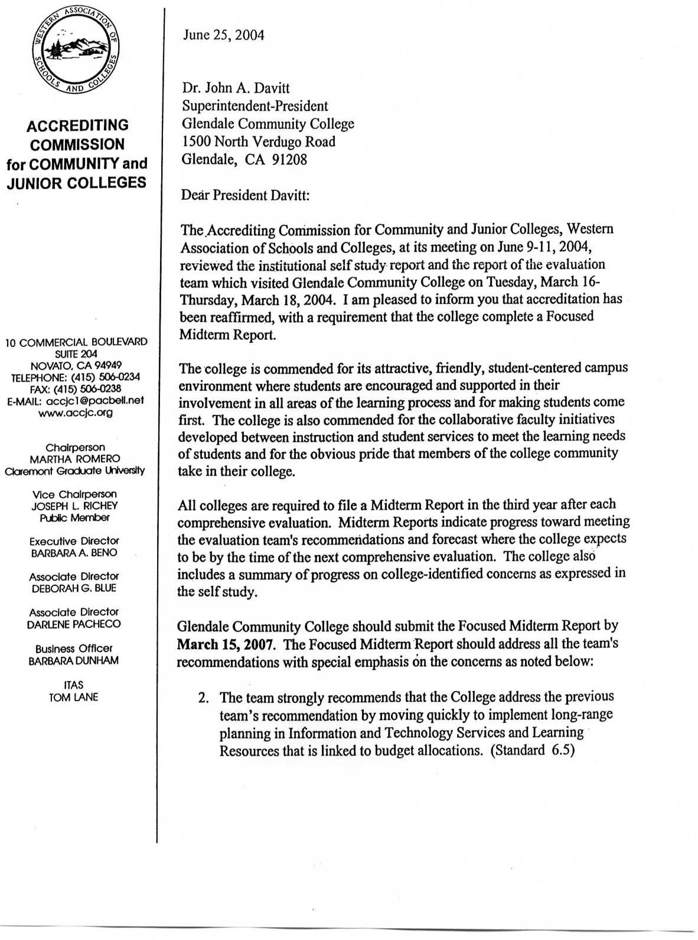
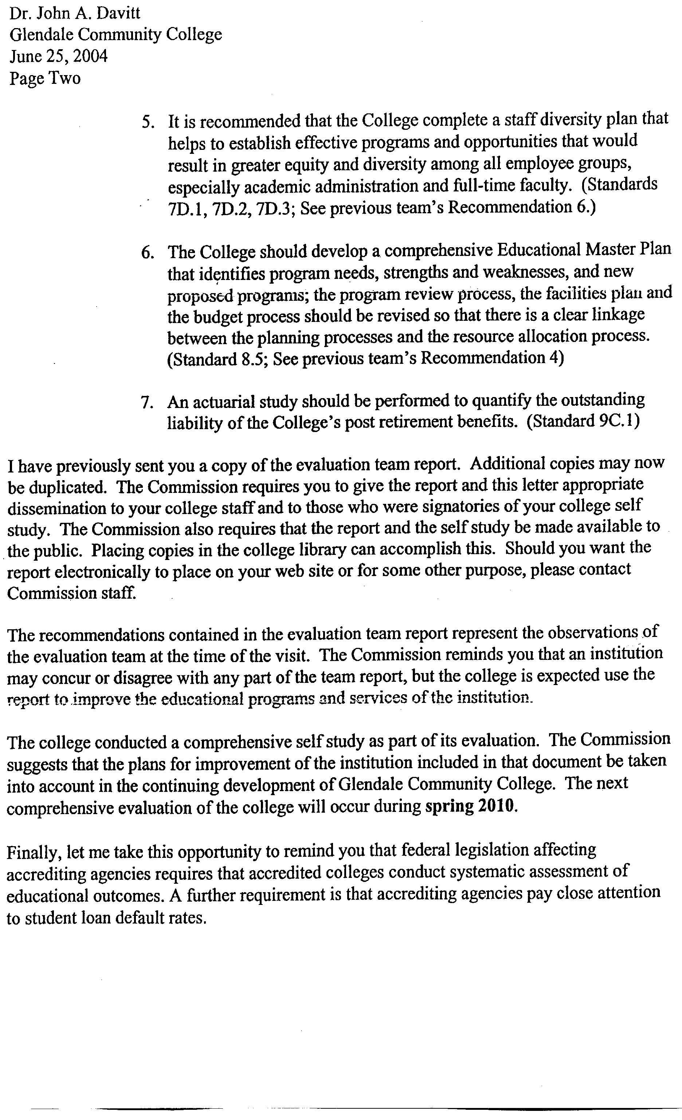
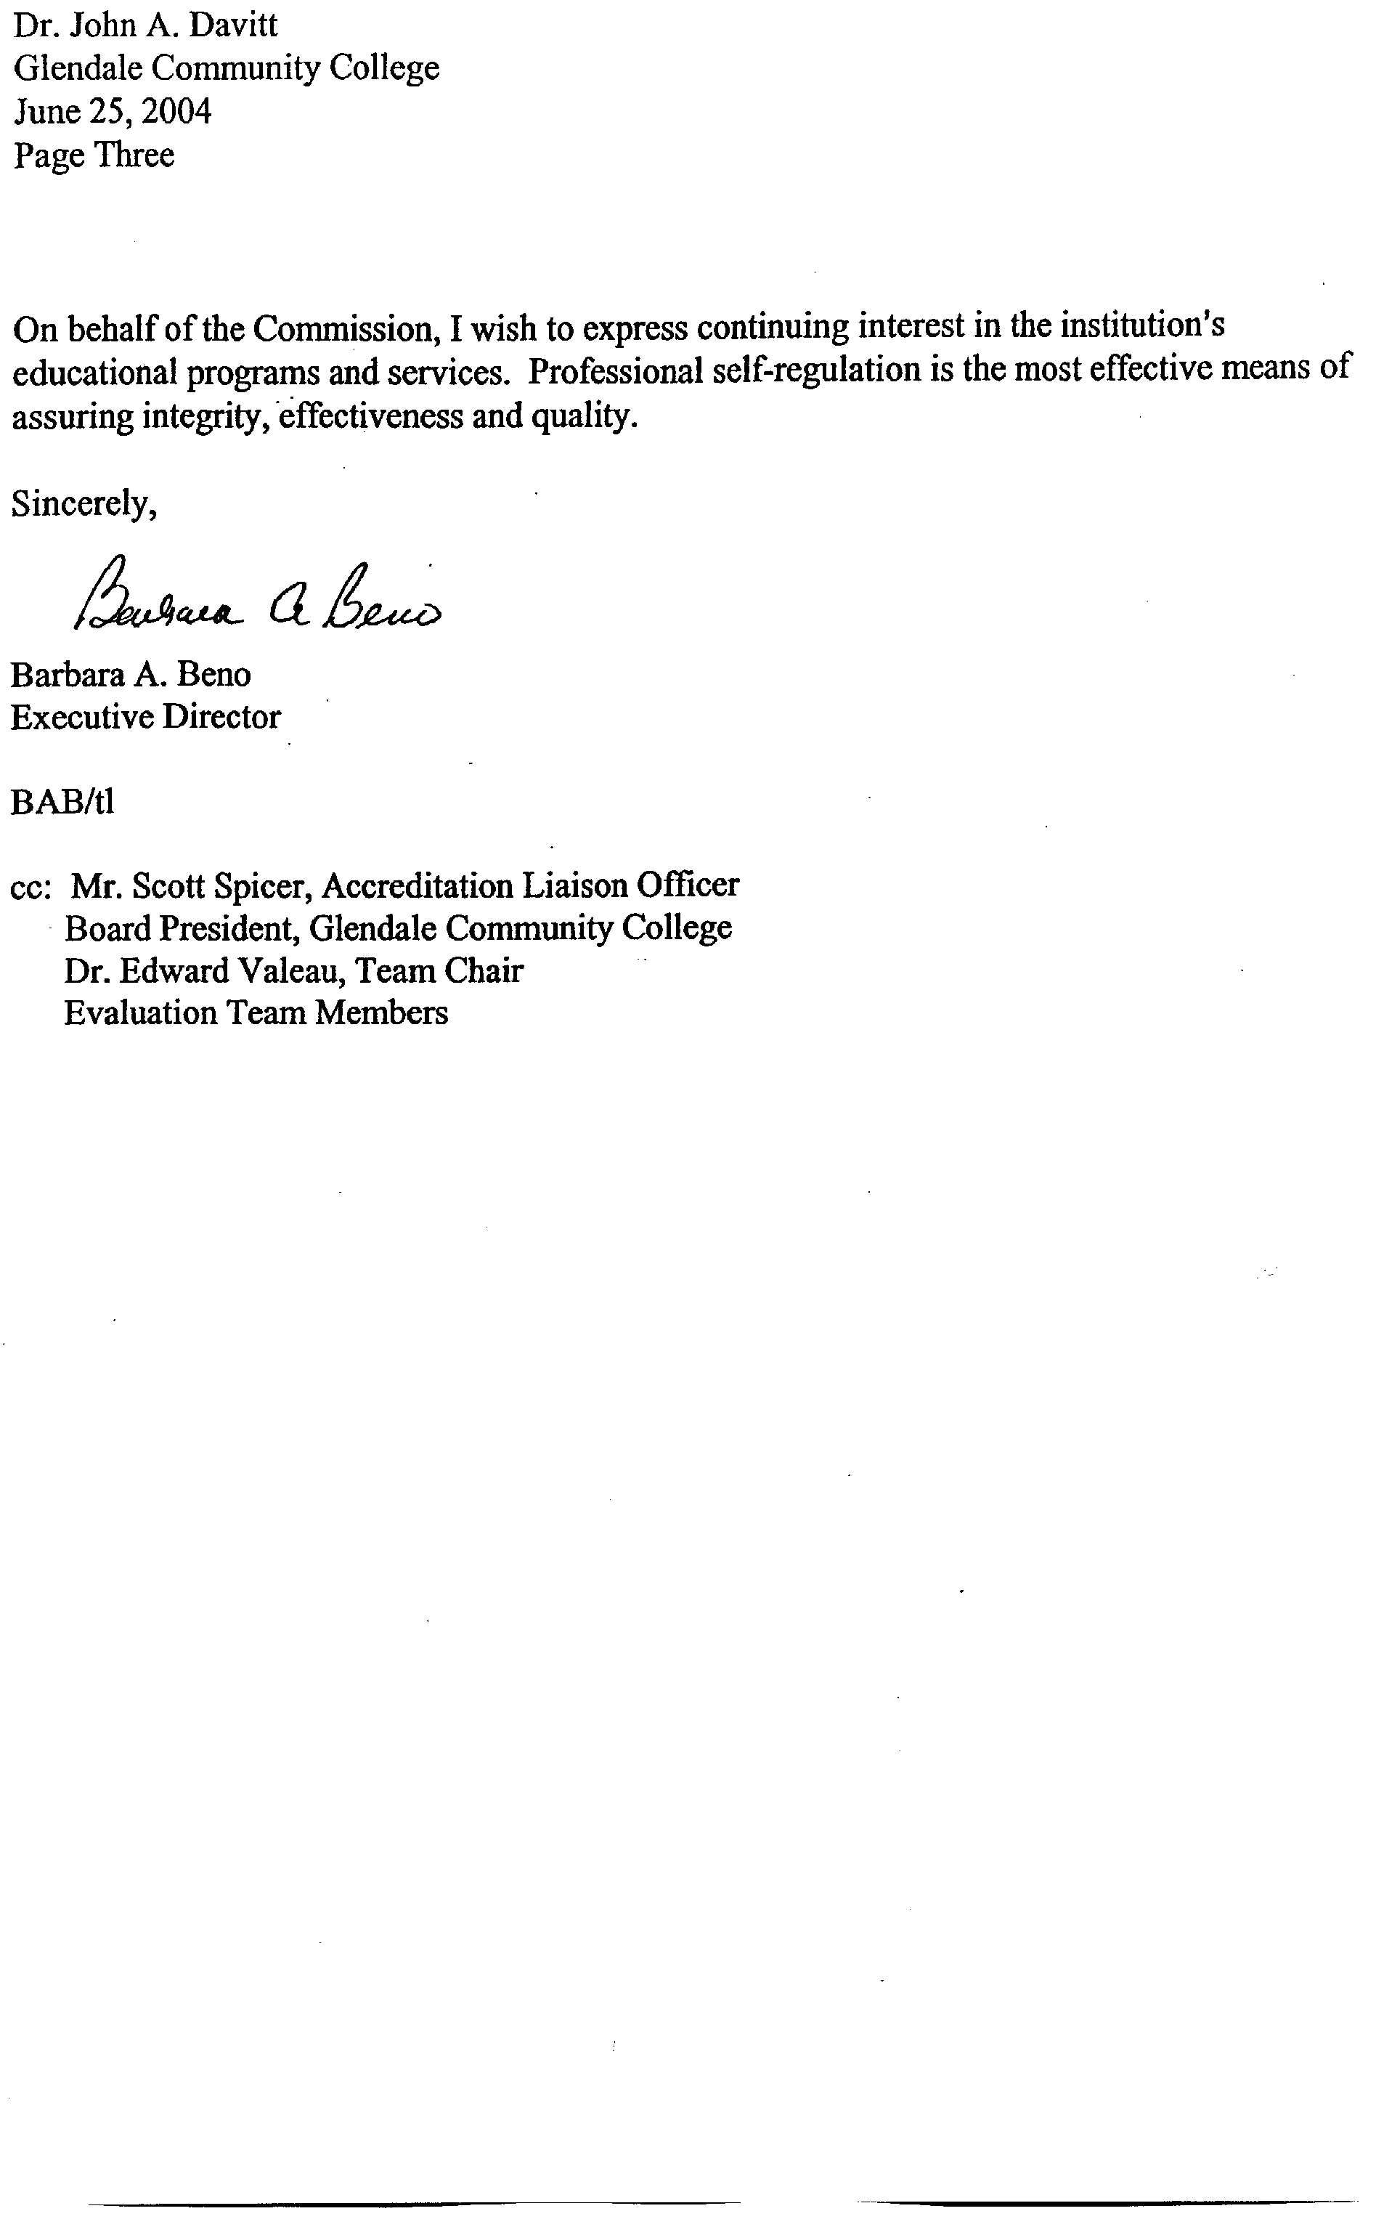
2006 Response to the

SELF-IDENTIFIED ISSUES
(From the 2004 Self-Study Report)

STANDARD 1
Goal:
1. Modify the mission and vision statements.
Status: Task to be done by Master Plan Committee in spring 2007.

STANDARD 2
Goals:
1. Revise website.
Status: RFP developed; completion of new website scheduled for fall 2007.

2. Implement new ERP.
Status: Oracle software purchased; installation of Finance and Human Resources software;
delayed implementation of ERP by the provider, contract for the student system is being renegotiated with Oracle.

3. Develop website oversight governance committee.
Status: The committee was created and is functioning.

4. Increase awareness of academic honesty policy.
Status: Academic Honesty statement appears in the schedule of classes, the college catalogue, and the student handbook, are posted on the college website, and published in course syllabi.

STANDARD 3
Goals:
1. Strengthen process of evaluating college goals by using baseline data and benchmarks of success.
Status: Baseline data are reported in the Campus Profile for many Strategic Master Plan KPIs. Other goals have been addressed by the Master Plan Committee.

2. Identify, anticipate and prioritize improvements to make the college more proactive using the shared governance system.
Status: The Master Plan Committee will address planning in spring 2007 as part of the SMP revision process. This committee has developed procedures to link planning to budget. Minutes of all governance committees are posted at the governance website to improve the flow of information between and among committees.

3. Use new ERP to integrate educational, financial, physical, and Human Resources planning and
link these plans to budgeting.
Status: Team A is testing new procedures designed to link educational, financial, physical and Human Resources planning to budget. Use of the ERP system to facilitate planning waits for negotiation with the provider and installation of the new software.

STANDARD 4
Goals:
1. Evaluate the unmet demands of the Non-Credit programs and expand offerings and services at
the Garfield campus.
Status: Planning for “best uses” of the new building at Garfield has begun and will continue until the “bridging document” is ready for the design-build RFP.

2. Assess and measure student learning outcomes and improve retention rates.
Status: A timetable and guidelines have been developed by Student Learning Outcomes Committee. See Self-Study (Identified Issues) Attachment 11.

3. Use the ERP system, both to aid students to provide more flexibility for students and to improve means of tracking them, to integrate our current infrastructure and communications processes used to evaluate programmatic change.
Status: Oracle software has been installed for Finance and is almost completed in Human Resources. The student component will be installed when contract re-negotiations are completed. The college has created a student system, titled My GCC, which provides the schedule of classes, financial aid information, grades, and access for change of address. The counselor system provides counselors with student records, transfer and graduation requirement information. The faculty system is not completed.

4. Develop a policy for program reduction and elimination.
Status: An Enhancement/Sunset policy has been developed and approved by the Academic Senate and the Board of Trustees. See Self-Study Attachment 12.

5. Improve infrastructure and support services in College Services.
Status: A College Services building to consolidate all student services programs into one location has been designed, approved and funding established. Work is in progress to improve orientation for all matriculating students, to provide assessment for all students, and to revamp the delivery of student services. See Strategic Master Plan Status Report, Self-Study Attachment 13.

6. Promote use of the most effective teaching modes.
Status: This work is part of the Strategic Master Plan. For details see Strategic Master Plan Status Report. See Self-Study Attachment 3, goal 2.1 & 2.2.

7. Improve: inter-divisional and intra-campus communications, programs and certificates, develop class offerings and other graduation requirements to enhance student success, assessment of students to improve student success.
Status: This work is part of the Strategic Master Plan. For details see Strategic Master Plan Status Report. See Self-Study Attachments 3.

8. Improve student surveys to capture success.
Status: Student surveys have been conducted and reported; for latest version see Student Views 2006. See Self-Study Attachment 14.

9. Link budget with planning.
Status: Linkage plan completed by Master Plan Committee, implementation in progress. See response to Recommendation 1 of the Midterm Report.

10. Establish student satisfaction to preferences regarding mode of instruction, logistics, course content
and increase student input.
Status: Students are surveyed every spring to establish satisfaction with course scheduling.
Assessment of satisfaction with programs certificates, or graduation requirements remains to be done.

11. Expand articulation agreements/improve working relationships with K-12 and local universities and colleges.
Status: Articulation of courses with the four year schools continues. For efforts to strengthen its collaboration with the local colleges and universities and the Glendale Unified School district. See the Strategic Master Plan Status Report Attachment 3 and the Educational Master Plan, 2005.

12. Set standards and evaluate hybrid and on-line courses.
Status: The Technology Mediated Instruction Committee presented criteria for evaluating hybrid and on-line classes and these were approved by Academic Affairs and the Academic Senate. These standards are posted on the Distance Education website. See Self-Study Attachment 15A.-Distance Education Course Approval Form and 15B.-Distance Education Guidebook
The web address is: http://www.glendale.edu/online/facultycenter/distance_education_overview.htm

STANDARD 5
Goals:
1. Improve relationship with the local community by translating the application into additional languages, improving communications, and developing student and faculty portals on the Web.
Status: Budget limitations have prohibited providing the application in the several languages spoken by residents in the district. Multiple efforts to reach the community have been developed, including post cards to announce classes and deadlines to greater Glendale, an 8 page newsprint newsletter, a bi-weekly television show featuring educational excellence at GCC, campus tours, and visits to the planetarium shows. This year the college conducted 5 tours of the campus, presented 10 slide shows, hosted 37 classes (2,567 students) through the Science Center Outreach Project, and developed over 500 electronic messages on the electronic billboard at the corner of the campus.

2. Monitor and increase student assessment.
Status: Assessment for English, ESL, and Math are regularly completed for placement purposes. The cut scores for English and math have recently been changed. Additional assessment will to be submitted to the budget process.

3. Increase student funds to aid non-credit students.
Status: This matter is unresolved due to legal issues.

STANDARD 6
Goals:
1. Improve library offerings and services.
Status: See response to Recommendation 2 of the Midterm Report.

2. Improve computer communications and support services, upgrade technology as needed, and improve the technological infrastructure.
Status: The 2007 Technology Plan will be completed in spring, 2007 when the new Associate Vice President of Technology is hired. For further discussion see response to Recommendation 2.

STANDARD 7
Goals:
1. Improve Human Resources support services by using the new technology and software in updated hiring and evaluation procedures.
Status: See responses to Recommendations 1 & 5 of the Midterm Report for the work and plans of Human Resources.

2. Expand Staff Development as money allows.
Status: See response to Recommendation 3 of the Midterm Report.

3. Increase the number of full-time faculty.
Status: An Academic Senate resolution calls for an increase in the number of full-time faculty; resolution has been referred to the Master Plan and Budget Committees.

STANDARD 8
Goals:
1. Upgrade facilities, including heating, air conditioning and ventilation.
Status: HVAC upgrades have been completed at the Garfield Campus and the gymnasium is in progress. A contract is in place with an engineering firm to advise/improve HVAC in the Administration Bldg. and the Auditorium.

2. Re-evaluate disaster preparedness plans.
Status: The disaster preparedness plans meet SEMS compliance; efforts in motion to bring them into federal compliance. A committee will develop procedures for addressing emergencies.

3. Upgrade facilities in buildings as needed.
Status: Proposals submitted to the budget process.

STANDARD 9
Goals:
1. Define the role of the Budget Committee
Status: Clarification of the role of the Budget Committee has been accomplished; Administrative Regulations that define the budget process have been revised. The Master Plan Committee has developed procedures for establishing budget priorities. See response to Recommendation 1.

2. Use the ERP to improve campus communications.
Status: Communications have improved in Finance and Human Resources and will improve when the student and faculty components are completed.

3. Develop plans for extended budget crises.
Status: Revisions to the budget process began in 2005; discussion has begun to address budget shortfall resulting from change in the state reporting requirements which caused a drop in FTES.

STANDARD 10
Goals:
1. Review and revise Board Policy 8000-9000
Status: Board Policies 9122 and 9340 have been revised. The remainder of this work remains to be completed.

