Digestive Health   
Calvin Tran, Dietetic Intern   
February 21, 2013

Beet and Apple Salad

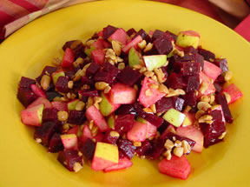

* Ingredients
  + 2 thinly sliced apples  
    4 thinly sliced celery stalks  
    1 minced shallot  
    Juice from 1 lemon  
    1 beet   
    1 tsp. sugar  
    3 tbs. chopped walnuts  
    3 tbs. olive oil  
    3 oz. unpacked endive  
    Salt and pepper to taste