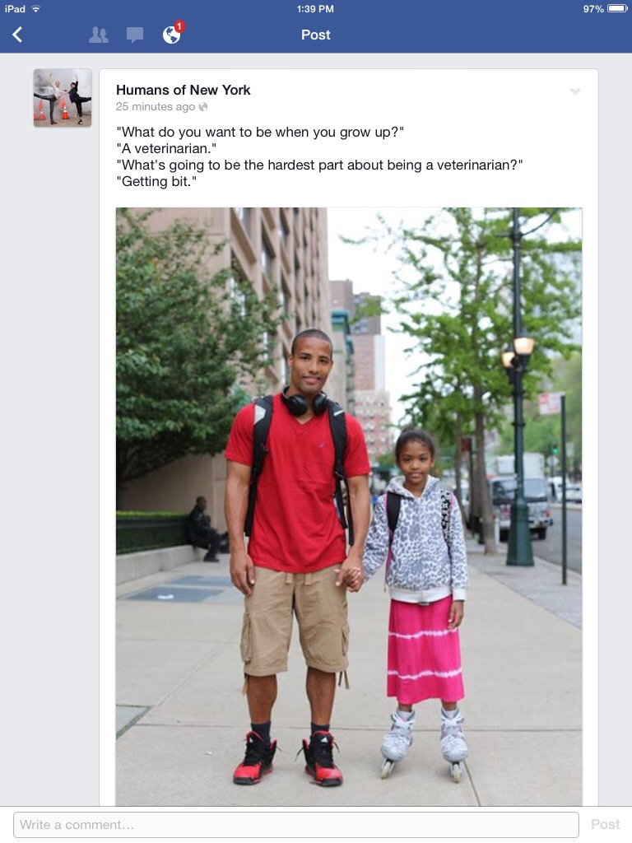

1. Often we ask children, “What do you want to be when you grow up?” We want to know what career they imagine they will have. Is this a common question in your culture? Why?
2. When you were a child, what did you want to “be when you grew up?”
3. How have your dreams changed now that you are an adult?
4. Do you think the girl in the picture will become a Veterinarian (animal doctor)? Why?

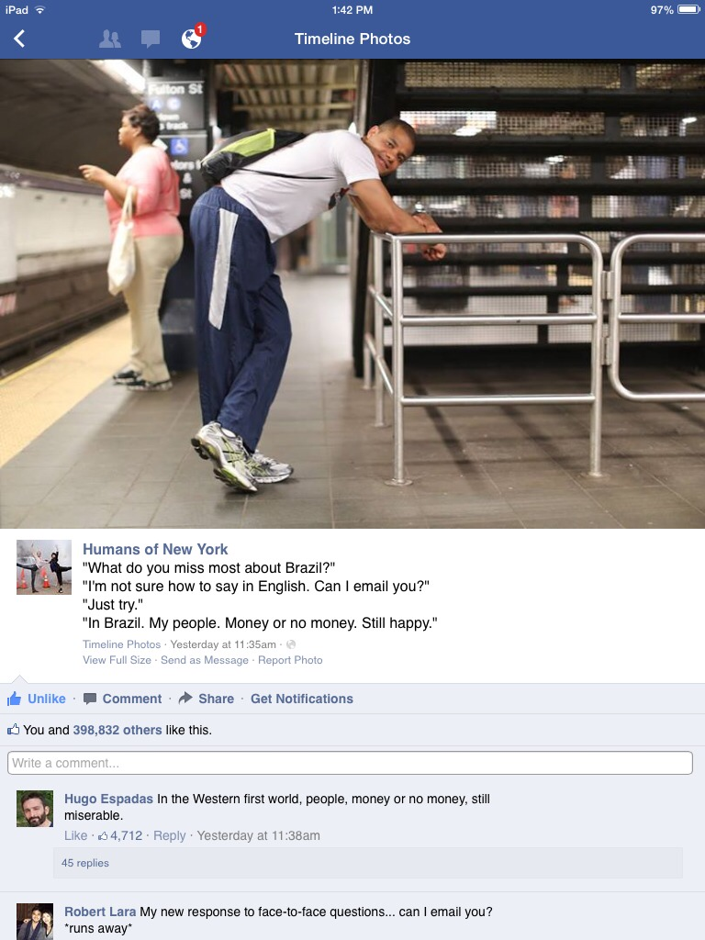

1. What do you miss about your native country?
2. In your opinion, can people be happy without money? Why or why not?
3. If you had more money, what would be different in your life?



1. Describe the family in the photo.
2. A “two career family” means that both parents have jobs. Do you live in a “two career family?” Explain.
3. In your culture, can women work as engineers?

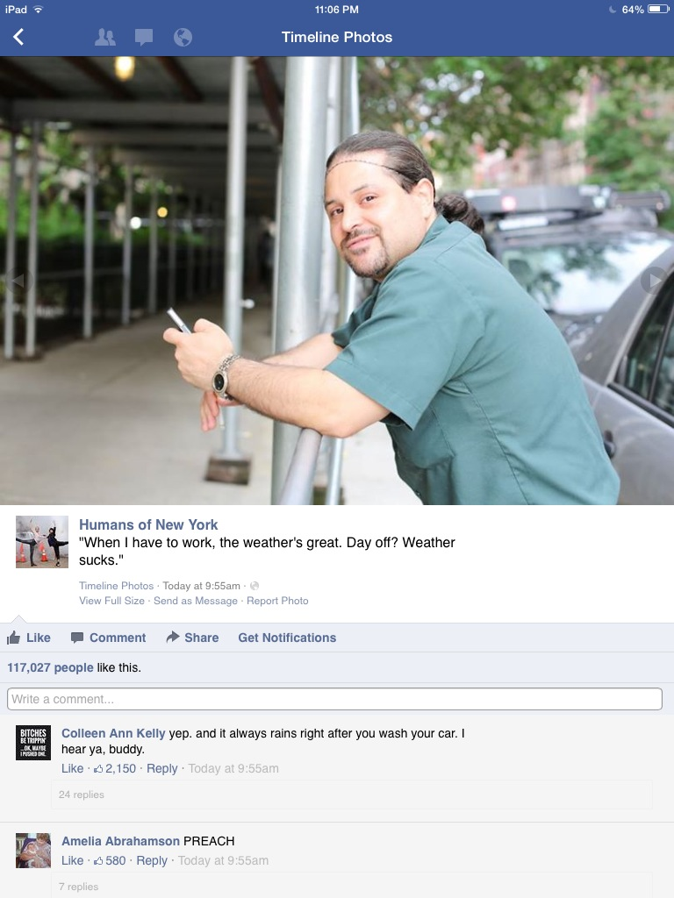

1. What’s your favorite weather?
2. What do you like to do when the weather’s great?
3. When we say something “sucks,” we mean it’s bad. For this man, when does the weather suck? [*Note: This is a slang word that is very informal and somewhat offensive.*]



1. How long have you known your best friend?
2. How often do you talk to him/her?
3. If you “pick right back up” with a friend, it means it feels like no time has passed since you last saw him/her. When you see someone after a long absence, is it easy or difficult for you to “pick right back up?”