**GCC REQUSITIONING**

**iProcurement will no longer be used. Log into Oracle the same way.**

**Click the “GCC Requisitioning” responsibility to enter a requsition.**

**Description**

**Although the “Description” in the upper left corner is not a required filed, this is what we will use to default into the Board Report every month. Please enter this field with a brief description of the entire requistion. Keep this brief, concise, and informational. Limit the length and punctuation as there are limited number of characters available.**

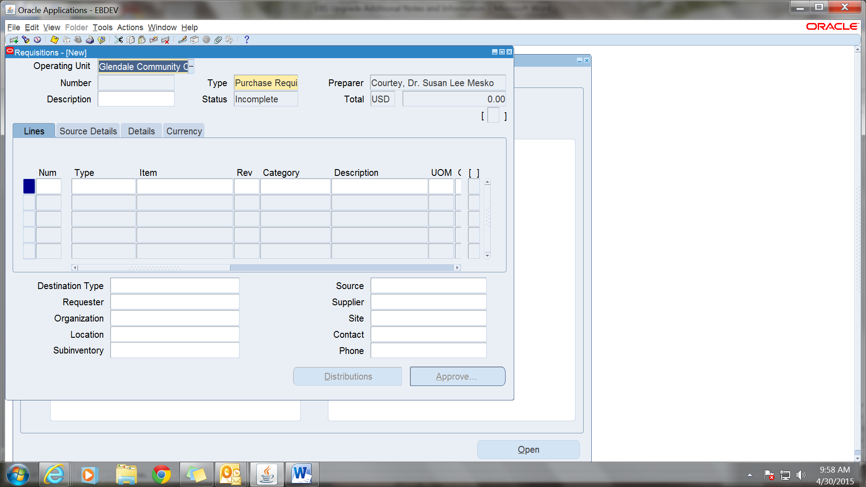

**Required Fields**

**The required fields are all the same they are just accessed a little differently. All require fields are yellow.**

**Type: This field will default to “Goods” Click on three lines to see all available options. Use “Service” for Blankets.**

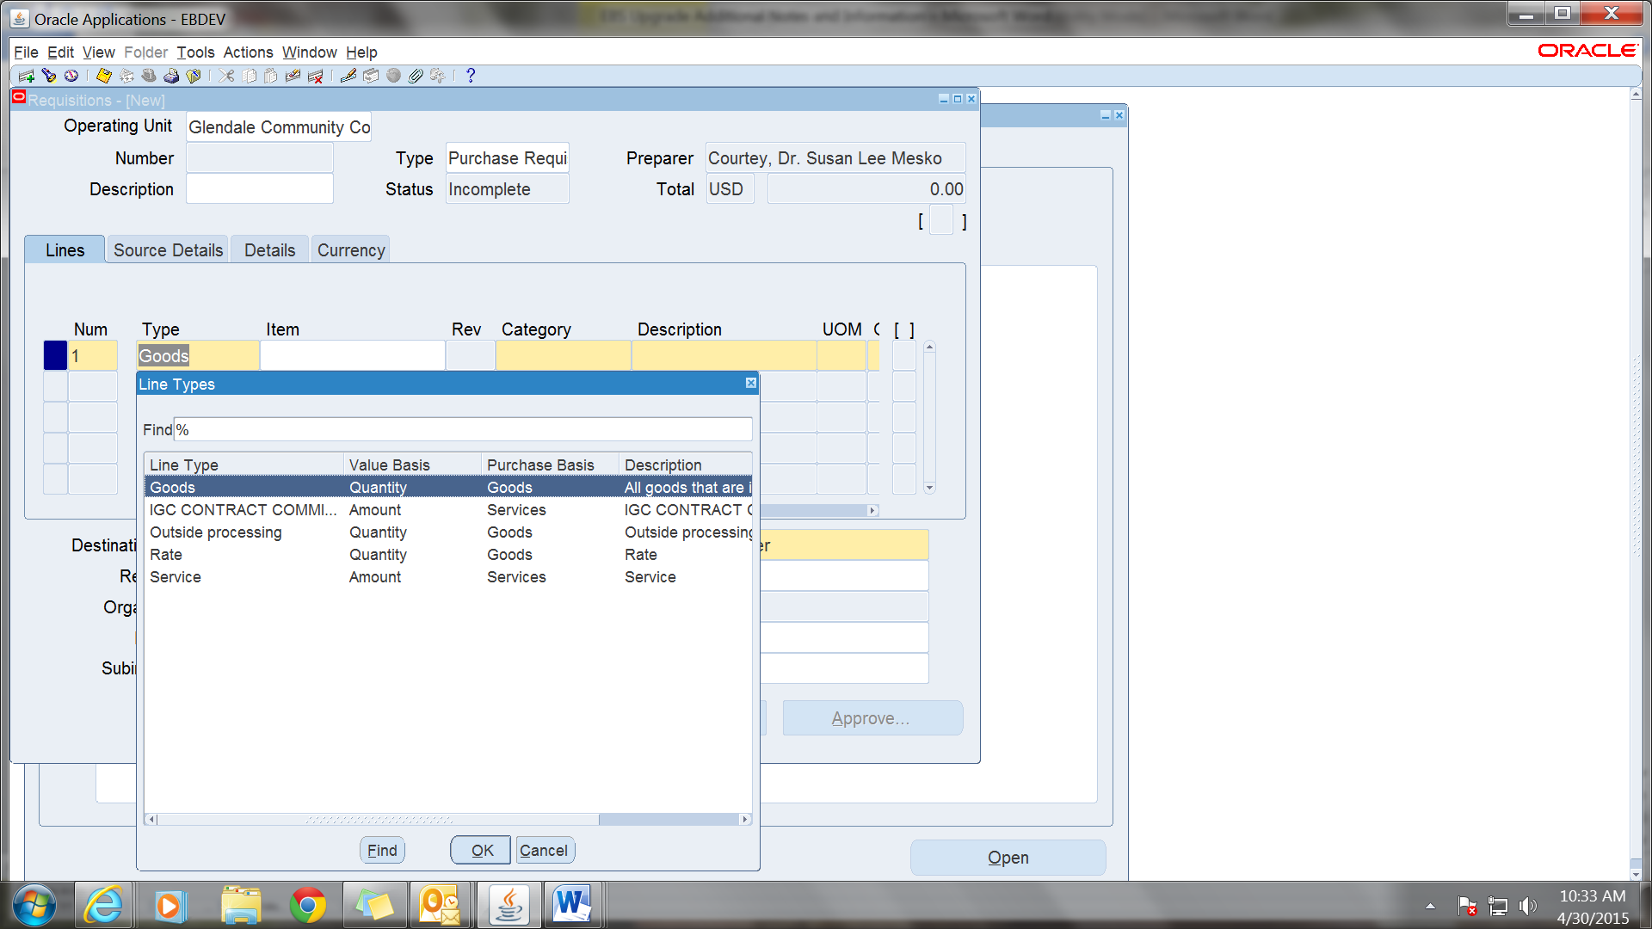

**Category: Options are the same as previous and the Major and Minor fileds must be entered. You can click on the three lines to see all available options for each.**

**Major:**



**Minor:**

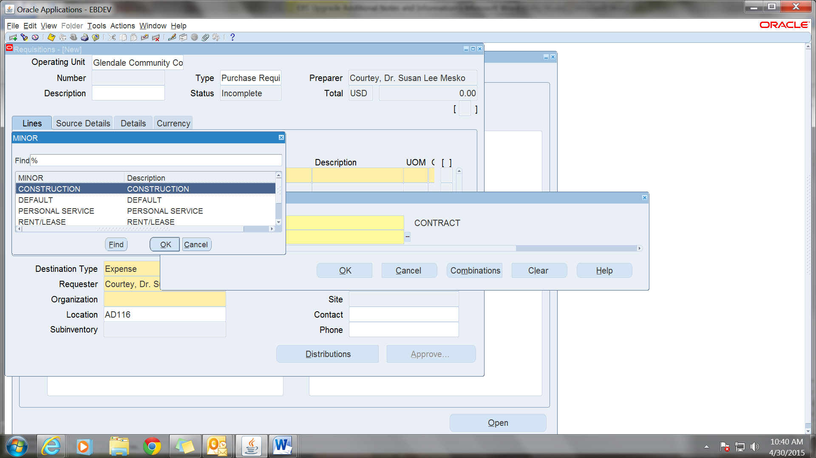

**The next required field is the Description. This will be the description of this line only. Include item number and/or a brief description for this line only.**

**Unit of Measure (UOM): Click on the three lines for a drop down list or type the first few letters of the desired option and tab over to the next field.**

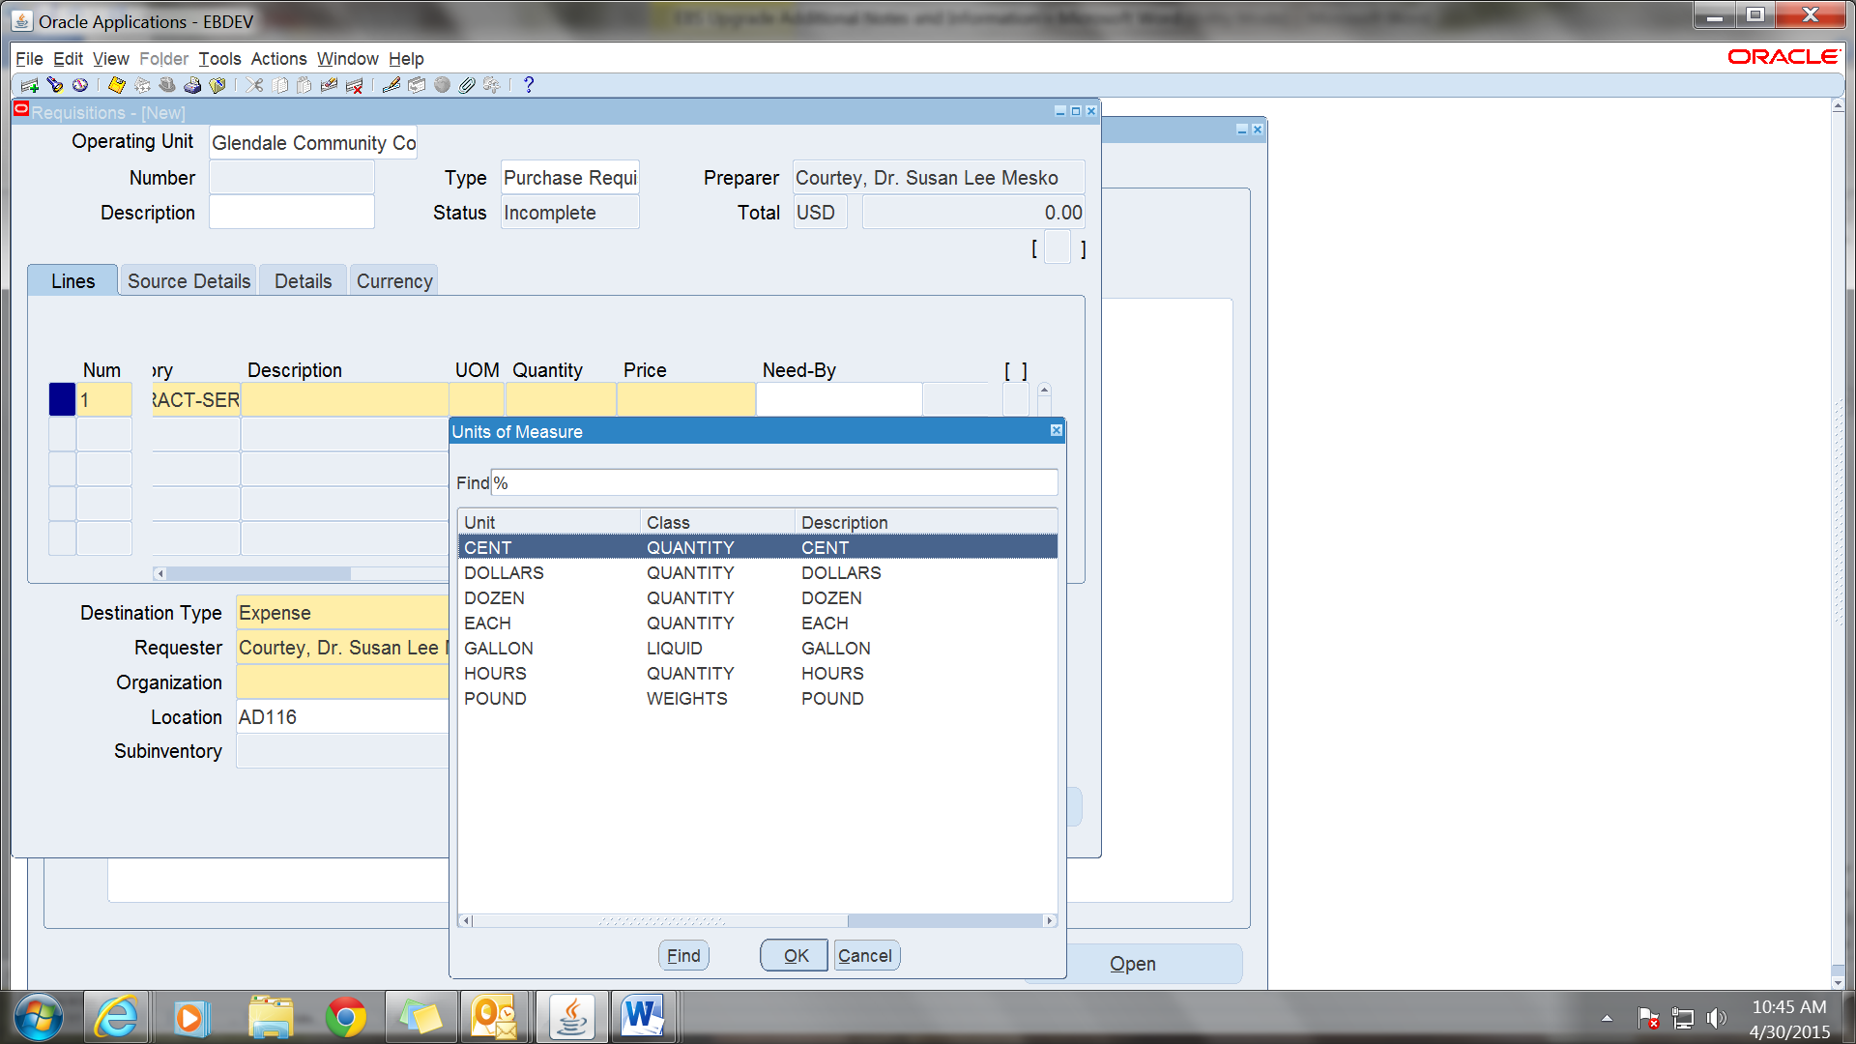

**Quantity and Price are required fields so enter accordingly.**

**The next block is in the lower left. The yellow fields are required and most will default in with the requestor’s information. The “Organization” may not default in. If it does not, just click on the three lines and “Glendale Community College” will fill the field.**

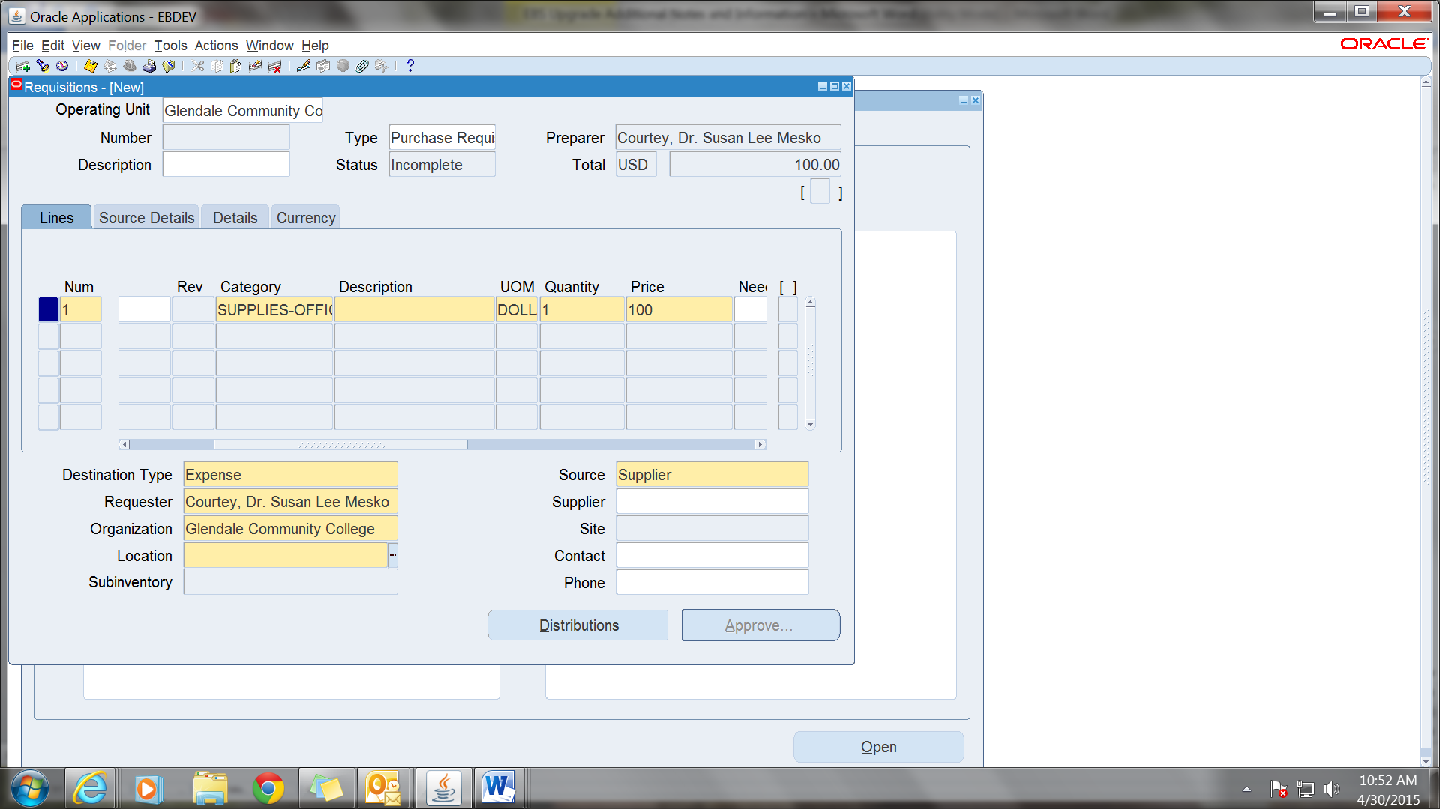

**The location is also a required field. If your location does not default in click on the three lines and put % in the box for a list of available options. Not all rooms are entered in Oracle, if you do not find your location put the department or other available option and let me know that the location has not been included.**

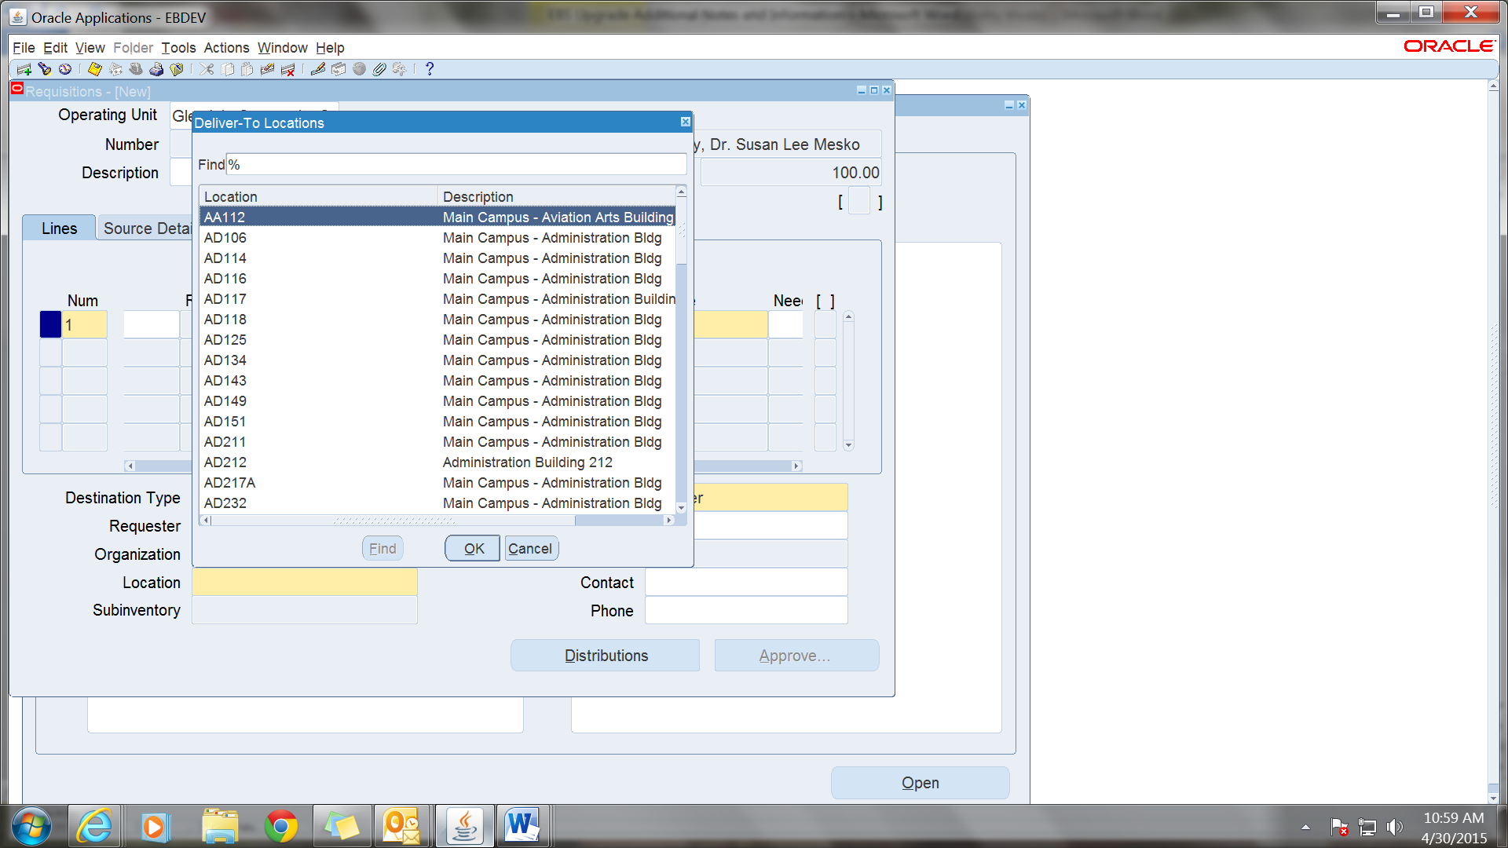

**“Source” is a required field but “Supplier” will default in. The field named “Supplier” is not required but if you know the vendor or want to sugest a vendor you can fill this field either by entering the first few letters of the name or by clicking on the three lines and getting a drop down menu. Please note that this field appears to be case sensitive so please use all CAPS for the inquiry. If the “Site” does not defult in click on the three lines. If there is only one site it will default in if there are multiple sites find your site if you know it. However, Purchasing and Accounts Payable will verify the info before issuing the PO and making payments so do not be concerned if you do not find the site you are looking for.**

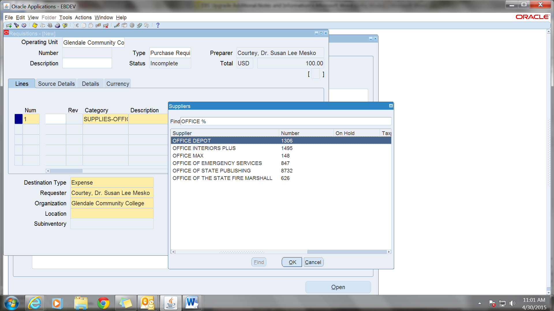

**The next required field is on the next page. Click on “Distributions at the bottom of the page to navigate there.**

**Click on the “Charge Account” filed to enter the account number.**

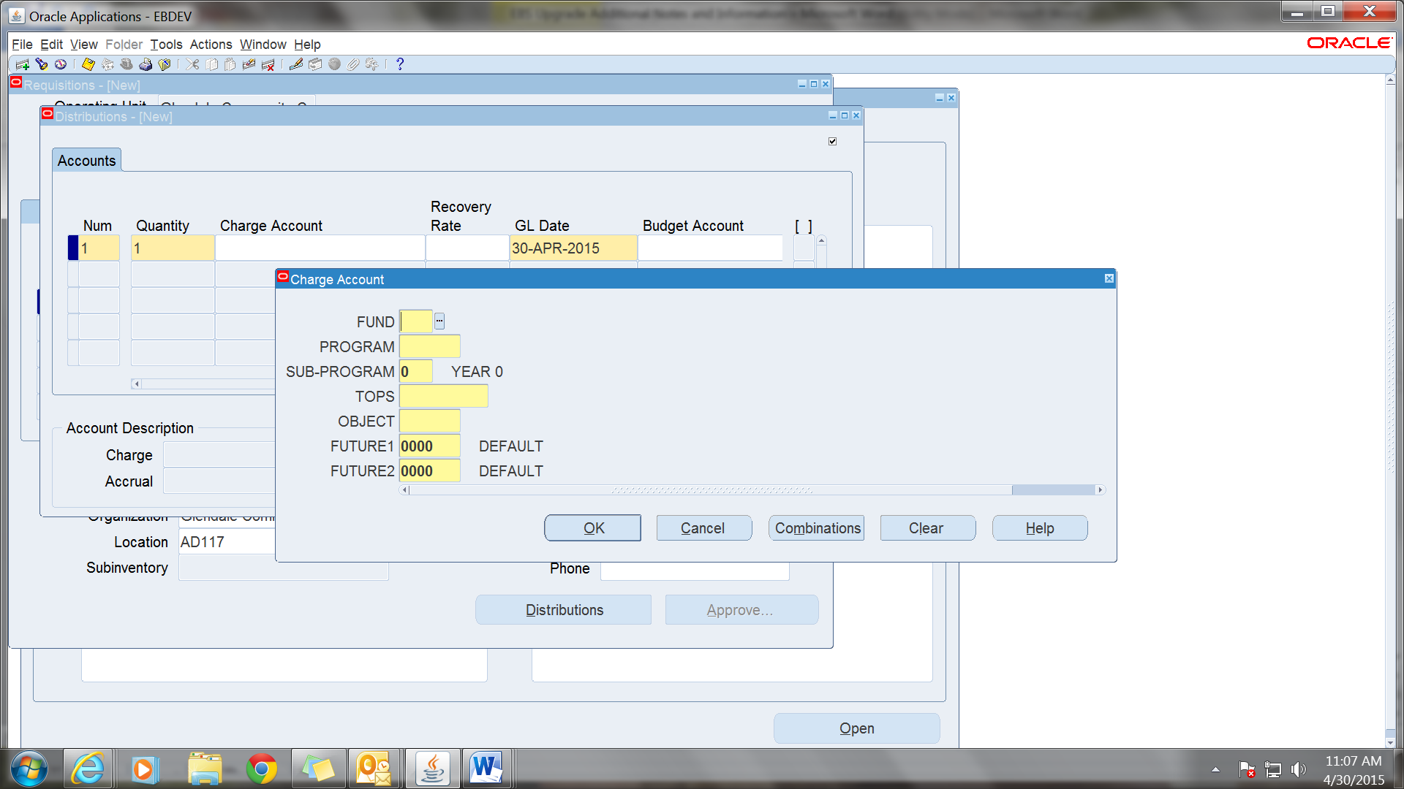

**There will need to be a distribution line for each requisition line. If you are doing a multiple line requsition, please refer to the Notes on Requsition Preferences and set the Default account before entering the requsition.**

**Click on the “Save” (Yellow Floppy Disk) at the top toolbar and click on the X a the top of the pop up to exit out.**

**If you are entering another line, click on the line under line one and you will get the fields for line two. Please refer to some suggested helpful hints in the notes at the end of this document for multiple line requsitions.**

**After you have saved the requisition, the number will appear in the upper left above the “Description.”**

**When you are done entering all lines of the requsitions and saved the requition, click on “Approve” at the bottom of the page.**

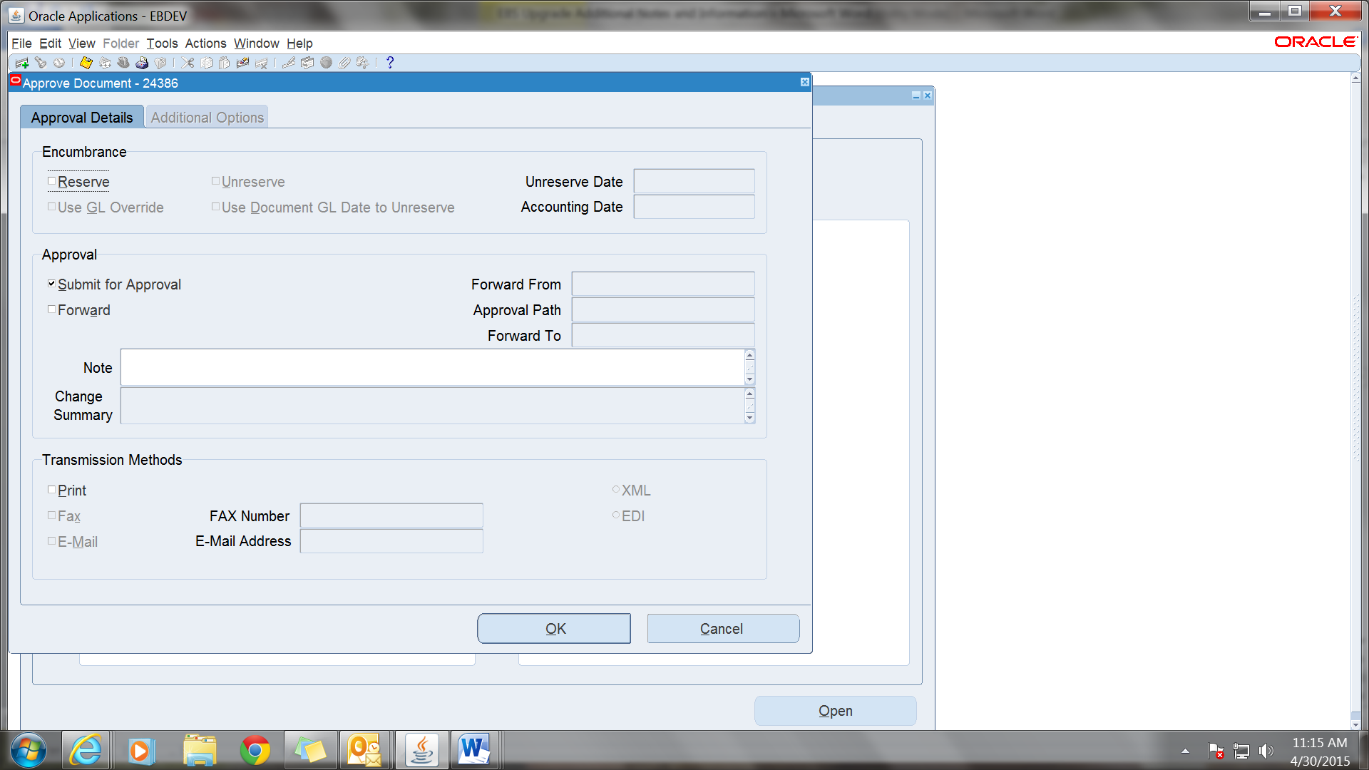

**One this page click on box for “Reserve” and the box for “Forward.” The “Forward To” field will also have to be completed. This is similar to entering the approvers in iProcurement except you will only be able to add one person. This will be the person you want to forward to next. The approvers will each have to “Approve and Forward” to any additional approvers that are required. The % can be used to find the approver to fill the field.**

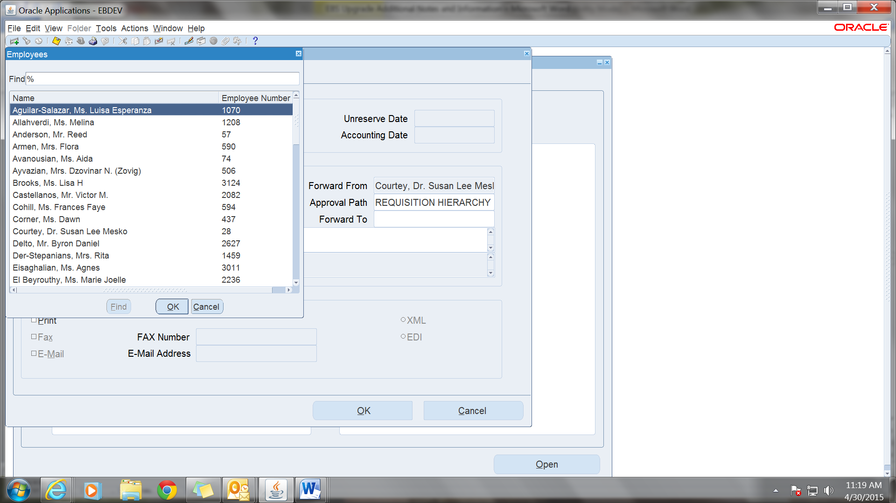

**Additional Information**

**Note to Buyer**

**Click on the second tab under the description, “Source Details” and please be brief. Most of these fields have limited characters. If space is not suffienct please send an email with additional information.**

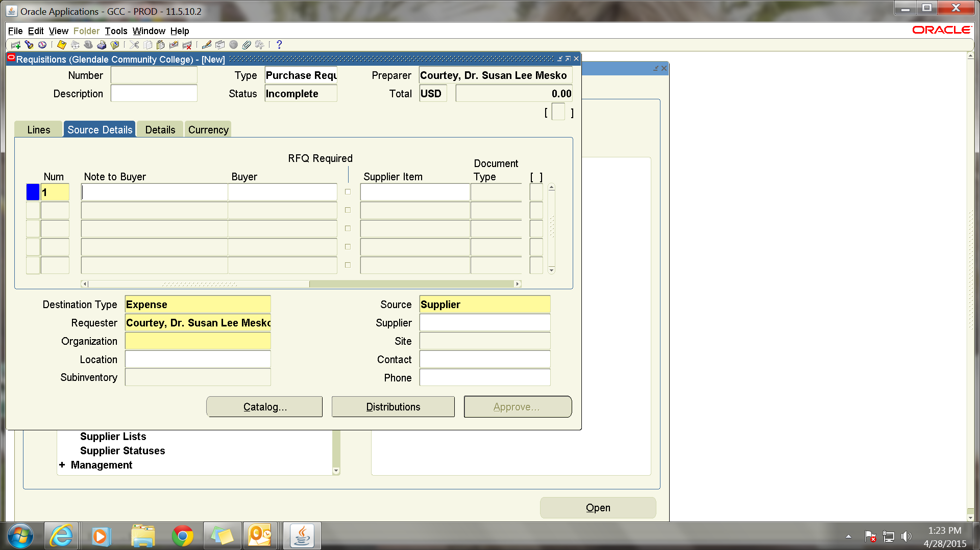

**Justifications**

**Click on third tab “Details” and again, be brief.**

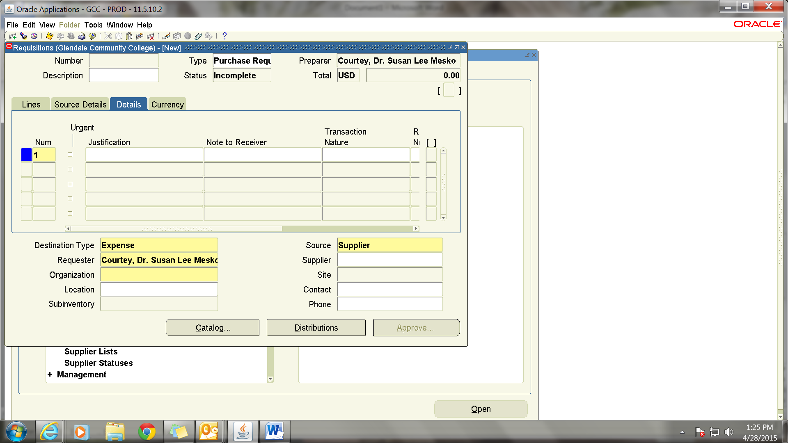

**Default Account for Multiple Lines**

**To use same Account number for all lines click on Tools in the top toolbar. Next click on Preferences and click on the “Charge Account” field. You will get a pop-up to fill in the account number. Click on “Apply” to save the information. Please remember that this will stay your default until you erase or change it. To delete the default account, go back under Preferences, click on the field, and hit space. The number will be erased. Please be sure to click on “Apply” to save the information.**

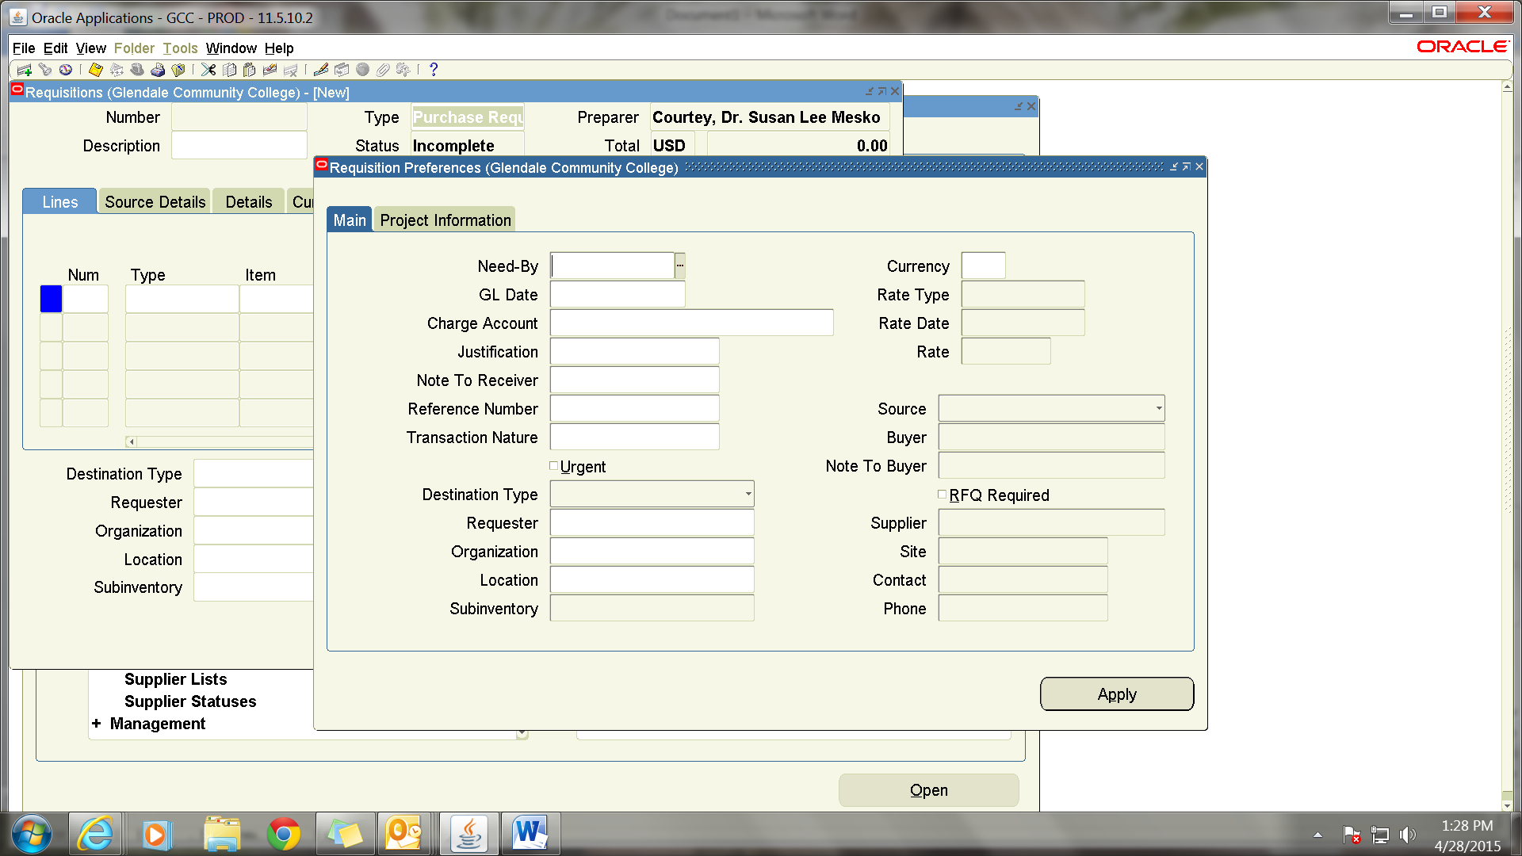

**To start the second line click on the second line. To duplicate everything in the prior line click on “Edit” on the top toolbar. You can then go to each field an update only the info that is different to the second line. For example description, price, quantity etc. If you have a default account entered you will not have to go to the distribution page. If you do not, you will have to enter a distribution for every line.**

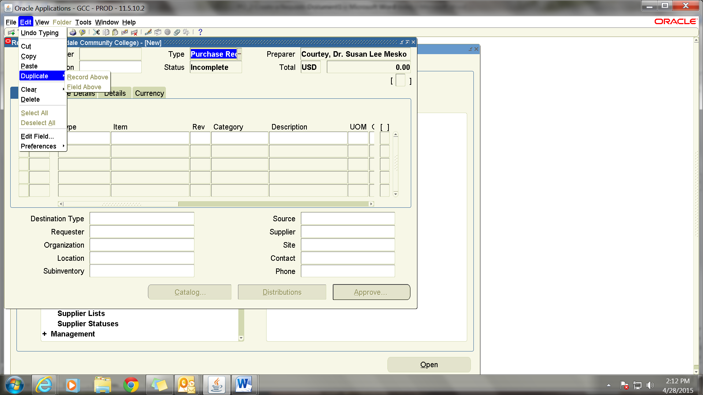

**Attachments**

**Click on the Paperclip on the top toolbar to get a new window. The two yellow field are required.**

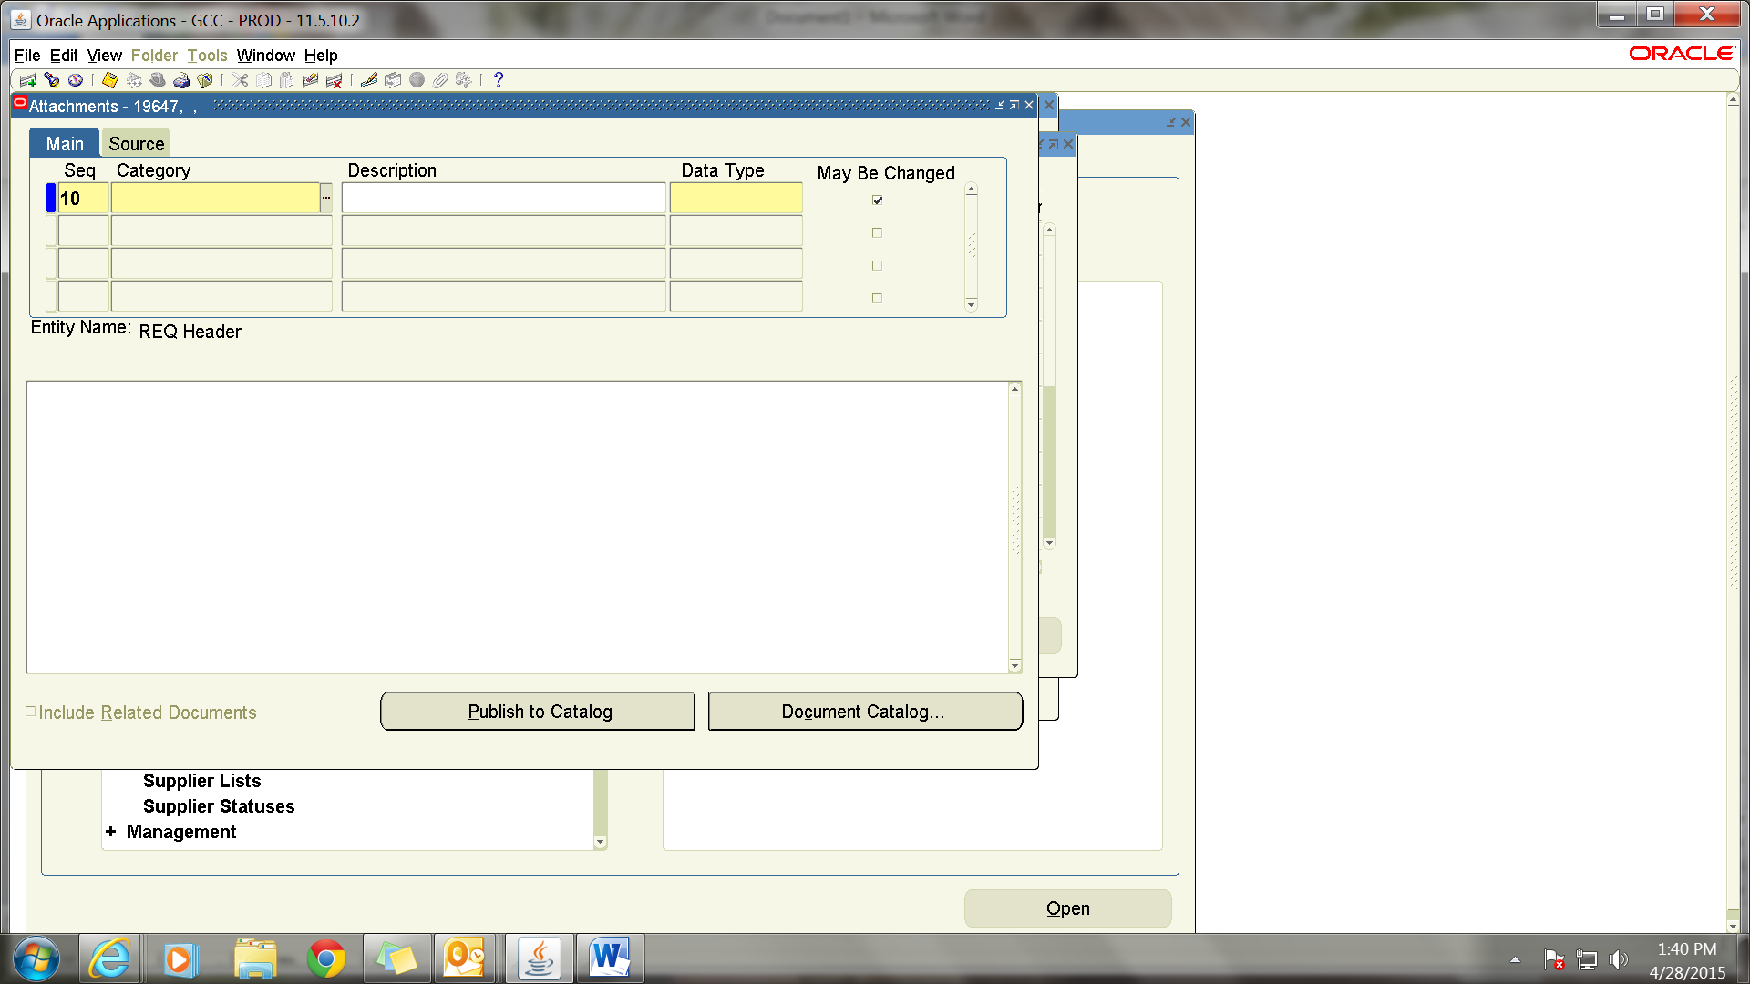

**Click on the Category field. Put % to get the list of options or type “Internal to Requisition” and make sure the field fills with the information.**

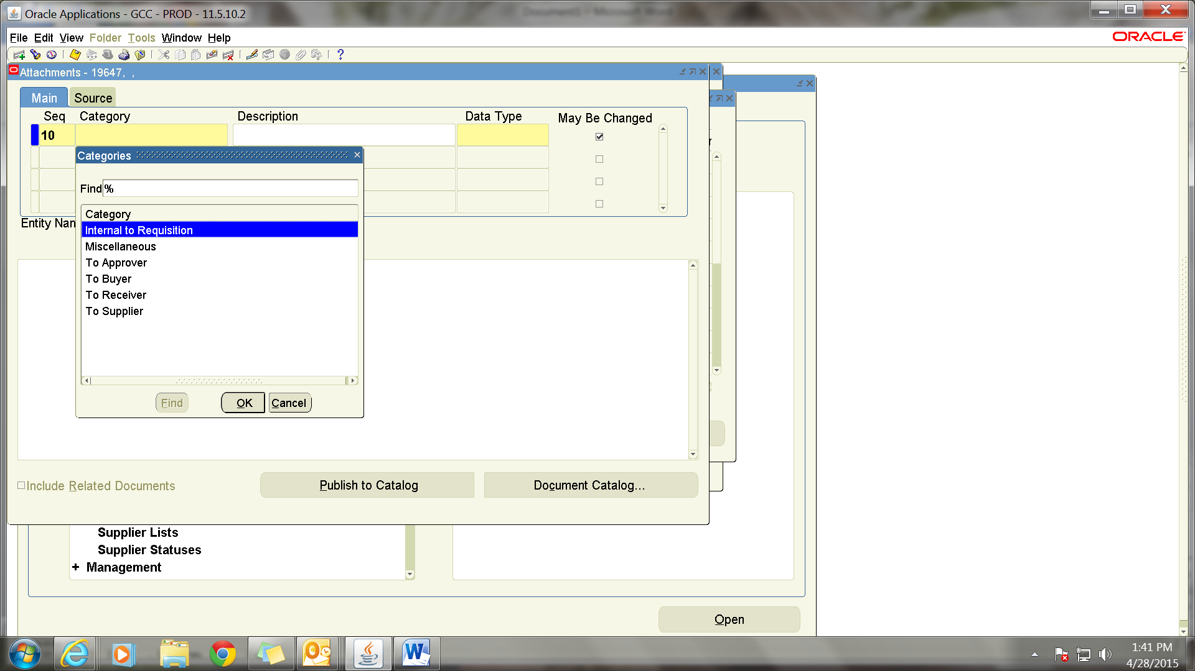

**The other required field is “Data Type.” Click on the three lines to get a drop down, or type “File” to fill this field. You will be directed to another screen to browse for the document.**

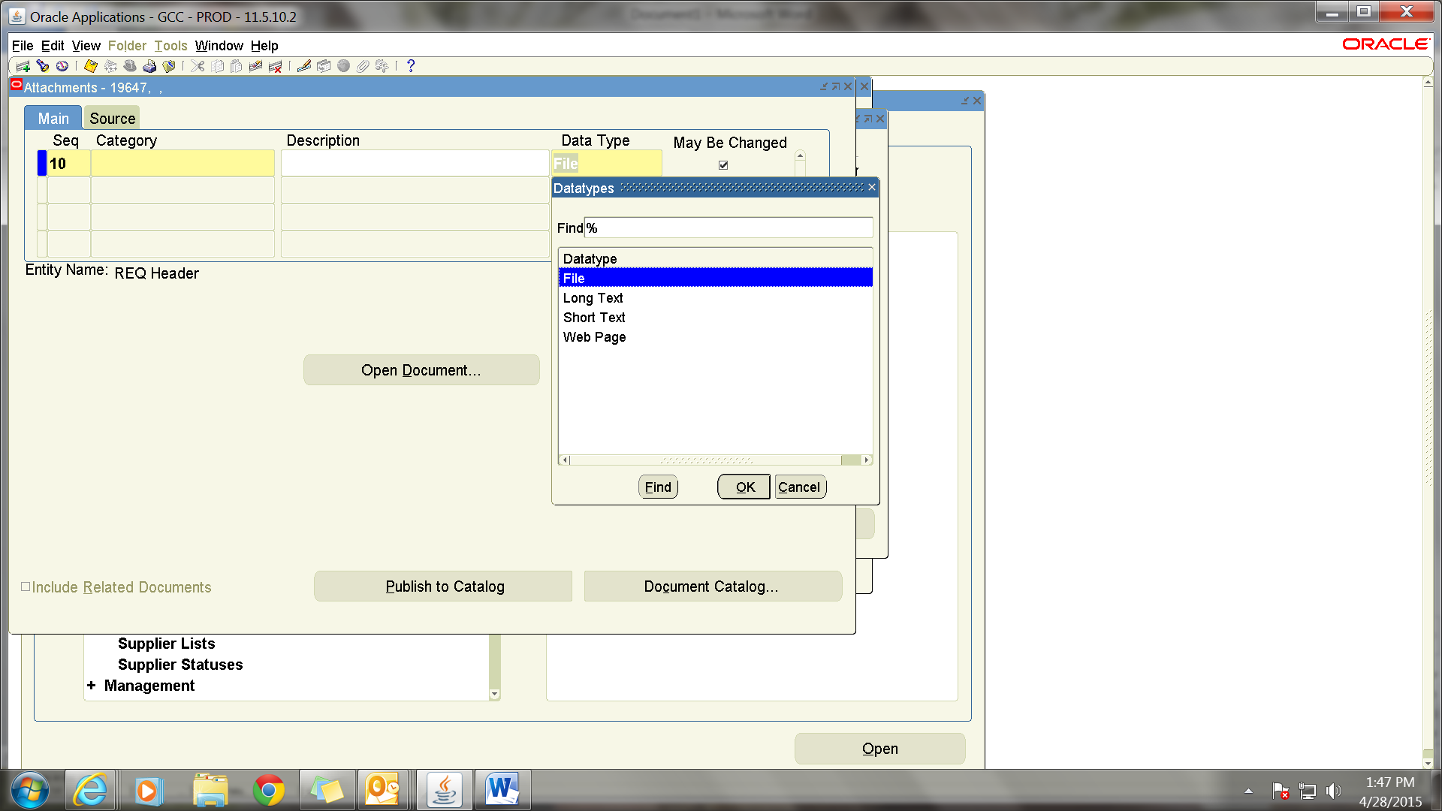

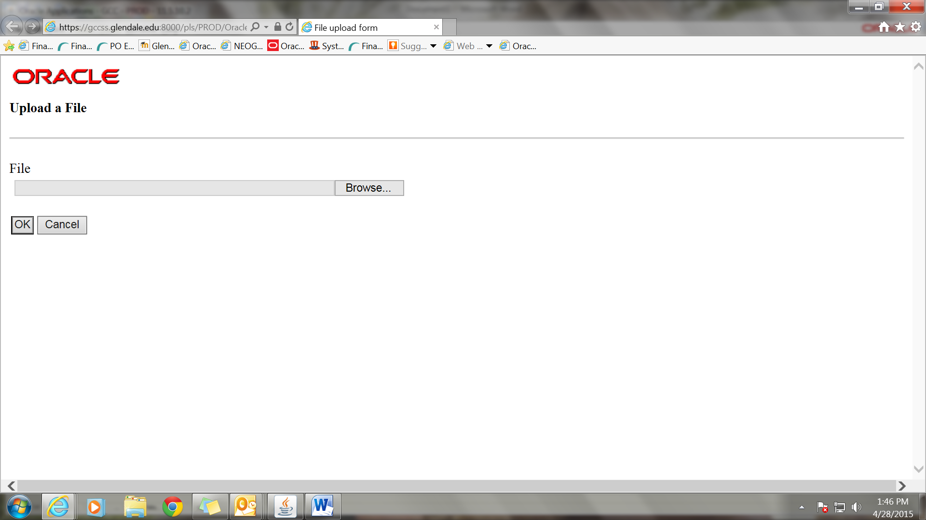

**After uploading the document, return to the prior screen and click “Yes”.**

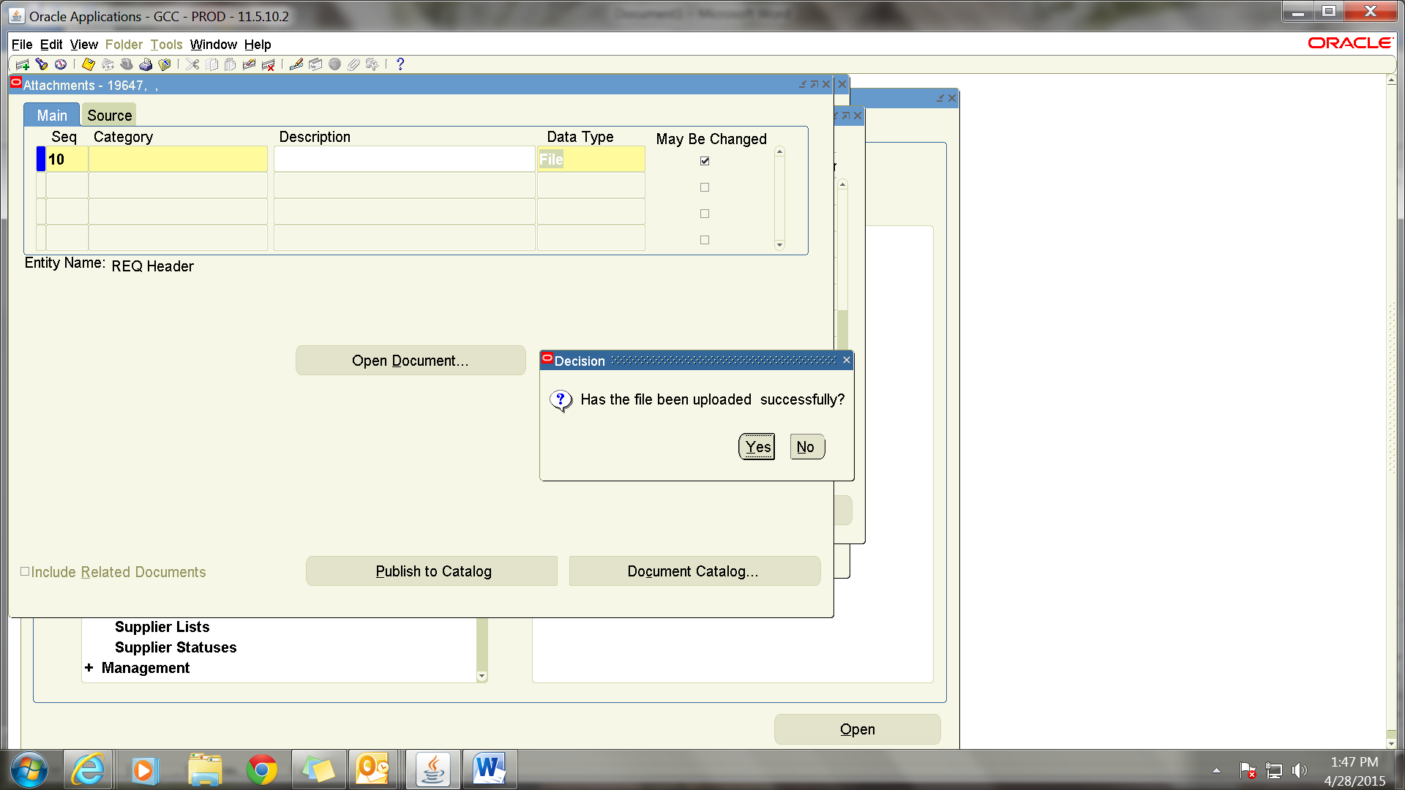

**For Splitting Between Multiple Accounts**

**Enter the requisition as a Service and complete required fields. Click on “Distributions” and click on the “Quantity” field and fill with the dollar amount for the account and enter the account number. Then click on the second line and the remaining amount will fill in the quantity field. If there are only two accounts you can fill in the account number and click on save. If there are more accounts, change the quantity to the dollar amount of the second account and enter it. Then click on the third line, etc.**

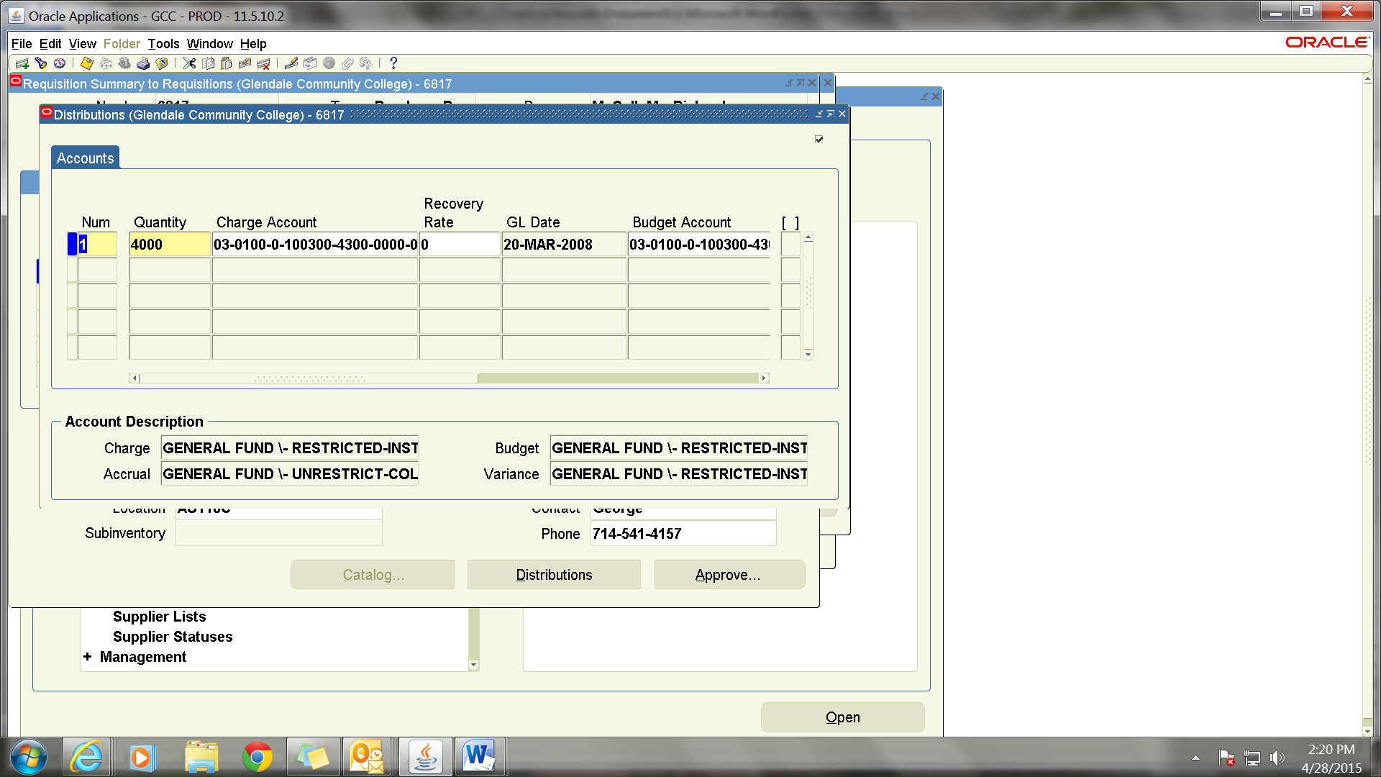

**Reviewing Entered Requisitions**

**If you are currently on a requisition page, click on the X at the top right in the blue shaded line. If you are logging in, click on the “Requisition Summary” responsibility. If you know the requsition number you can enter it in the “Requisition Number” field and click on find. If you do not know the number or want to review all your requisitions you can find it by the Preparer Name.**

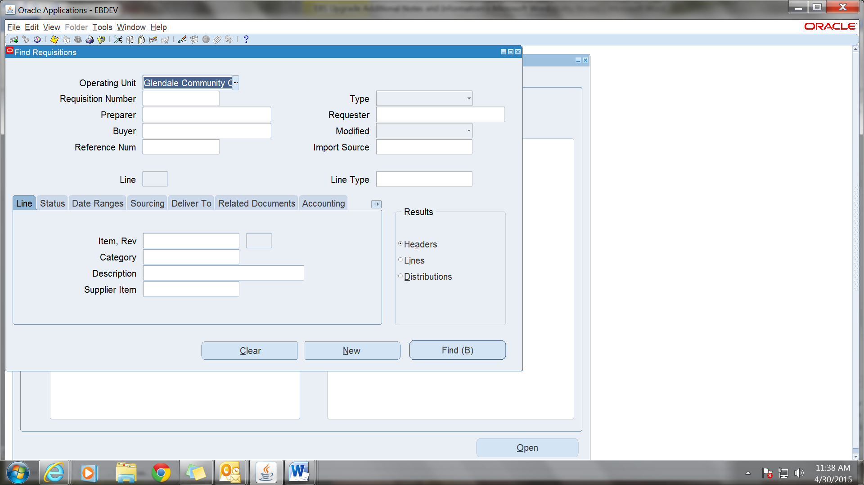

**Fill in the Preparer field with your name. You can do this by entering the first few letters of your last name and tab or by the % inquiry. When this field is entered, click on Find at the bottom.**

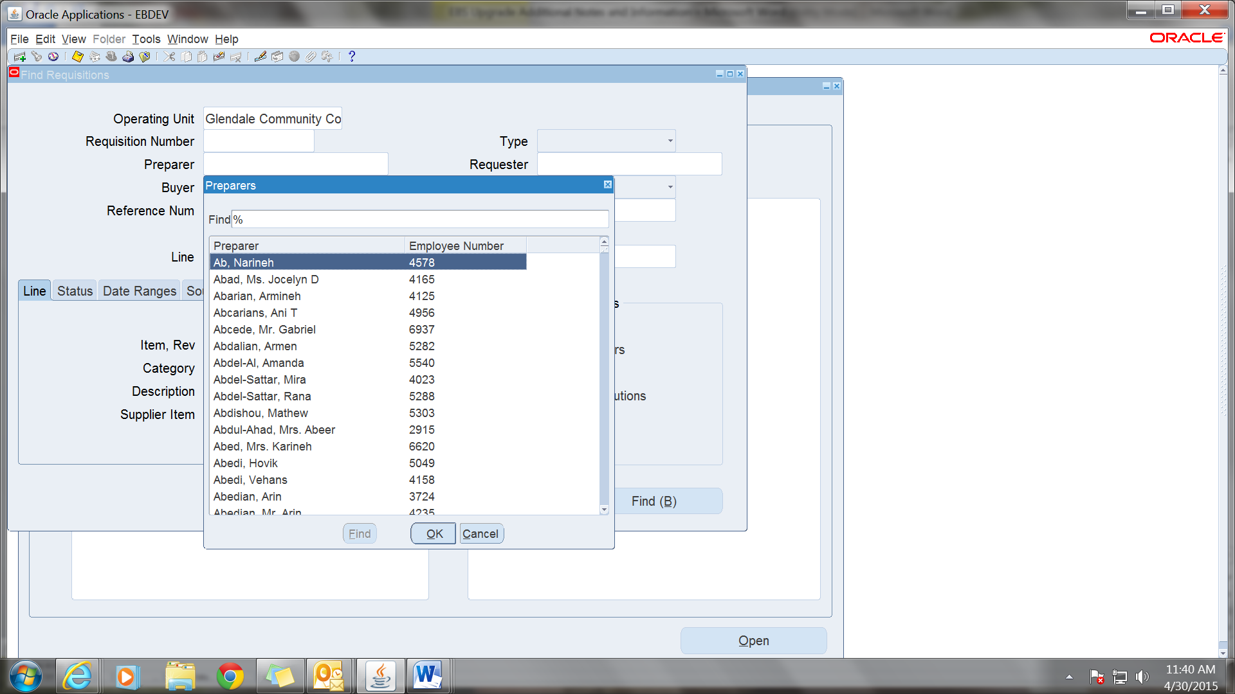

**You will see a list of all of your requisition on this summary and the status will show as Approved, Incomplete, or In Process.**

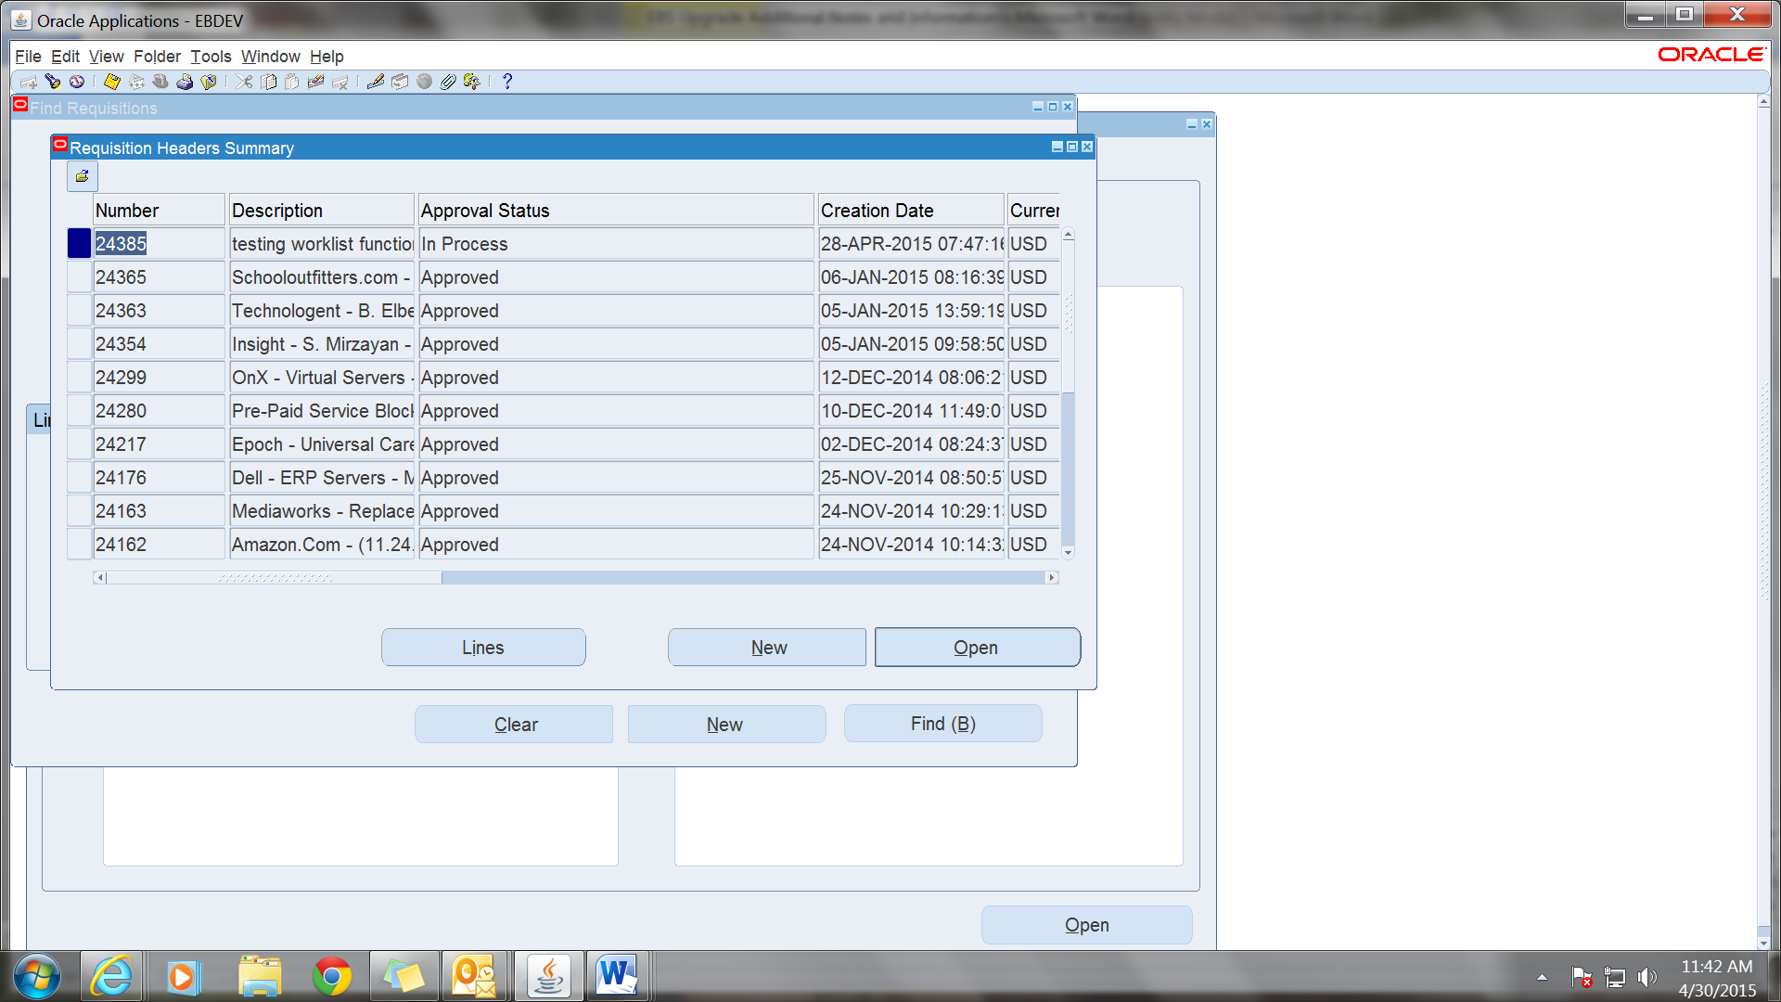

**To review, click on the Req you want to look at. You can click on lines to see the lines of the PO and by scrolling over you can see if there has been a PO issued and if so, the PO number.**

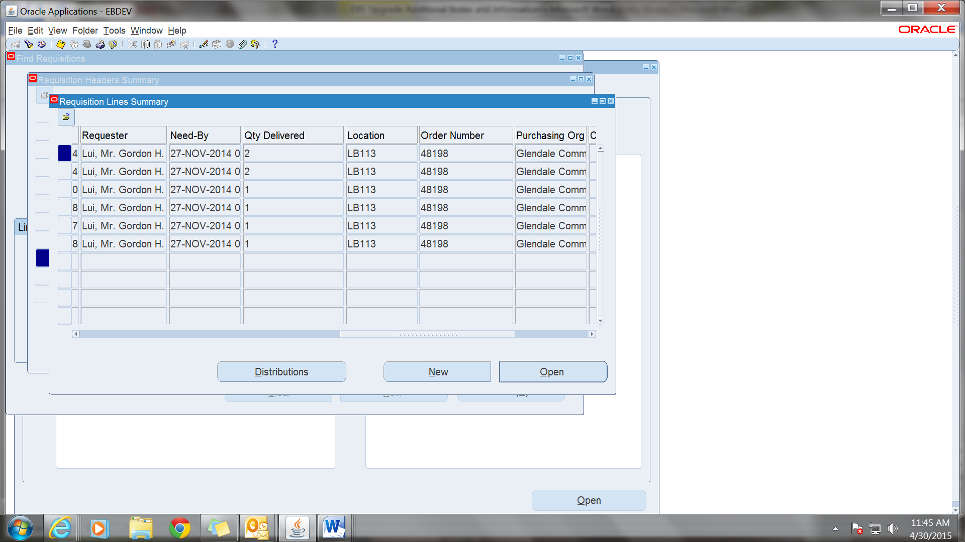

**You can also click on Distributions to see the account number for the requisition.**

**Click on the X to exit out of the pop up.**

**By Clicking on “Tools” in the toolbar at the top of the page you make other inquiries.**

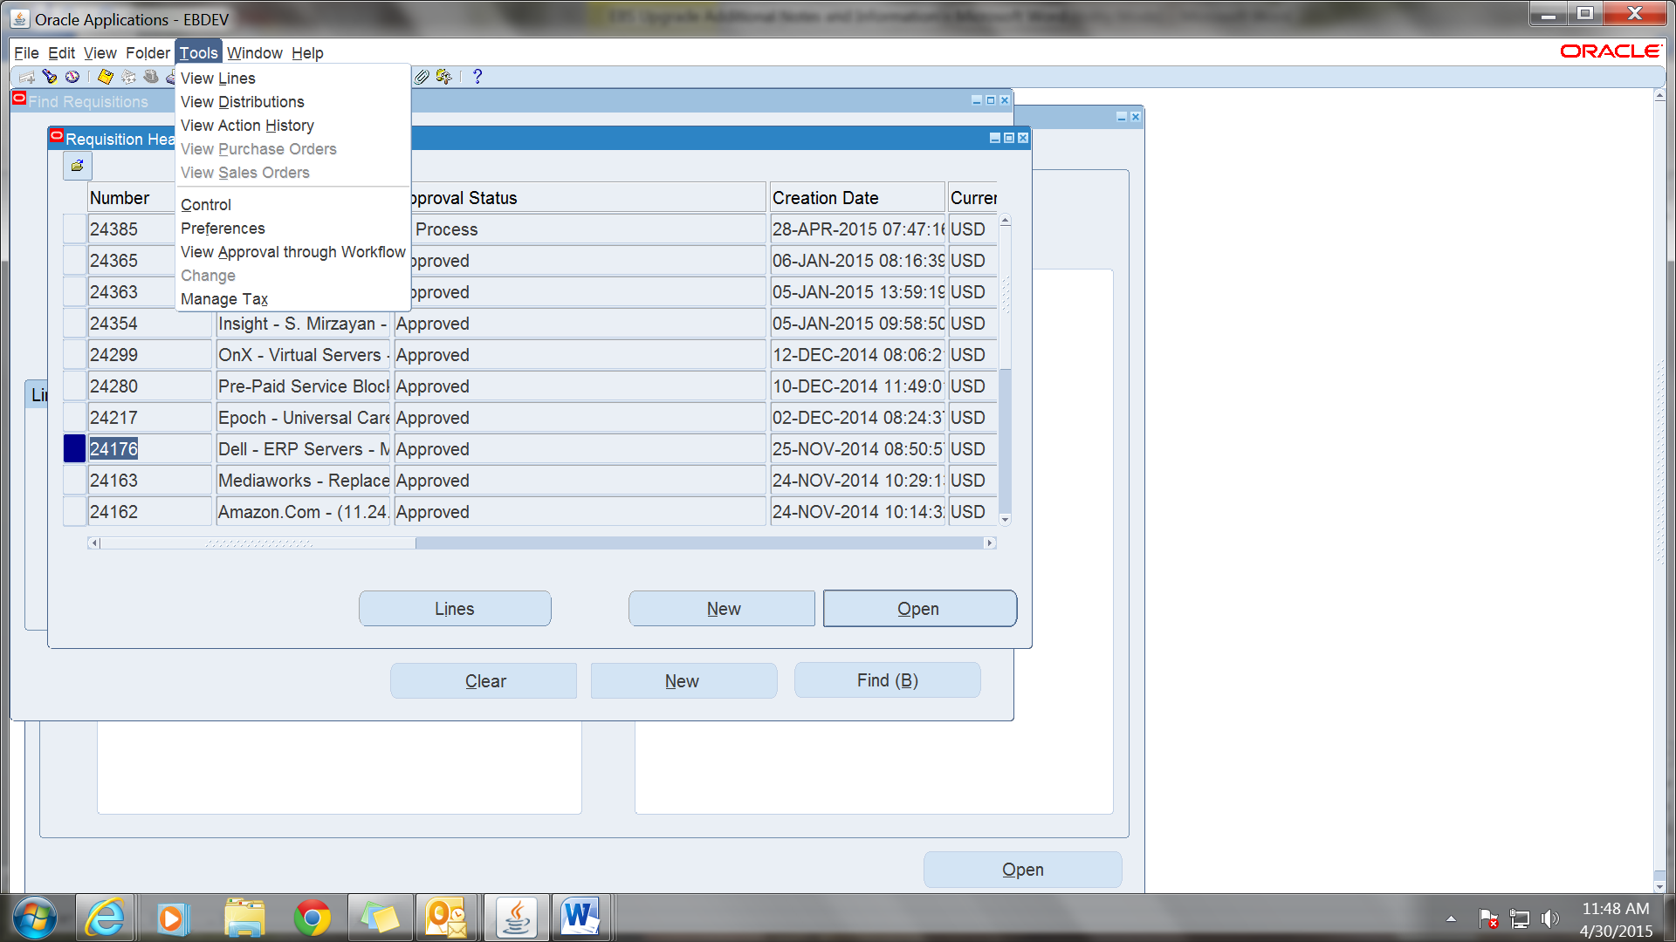

**You can also get to Lines and Distributions from here.**

**Also available is Action History which will tell you the approval history.**

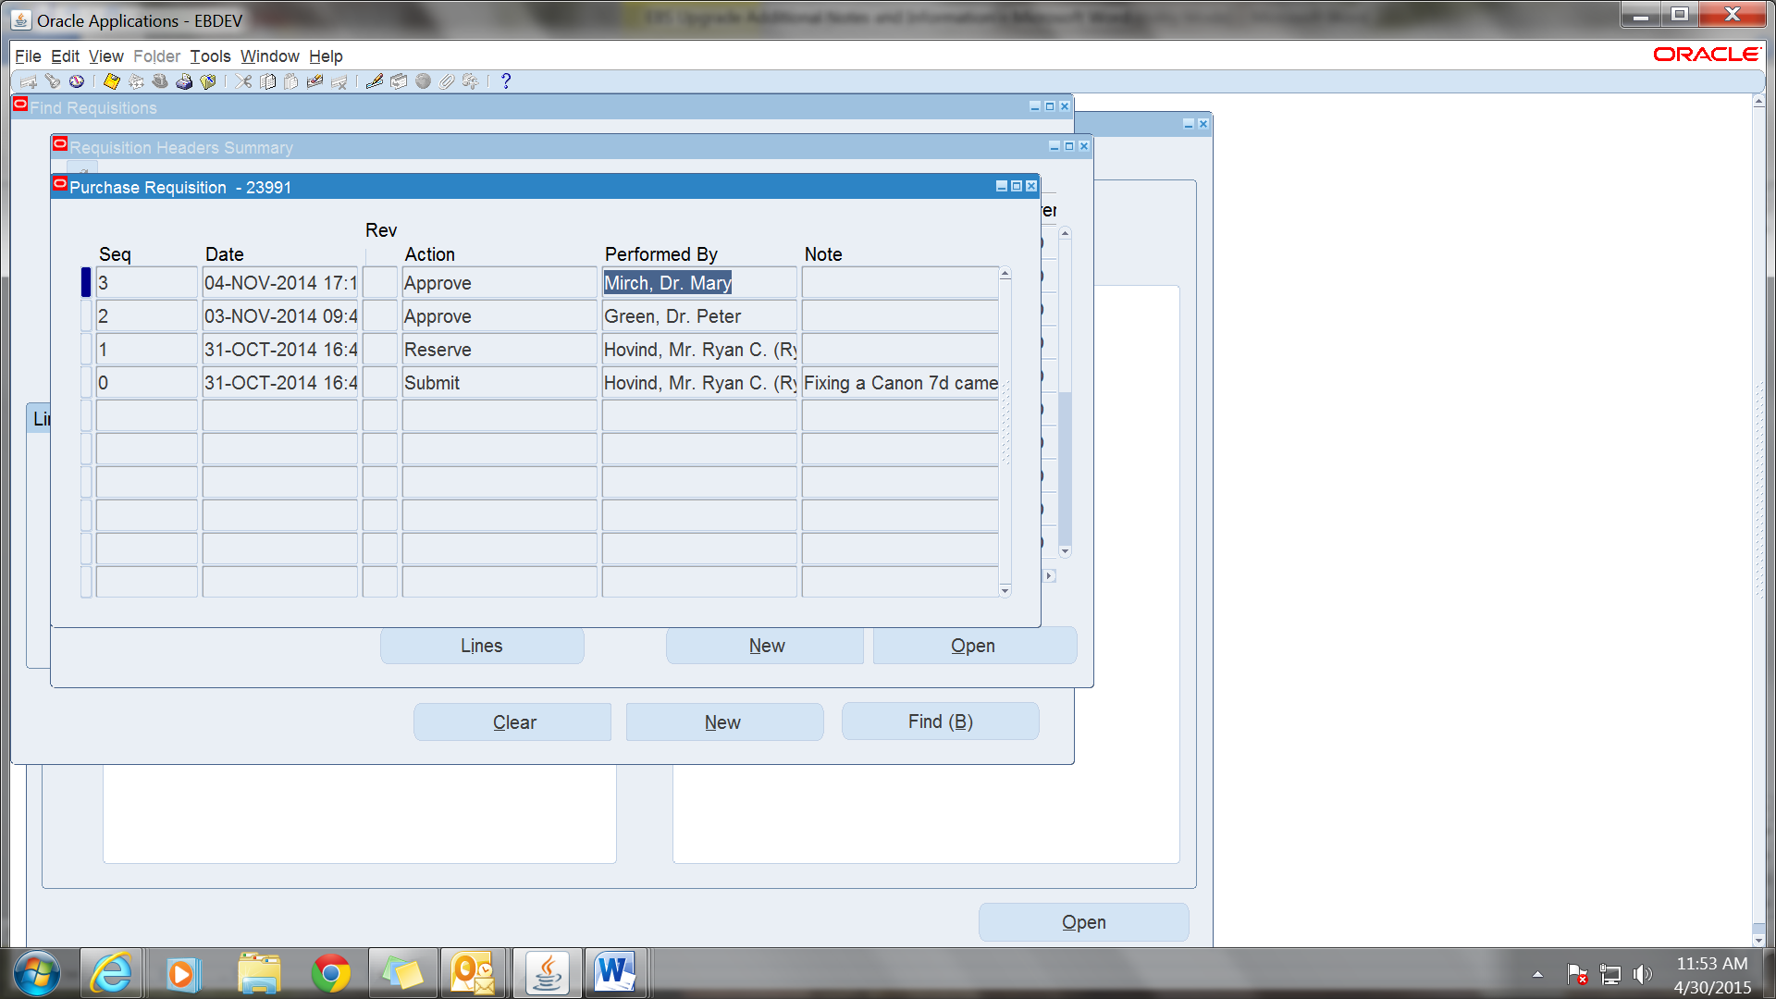

**Canceling a Requisition**

**Find the req you want to cancel and make sure you are clicked on the right line for that req.**

**Click on Tools then click on “Control”**

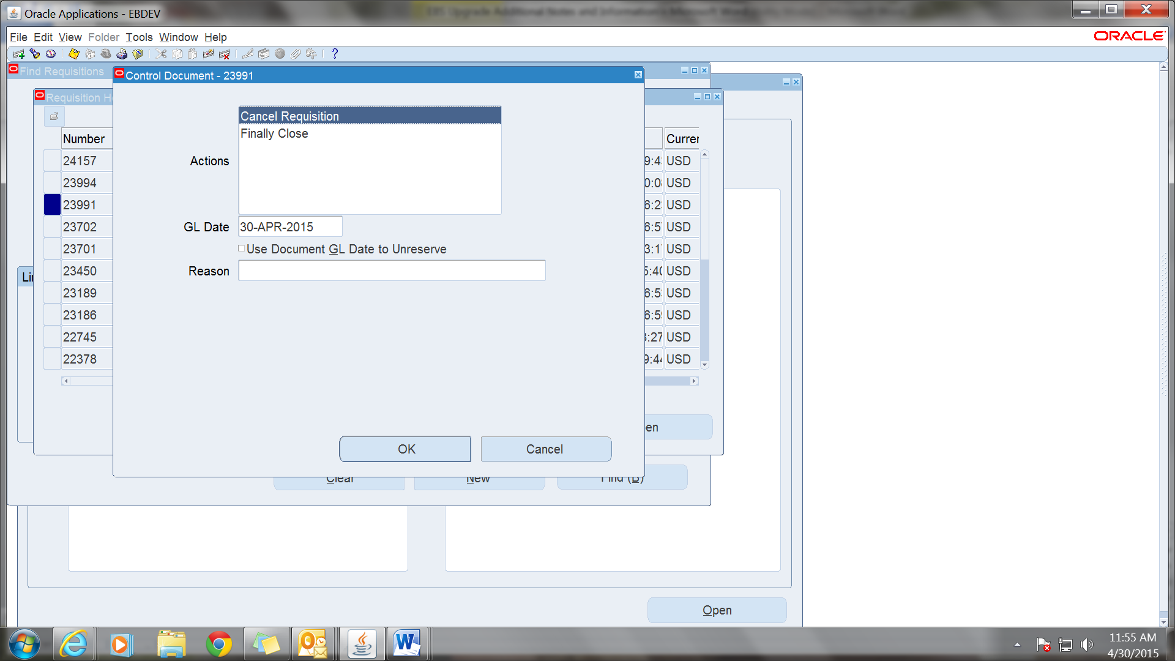

**If you want to enter a reason for the cancelation fill in that field with a brief description and then click on “OK” and then “Yes” when asked if you are sure.**

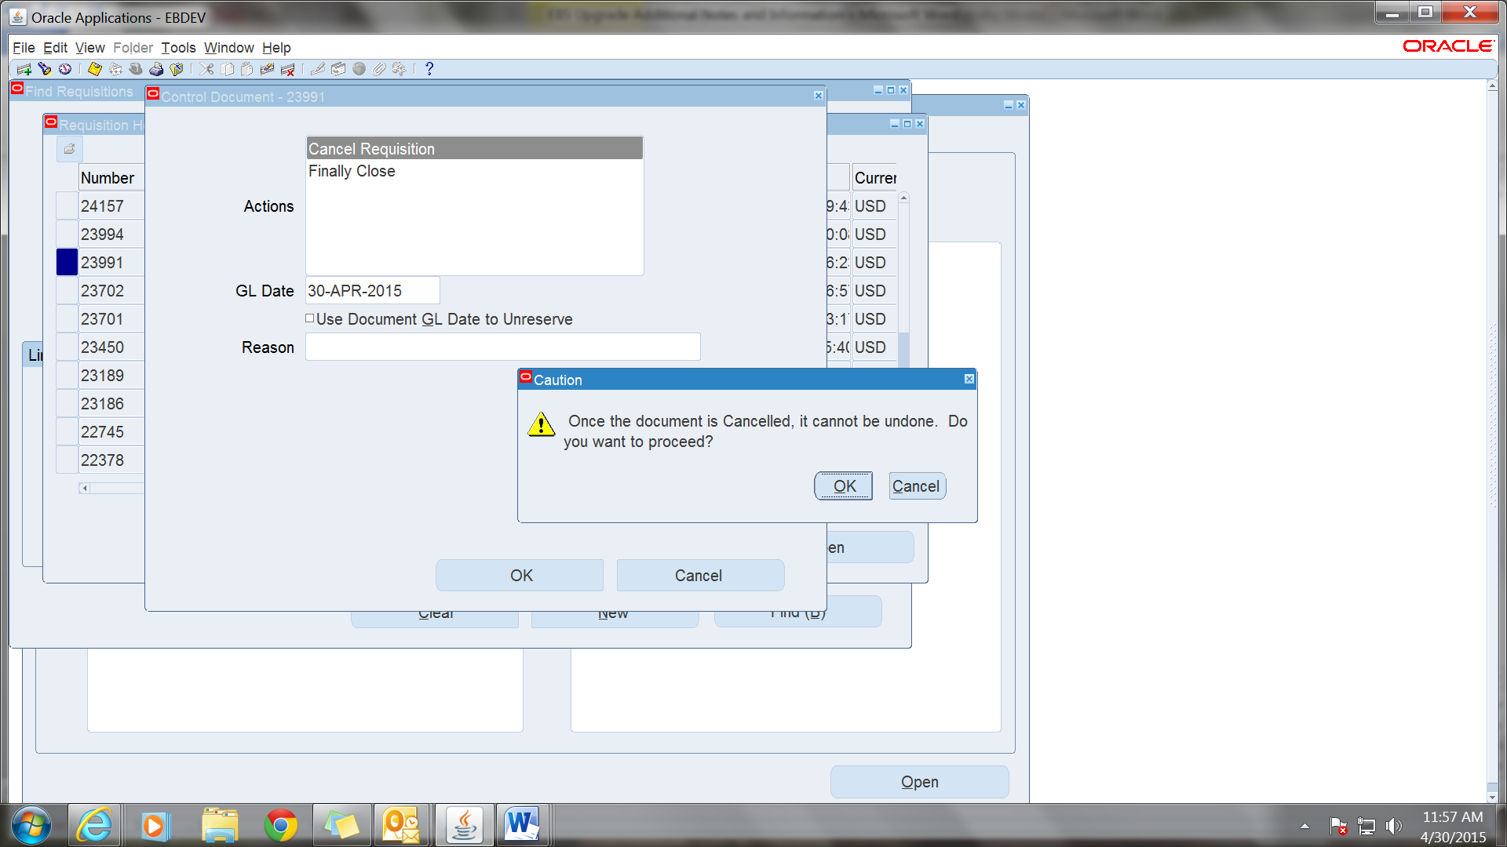

**By exiting out and going back in you can verify that the req has been canceled as the Approval Status will be changed from Approved or In Process to Canceled.**

