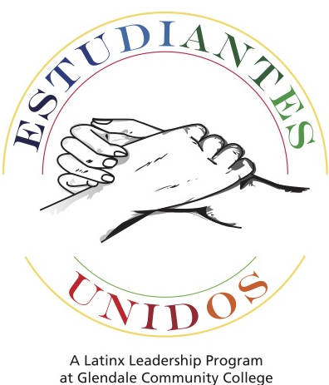
Estudiantes Unidos Application
2017-2018
A program of the Multicultural & Community Engagement Center
Please return this completed application to Sierra Madre 267
before SEPTEMBER 1, 2017.

Name: ___________________________________________________ ID#: ____________________________

Primary Phone Number: (____)_____________________ Alternate Phone Number: (____)____________________

GCC Email Address: ________________________________________________________________________
(Please write email address in ALL CAPS and the number “zero” as Ø)

Have you had any previous leadership training or experiences? If yes, what did you do and when did you participate?

__________________________________________________________________________________________

__________________________________________________________________________________________

__________________________________________________________________________________________

What would you like to learn/gain from this program? Please be as specific as possible.

__________________________________________________________________________________________

__________________________________________________________________________________________

__________________________________________________________________________________________

__________________________________________________________________________________________

Tell us a little about yourself (hobbies, activities on and off campus).

__________________________________________________________________________________________

__________________________________________________________________________________________

In your opinion, what is one or two important things college students need in order to be successful?

__________________________________________________________________________________________

__________________________________________________________________________________________

__________________________________________________________________________________________
How did you hear about the Leadership Academy?
□ Classroom Presentation □ Friend
□ Teacher Announcement □ Announcement on Campus/Email
□ Counselor Recommendation □ Other __________________

What high school did you attend/graduate from? __________________________________________________

- Tell us about yourself, focusing on significant events that have shaped your character/personality or life. You can add additional sheets, if you need more space.

Attach additional sheet, if needed.

____________________________________________ ________________________
Signature Today’s Date

By signing this form, you acknowledge that the Multicultural & Community Engagement Center can: (1) share your contact information with other participants in the program and, (2) use the information provided to contact you about the program. Your information will not be shared or used for any other purposes.

