**Vision Screening**

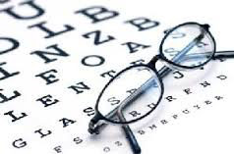

**Date**: July 17, 2017

**Time**: 9:00 AM – 1:00 PM

**Place**: GCC Plaza

**Services Included:**

* Free Refraction/Determination of Eyeglass Rx
* Contact Lens Fit/Determination of Contact Lens Rx (with fee)
* Eyeglass and Sunglass On-Site Frame Purchase
* Rx Orders for Eyeglasses and Sunglasses
* Screening/Education on Eye Diseases (ex: diabetes, glaucoma, etc.)
* Custom Computer Rx for Eyestrain and Fatigue
* Appropriate Referrals to Eye Specialists (if needed)
* Student/Faculty Discounts on Online Orders/Purchases

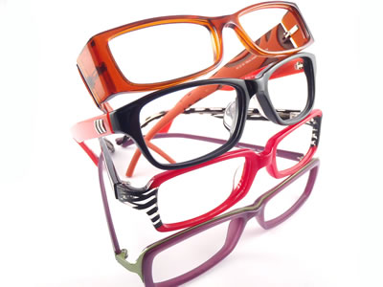**Join us, Students and Faculty! We will make sure all your eye-related needs are met!**

**Eye Care Optics**

804 S. Victory Blvd.

Burbank, CA 91502

818-842-4747

www.eyecareoptics.com