**Lab: Unit Circle *(Instructor Version)***

*This lab is meant to be a discovery lab and should be done after right triangle trigonometry but before Section 6.1.*

*This lab is meant for students to work in pairs and turn in one packet per pair.*

**Motivation:** To not memorize the unit circle but to see the relationship between it and right triangle trigonometry.

**Objective:** To discover the coordinates on the unit circle for common angles and find relationships between those coordinates and the reference angle.

**Materials:** Three copies of the unit circle for each pair of students, protractor, straight edge and lab activity

*Have your students follow the steps below to discover the coordinates on the unit circle and determine a pattern. This lab should take about 20 minutes for each quadrant. So the total lab should take about 90 minutes including a discussion at the end for questions 7 and 8.*

1. Use the fact that the unit circle has equation $x^{2}+y^{2}=1.$
   1. What is the center of the unit circle? __________
   2. What is the radius of the unit circle? __________
2. Determine the coordinates of the points where the unit circle intersects the $x$- and $y$-axis.
3. 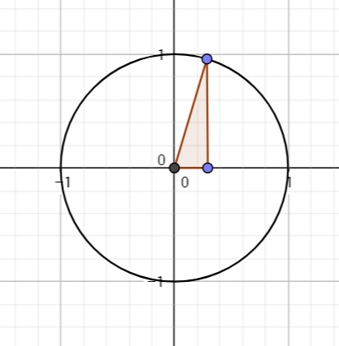Use your protractor and straight edge to draw a $45°-45°-90°$ triangle inscribed in Quadrant 1 of the first unit circle with a $45°$ angle at the origin and the $90°$ on the $x$-axis. (An example of what it should resemble is on the right.)
   1. Using what you know about right triangle trigonometry, find the lengths of the sides of the triangle (remember that the unit circle has radius 1).
   2. What can you say about the coordinate of the point where the triangle intersects the unit circle? Label the point on your Unit Circle.
4. Use your protractor and straight edge to draw a $30°-60°-90°$ triangle inscribed in Quadrant 1 of the second unit circle with the $30°$ angle at the origin and the $90°$ on the $x$-axis.
   1. Using what you know about right triangle trigonometry, find the lengths of the sides of the triangle (remember that the unit circle has radius 1).
   2. What can you say about the coordinate of the point where the triangle intersects the unit circle? Label the point on your Unit Circle.
5. Use your protractor and straight edge to draw a $30°-60°-90°$ triangle inscribed in Quadrant 1 of the third unit circle with the $60°$ angle at the origin and the $90°$ on the $x$-axis.
   1. Using what you know about right triangle trigonometry, find the lengths of the sides of the triangle (remember that the unit circle has radius 1).
   2. What can you say about the coordinate of the point where the triangle intersects the unit circle? Label the point on your Unit Circle.
6. Repeat steps 3-5 with Quadrants 2, 3 and 4. Put all the $45°-45°-90°$ triangles on the same unit circle used in step 3. Put all the $30°-60°-90°$ triangles with the $30°$ angle at the origin on the unit circle used in step 4. And finally, put all the $30°-60°-90°$ triangles with the $60°$ angle at the origin on the unit circle used in step 5.
7. ***TPS***Do you see a pattern between the triangles you drew and the corresponding coordinates? Explain the relationship.
8. ***TPS*** Based on what you know about right triangle trigonometry, which trigonometric functions do the $x$-coordinate and $y$-coordinate of the point on the unit circle represent? Why?