- Issue #4  October 2018  Featured Workshops  First Fridays at @ONE  A one-hour, online, synchronous workshop in various topics each first Friday of the month.  Register Free:  http://onlinenetworkofeducators.org/first-fridays/  @ONE Facilitator  Online + Synchronous  Friday, October 5th  3 Sessions: 11a/12p/1p  NEW GADER Policy!  GADER is now Due March 15, 2019!  Please review the new GADER Policy:  https://tinyurl.com/GADER-POLICY  GADER Approved List: https://tinyurl.com/GCC-GADER | DE @ GCC!  Become Distance Education Certified!  GCC is proud to offer GCC Faculty a free, 4-week, fully online DE Certification course in partnership with the @ONE Teach-the-Teacher Training Program  --------------------  Next Classes: Oct. 22nd and January 14th!  Register right away: https://tinyurl.com/DE-Certification  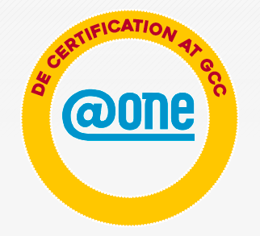  (Completing this IOTL course will earn you 40 hrs of Flex 'OR' a 1.25 step-in-column raise)  ---------------------  GCC Canvas Sample Course Shell  The Glendale Community College "Committee on Distance Education" (CoDE) has put together this course shell based upon effective course design elements for use in a face-to-face, hybrid or online course environment.    This shell is available to you to explore, tinker with, adapt and adopt, if you would like.  Now Available for Download on Canvas Commons!  Log into Canvas: https://gcc.instructure.com/  ---------------------  NEW FALL GADER WORKSHOPS SCHEDULE IS HERE!  View all the great opportunities to learn:  https://tinyurl.com/GCC-GADER  Contact Me with GADER Questions!  Instructor Julie Gamberg  defacdev@glendale.edu  (818) 240-1000 x5345  Faculty Innovation Center (SV)    Recertification (GADER) + Course Design + Pedagogy + Workshops + PEER COURSE REVIEW + OEI

