- Issue #7  February 2019  Featured Workshops  First Fridays at @ONE  A one-hour, online, synchronous workshop in various topics each first Friday of the month.  Register Free:  http://onlinenetworkofeducators.org/first-fridays/  “Creating a Sense of Belonging”  Online + Synchronous  Friday, February 1st  2 Sessions: 11a/12p  NEW GADER Policy!  GADER is now Due March 15, 2019!  Please review the new GADER Policy:  https://tinyurl.com/GADER-POLICY  GADER Approved List: https://tinyurl.com/GCC-GADER | DE @ GCC!  Spring 2019 COMMUNITY OF PRACTICE (CoP)  https://tinyurl.com/GCC-GADER    Join Julie and the DE Superstar Team in the Faculty Innovation Center (SV – 1st Floor) for DE collaboration and training with your colleagues!  The GCC DE CoP is a way of deepening the learning that we do together in DE pedagogy and practice, and in deepening the connection between GCC faculty who teach online, as well as connecting us to practitioners around the state.  Become Distance Education Certified!  GCC is proud to offer GCC Faculty a free, 4-week, fully online DE Certification course in partnership with the @ONE Teach-the-Teacher Training Program  2019: April 22, July 22, Sept. 30!  Register right away: https://tinyurl.com/DE-Certification  (Completing this IOTL course will earn you 40 hrs of Flex 'OR' a 1.25 step-in-column raise)  GCC Canvas Sample Course Shell  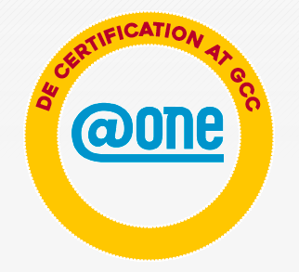  The Glendale Community College "Committee on Distance Education" (CoDE) has put together this course shell based upon effective course design elements for use in a face-to-face, hybrid or online course environment.  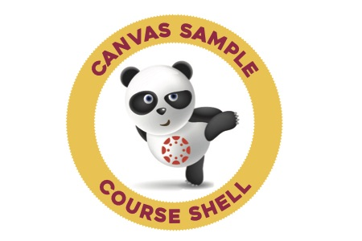  This shell is available to you to explore, tinker with, adapt and adopt, if you would like.  Now Available for Download on Canvas Commons!  Log into Canvas: https://gcc.instructure.com/  Connie Lantz (clantz@glendale.edu) can also set-up a Sample Shell for you if you email a request!

