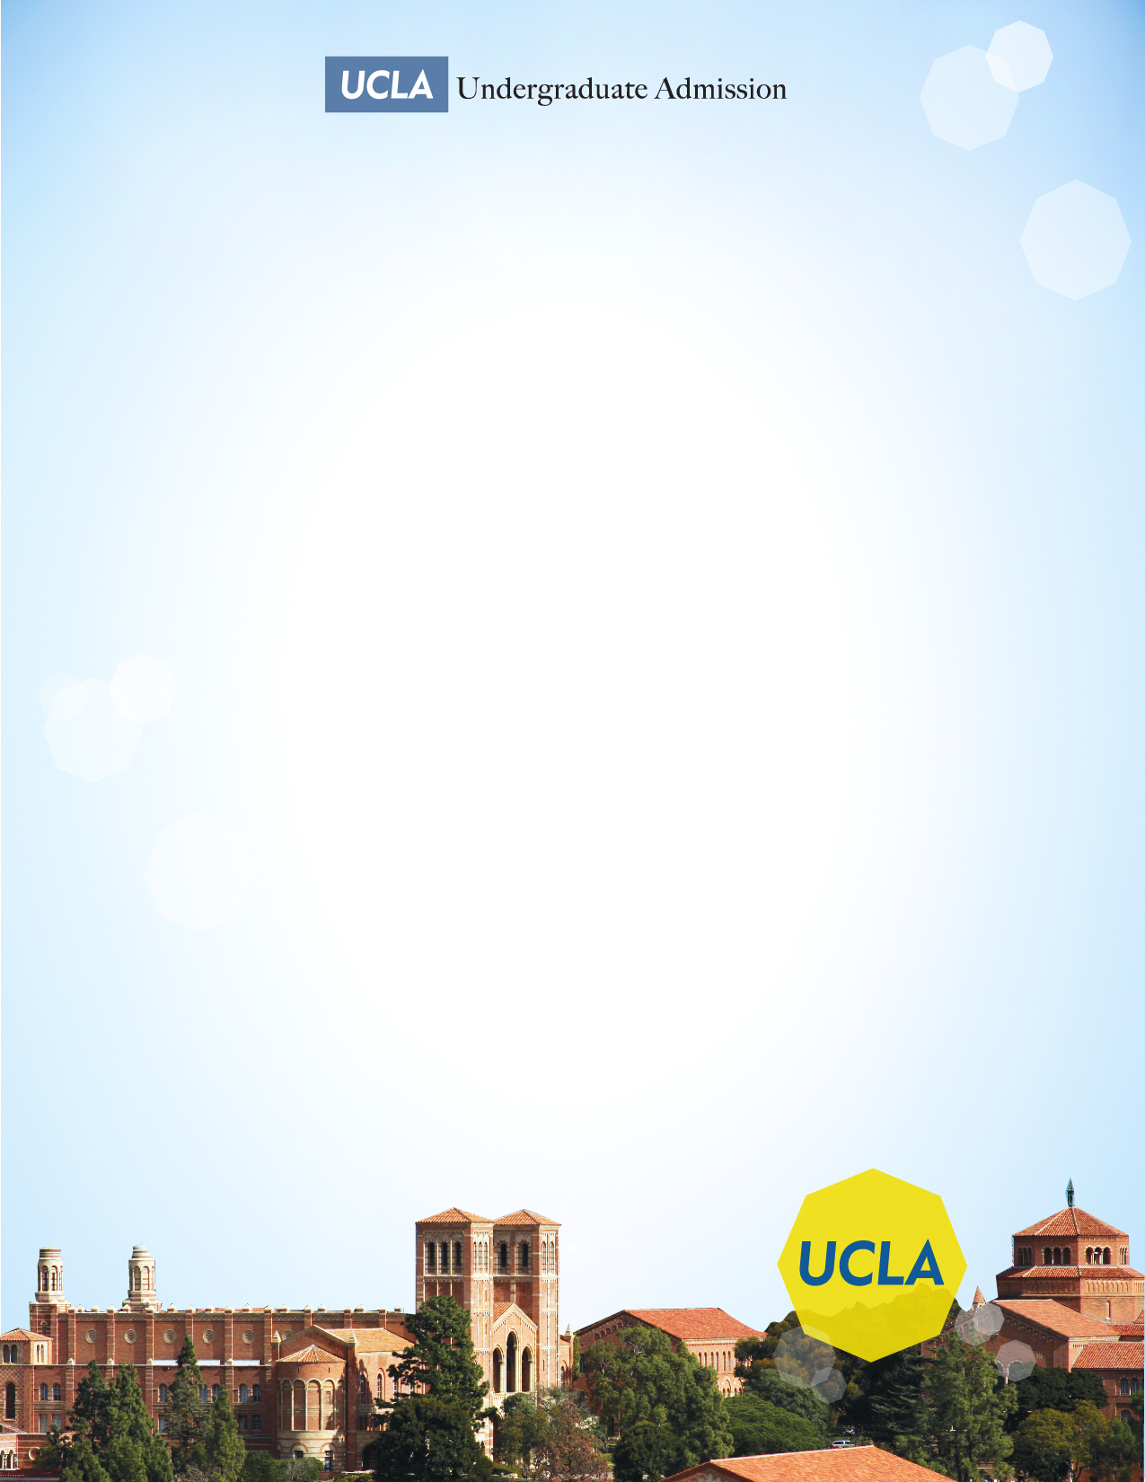**UCLA**

**TRANSFER ADMISSION WORKSHOP**

Come meet your representative from the UCLA Undergraduate Admission office, learn all about admission requirements and major selection, and discover what an application reader looks for in a competitive applicant!

**Wednesday, March 27, 2019**

**12:00PM-1:30PM**

**Glendale Community College**

**Transfer Center**

Sierra Vista Building 3rd floor

­­