- Issue #10  - May  2019  Featured FREE Courses  FREE @ONE  New Self-Paced  Courses!  Canvas Accessibility  *Microsoft Word  *PowerPoint  *Video Captioning  *PDF Creation  Register Free:  https://catalog.onlinenetworkofeducators.org/  FREE New @ONE  Self-Paced  Intro. to Teaching with Canvas  Register Free: https://tinyurl.com/self-paced-canvas  NEW GADER Policy!  GADER is Due March 15, 2020!  Please review the GADER Policy:  https://tinyurl.com/GADER-POLICY  GADER Approved List: https://tinyurl.com/GCC-GADER | DE @ GCC!  3-2-1 Go!  https://tinyurl.com/gcc-3-2-1-go  Julie Gamberg has created 10 fantastic videos  Ten Snazzy Videos to Help You Build an Online Class!  Become Distance Education Certified!  GCC is proud to offer GCC Faculty a free, 4-week, fully online DE Certification course in partnership with the @ONE Teach-the-Teacher Training Program  July 22 (9 Slots Left!) + Sept. 30!  Register right away: https://tinyurl.com/DE-Certification  (Completing this IOTL course will earn you 40 hrs of Flex 'OR' a 1.25 step-in-column raise)  UPDATED Canvas Sample Course Shell  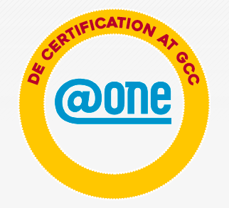    The Glendale Community College "Committee on Distance Education" (CoDE) has put together this course shell based upon effective course design elements for use in a face-to-face, hybrid or online course environment.    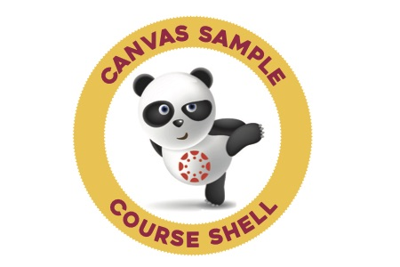  This shell is available to you to explore, tinker with, adapt and adopt, if you would like.  Now Available for Download on Canvas Commons!  Log into Canvas: https://gcc.instructure.com/  Connie Lantz (clantz@glendale.edu) can also set-up a Sample Shell for you if you email a request!

