Course Design Academy!  https://tinyurl.com/gcc-cvc-oei  Do You Want to Improve Your Online Course So It Can Be Offered Through The CVC-OEI?  HOW TO JOIN THE COURSE DESIGN ACADEMY THROUGH GCC!  - DE Coordinator  Alexa Schumacher, Ph.D.  de@glendale.edu  818-240-1000, x5298  Faculty Innovation Center (SV112)  http://glendale.edu/online | One of the many benefits of GCC becoming apart of the CVC-OEI as a Consortium College is the ability to ascertain OEI endorsed Canvas Tools for optional use for faculty!  Learn about all these new tools:  https://cvc.edu/ecosystem/  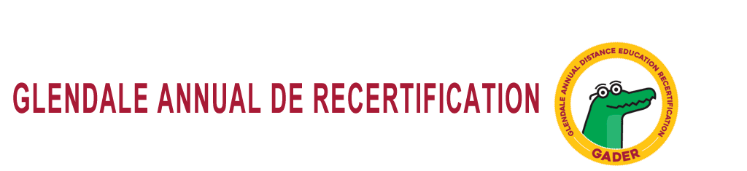  DE Community of Practice…How does it work?  The Distance Education Community of Practice (CoP) at GCC is organized within a Canvas course of the same name. All DE certified faculty have been added to the course. If you do not see the course or your dashboard, contact defacdev@glendale.edu to be added.  All Community of Practice (CoP) Modules have 3 Parts:  I. Read or Watch something in advance of meeting (in the Canvas course)  II. Discuss something in advance of meeting (in the Canvas course)  III. Meet face-to-face (in the Faculty Innovation Center, SV 105; participation by Zoom welcome)!  You will be awarded 3 hours of GADER for each Module.  If you cannot come to the meeting, you can still be awarded 2 hours of GADER; however, you cannot be awarded GADER for attending the face-to-face meeting without doing the online meeting work in advance.  -----------------------------------------------------------------  @ONE Professional Development for GADER  You may take a professional development course at @ONE.  These @ONE courses are high quality professional development, and you are strongly encouraged to consider taking one or more if you plan to continue teaching online.  http://onlinenetworkofeducators.org/pd/registration-introduction/  -----------------------------------------------------------------  Need Canvas Tech Support?  https://tinyurl.com/CanvasTechSupport
Page 2

