|  |  |
| --- | --- |
|  | **Summer 2019** |
|  |  |

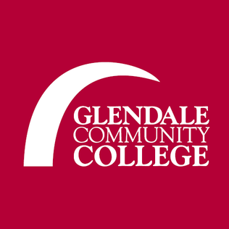

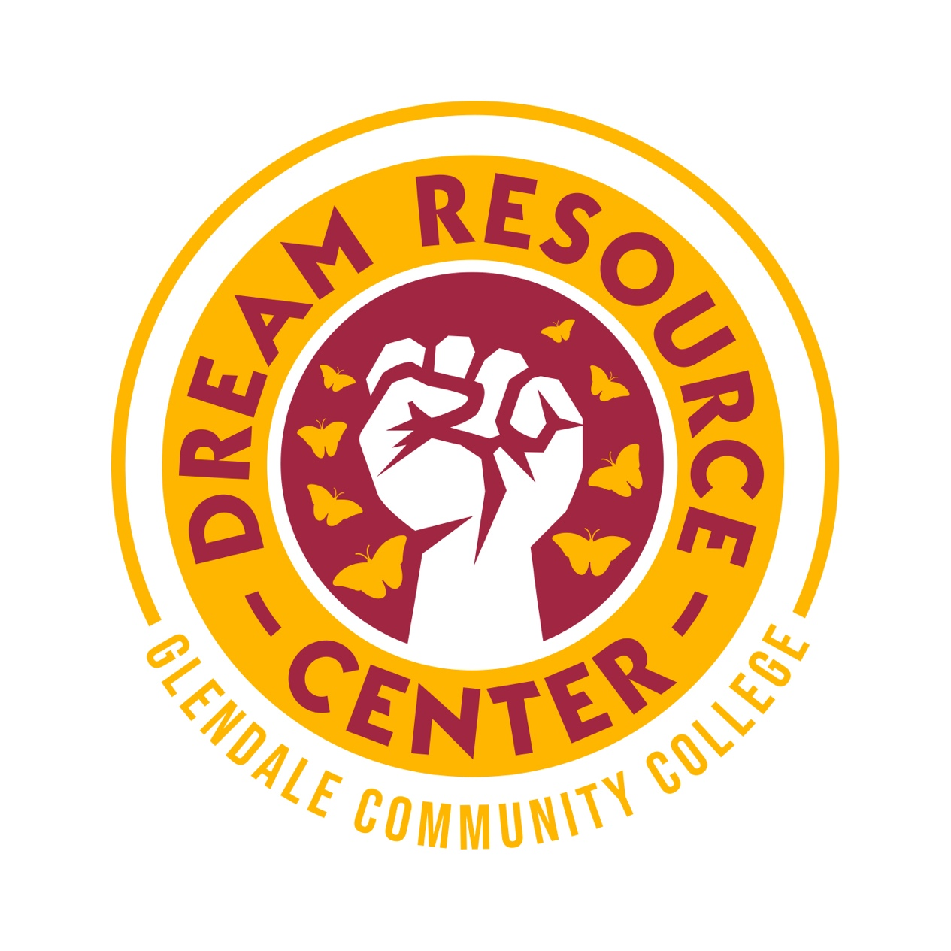

**Sierra Madre Building (SM267)**

**Email: GCCDreamers@Glendale.edu**

**(818) 240-1000 ext.5810**

**Food Pantry**

**GCC Food for Thought Pantry (Glendale Students Only)**

Verdugo Campus Food Pantry is located in SR 133 (Walk through the hallway marked SR 134 on the first floor of San Rafael.) The Garfield Campus Pantry is located in TR 207. The Food for Thought Pantry is open to any currently enrolled GCC student who completes a short application.

<https://www.glendale.edu/students/student-services/the-gcc-food-for-thought-pantry>

**Catholic Charities: Loaves and Fishes**

4322 San Fernando Road, Glendale, CA 91204

Pantry Hours: 10am-3pm M-W and F   
Phone: (213) 251-3512  
Fax: (818) 956-1857

[www.catholiccharitiesla.org](http://www.glendaleca.gov/?splash=https%3a%2f%2fcatholiccharitiesla.org%2f&____isexternal=true)

Clients must live in certain areas to get services (Glendale, Burbank, Eagle Rock, Highland Park, Atwater, and part of Sunland) call and ask if they serve your zip code. Loaves and Fishes provide immigration assistance and food pantry services. Bring picture ID, SS card, proof of address, children's birth certificates, and proof of income.

**Burbank Temporary Aid Center (Food Pantry is once a month)**

1304 W. Burbank Blvd. Burbank, CA 91506  
Phone: (818) 848-2822  
Fax: (818) 848-0842

<http://www.burbanktemporaryaidcenter.org/>

BTAC provides clients a variety of programs and services including: Groceries from BTAC's Food Pantry. Daily sack lunches for the homeless. Assistance with utility bills. Transportation assistance. ID/License replacement program. Limited medical assistance. Burbank Residents Only!

**Meet Each Need with Dignity (MEND)**

Food Box Distribution

Thursday: 8:00 am – 2:00 pm

Friday: 8:00 am – 2:00 pm

Saturday: 9:00 am – Noon

<https://mendpoverty.org/programs/emergency-food-bank>

10641 N. San Fernando Road, Pacoima, CA 91331   
(818) 897-2443

MEND’s Emergency Food Bank is unique in that it is the largest in Los Angeles providing direct distribution to clients in need, and one of the largest in the state of California. Emergency food boxes provide a generous, nutritionally balanced three-day supply of emergency food, designed to help the families make ends meet, but not to create a dependency on MEND.

**Resurrection Church Foodbank**

3324 E. Opal St, Los Angeles CA. 90023

323-268-1141

<http://www.resurrectionla.com/>

Resurrection Church is an East Los Angeles landmark. Serving the East Side since 1923, Church food bank serves mainly fruits and vegetables provided by local markets.

**World Harvest Food**

3200 S. Grand Ave. Los Angeles, CA. 90005

213-746-2227

Established in 2007, World Harvest Food Bank is a non-profit organization that provides food to people who are at risk of hunger.

**Clothing Centers**

**The Salvation Army (Closet for the Needy)**

801 S. Central Avenue, Glendale, CA 91204

Pantry Hours: 1-4pm M-F  
Phone: (818)246-5586  
Fax: (818) 246-2419

[www.glendale-ca.salvationarmy.org](http://www.glendaleca.gov/?splash=http%3a%2f%2fglendale-ca.salvationarmy.org%2f&____isexternal=true)

Individuals can receive free clothing from the South Corps. There are coats, children's clothes, women's and men's attire.

**Volunteer League of the San Fernando Valley (Clothes Center**

14603 Hamlin St., Van Nuys, CA 91411

818-785-4134

Providing a basic wardrobe of essential clothing to underprivileged children enrolled in schools in the San Fernando Valley. The clothes center is currently the only non-profit that provides the complete clothing needs (school uniforms, backpacks, and hygiene kits) of the LAUSD children grades from K-12 and LAUSD Homeless Ed Department to middle school and high school students. By appointment only

<http://www.volunteerleague.com/centre-clothes-corner>

**Meet Each Need with Dignity (MEND) Clothing Center**

10641 N. San Fernando Road, Pacoima, CA 91331   
(818) 897-2443

MEND’s Clothing Center is set up like any mall shop with attractive window displays and well-organized clothing for men, women and children. Clients are welcome to a monthly allotment of clothes for each family member.

**Please Note**

* A donation of $5.00 is requested
* Please bring a picture ID, proof of current address and proof of income.
* Clients can receive assistance once every 30 days (once monthly only).
* For more information please contact Veronica Soto at 818-686-7328 or [veronica@mendpoverty.org](javascript:;) or <https://mendpoverty.org/programs/clothing-center>

**Healthcare & Mental Wellness**

**Glendale College Health Center** (GCC Students Only)

A Registered Nurse is available dailyfor health assessment on a walk-in basis.

Daily services include: First aid, blood pressure screenings, and over-the-counter medications.  
Seasonal Flu Shots $15 for students, $20 for GCC Staff

By appointment: Personal/Mental Health counseling and Medical Doctor visits weekly.

<https://www.glendale.edu/students/student-services/health-center/daily-services>

**Mi Salud L.A.**

My health L.A. is no-cost health care program for low-income residents, 6 years old and older, who don’t have health insurance, regardless of immigration status. My Health LA members get FREE basic medical care at one of the 164 non-profit clinics that are “Community Partners.” People can call the clinics to make an appointment to enroll and to check if the clinic is accepting new patients. My Health LA provides children, families, and single adults in Los Angeles County a medical home, where patients can get primary care from doctors and nurses who understand their medical history.

<http://dhs.lacounty.gov/wps/portal/dhs/mhla>

**Bienvenidos Mental HealthCare**

323-869-9255 ext. 231

<http://bienvenidos.org/bienvenidos-programs/mental-health>

Bienvenidos fulfills its mission by delivering a comprehensive array of services that empower children and their families.

**Via Care**

607 S. Atlantic Blvd. Los Angeles, CA. 90022

323-268-9191

<http://www.viacarela.org/>

Via Care is a non-profit federally qualified health center. Accepts everyone regardless of their insurance or financial/legal status. Must Bring a form of ID proof of address and proof of income if individual has one.

**Bienvenidos Mental HealthCare**

(323) 869-9255 ext. 231

<http://bienvenidos.org/>

Bienvenidos offers a wide variety of mental health and counseling services at multiple locations. Services include individual, family, and group therapy.

**Legal Assistance & Referrals**

**Catholic Charities Glendale Community Center**

4322 San Fernando Rd. Glendale, CA 91204  
(213) 318-5707

<http://www.catholiccharitiesla.org>

Immigration Services to assist clients apply and complete citizenship process. Offers life skills workshops, employment services, senior services, nutrition training, microenterprise development and home based childcare training to refugees, asylees, and human trafficking survivors.

**Neighborhood Legal Services of Los Angeles County**

1102 E. Chevy Chase Dr. Glendale, CA 91205

(800) 433 – 6251

http://www.nlsla.org

Provides free legal services to low income families such as housing, immigration, labor, consumer, family and government benefits i.e.: food stamps, Social Security, Medicare, Medi‐Cal related health care.

**Housing Rights Center- Fair Housing Services**

3255 Wilshire Blvd., Suite 1150 Los Angeles, CA 90010  
(800) 477 – 5977 Toll free

http://www.hrc‐la.org

Nonprofit that provides information & counseling regarding landlord & tenant issues. Investigates housing discrimination complaints. Offers monthly vacancy listings. Fair housing counseling and educational services. Mediation program for Pasadena residents. Call for walk‐in clinic hours. Spanish, Mandarin, Korean, Armenian, Russian spoken.

**CHIRLA**

Coalition for Humane Immigration of Los Angeles

2533 W. 3rd. Street ste. 101

Los Angeles, CA., 90057

(213) 353-1333

<http://www.chirla.org>

CHIRLA’s mission is to achieve a just society fully inclusive of immigrants. Offering various immigration services including DACA assistance.

**Asian American Advancing Justice Los Angeles**

1145 Wilshire Blvd, Los Angeles, CA. 90017

(213) 977-7500

<http://advancingjustice-aajc.org/>

Asian American Advancing Justice promotes equal protection by ensuring that civil and human rights are recognized and protected to create a more just America for all.

**Legal Aid Foundation of Los Angeles**

5228 Whittier Blvd. Los Angeles, CA. 90022

1 (800) 399-4529

<https://lafla.org/>

Legal Aid Foundation of Los Angeles seeks to achieve equal justice for poor and low-income people in greater Los Angeles. We change lives through direct representation, systems change and community education.

**Mil Mujeres**

448 S. Hill St. suite 815 Los Angeles, CA. 90013

(213) 568-4720

<http://www.milmujeres.org/>

Mil Mujeres is a non-profit organization providing legal services, community education, and empowerment to low-income Latino immigrants and their families in the United States. DACA and Visas included.

**Scholarships & Financial Assistance**

**Voices Organizing Immigrant Communities for Educational Success (V.O.I.C.E.S)**

Glendale Community College

Contact: [VoicesGCC@gmail.com](mailto:VoicesGCC@gmail.com)

V.O.I.C.E.S is a student club/support group aimed at promoting higher education for AB-540 students at Glendale College. Every semester V.O.I.C.E.S awards scholarships to AB-540 students who participate in club events.

**AB-540 Committee at Glendale Community College**

GCC Community Service Scholarship & DACA Renewal Scholarship

Contact: Greg Perkins at [gperkins@glendale.edu](mailto:gperkins@glendale.edu)

The goal of the Glendale Community College AB 540 Committee is to make the dream of higher education possible for undocumented California resident students. Every semester the AB-540 Committee awards scholarships for community service and DACA renewals ($495).

**Dream Resource Center (DRC) at Glendale Community College**

Sierra Madre Building (SM267)

Email: [GCCDreamers@glendale.edu](mailto:GCCDreamers@glendale.edu)

(818) 240-1000 ext.5810

The mission of the DREAM Resource Center at Glendale Community College is to support an inclusive campus culture and to empower undocumented students to achieve academic and personal pursuits and become active members of our communities. The DRC has an extensive scholarship list on the website and offers assistance with California Dream Act applications as well as AB 540 affidavits.

**MALDEF (Mexican American Legal Defense and Educational Fund) Scholarship Resource Guide**

National Headquarters 634 S. Spring Street, Los Angeles, CA. 90014

213-629-2512

<http://www.maldef.org/leadership/scholarships/>

The MALDEF Scholarship Resource Guide is a free, informative resource guide for students, parents, and educators with an extensive list of scholarships, including many that do not inquire about immigration status.

**Mexican American Opportunity Foundation (MAOF) Lending Circles**

401 N. Garfield Ave. Montebello, CA. 90640

(323) 890-9600

<http://www.maof.org/lending-circles/>

Mexican American Opportunity Foundation has partnered with San Francisco based Mission Asset Fund to bring lending circles, a social loan program to Los Angeles.

**Alterra Home Loans**

1968 W. Adams Blvd. Suite 101, Los Angeles, CA. 90018

(877) 845-4805

<https://goalterra.com/our-products/itin-products/>

I-TIN Loan Products are for people without a social security number looking to buy a home to live in the United States. These loans require higher down payment, but are a solid 30 year fixed mortgage.

**Online Resources and Support Groups**

**Dream Team Los Angeles (DTLA)**

Meetings every Tuesday at 6:30pm: Contact for current meeting location: (323) 795-5789

[info@dreamteamla.org](mailto:info@dreamteamla.org) and <http://dreamteamla.org/>

DREAM Team Los Angeles (DTLA) aims to create a safe space in which undocumented immigrants from the community and allies empower themselves through activism and life stories. DTLA is a grass roots organization that welcomes anyone who is interested in being part of the work, both in L.A. and nationally; we do as part of the immigrants’ rights movement.

**CHIRLA’s California Dream Network**

Contact: Melody Klingenfuss Statewide Organizer (CDN)

(213) 201-8708, [Melodyk@chirla.org](mailto:Melodyk@chirla.org)

<http://www.chirla.org/content/california-dream-network-cdn>

CHIRLA's California Dream Network is a statewide network of existing and emerging college campus organizations who actively address issues primarily affecting undocumented students and the immigrant community.

**United We Dream**

<https://unitedwedream.org/heretostay/>

United We Dream is largest immigrant youth-led community in the country. The goal of United We Dream is to transform fear into finding your voice. We empower people to develop their leadership, their organizing skills, and to develop our own campaigns to fight for justice and dignity for immigrants and all people. Sign-up for community meetings!

**211 LA County**

Phone: Dial 211

<https://www.211la.org/>

211 LA County is the central source for providing information and referrals for all health and human services in LA County.

**Emergency Living & Shelters**

**Ascencia**

1851 Tyburn Street, Glendale, CA 91204

(818) 246-7900

<http://www.ascenciaca.org/>

Forty emergency shelter beds are located onsite and are available to eligible families with children and adults for up to 60-90 days. There are no age limits or other restrictions. This program is not a drop-in shelter. There is usually a wait of at least a few days for a bed to become available. Priority is given to Glendale residents.

**Los Angeles Family Housing**

7843 Lankershim Blvd, North Hollywood, CA 91605

(818) 982-4091

<https://lafh.org/>

Bridge housing is temporary housing solution (previously referred to as “shelter” or transitional housing) for individuals and families as they work with case managers to move into permanent housing.

**San Fernando Valley Rescue Mission**

Located in Northridge, the new 90-bed family shelter offers hope, shelter and safe, supportive housing to thousands of families who are homeless. The new facility includes private family bedrooms, a commercial kitchen, common dining room and living spaces, meeting rooms, computer education center, playground and garden – all geared toward helping families achieve a

8756 Canby Ave. Northridge, CA 91325

(818) 785-4476

<https://sfvrescuemission.org/>