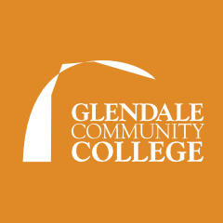

**We will be scheduling the next workshop soon.**

For more information and sign up please visit glendale.edu/Math 104E workshop.

**M104E WORKSHOP**

*(Required for all students coming from M103 taken prior to Fall 2019)*

* Covers material in Math 103E that was not in Math 103 (early transcendentals)
* Webassign based
* Has built in HW, quizzes, tests and the textbook
* Two weeks to complete the course with exams
* There will be a follow up support workshop to help with the content.

Did you take Math 103 prior to Fall 2019? Do you plan to take Math 104E?

Then you will need to complete a free workshop to prepare you for Math 104E.

**MATH 103 TO 104E TRANSITION WORKSHOP**