Performing Arts Day

Saturday February 15, 2020

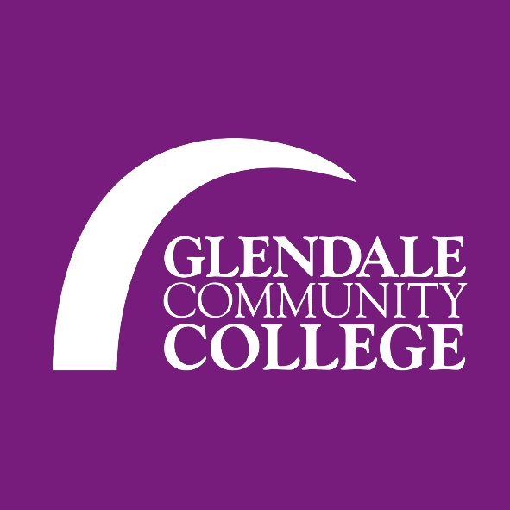

**Master Class Entry Form**

(to be completed by advisor)

Organization___________________________________________________________Middle/ Senior/ Studio

Address:___________________________________________________ Phone:_____________________________

City/Zip:____________________________________________________Cell:_________________________________

Advisor:_______________________________________ Email: ___________________________________________

|  |  |  |  |
| --- | --- | --- | --- |
| **Master Class** |  |  | **# of students** |
| Ballet Fusion Master Class  Victor Robles |  |  |  |
| Middle Eastern Dance Master Class  Tamra-henna Swan |  |  |  |
| Lecture: Dance as Protest & Political Activism  Kory Wicks |  |  |  |
| Jazz Dance Technique Master Class  Chelsea Asman |  |  |  |
| Salsa Workshop  Ani Hovhannisyan |  |  |  |
| Lecture: Dance on Film: The Integration of dance & technology  Koryn Wicks |  |  |  |
| Total # of students attending: |  |  |  |

E-mail Form to: [vrobles@glendale.edu](mailto:vrobles@glendale.edu)

Direct questions to: Victor Robles 818-240-1000 ext. 5494/ [vrobles@glendale.edu](mailto:vrobles@glendale.edu)

*Advisor listed on entry form will receive all notifications regarding the festival.*

If prefer to Mail, send to:**Glendale Community College (Attn: Victor Robles)**

**1500 N. Verdugo Road**

**Glendale, CA 91208**