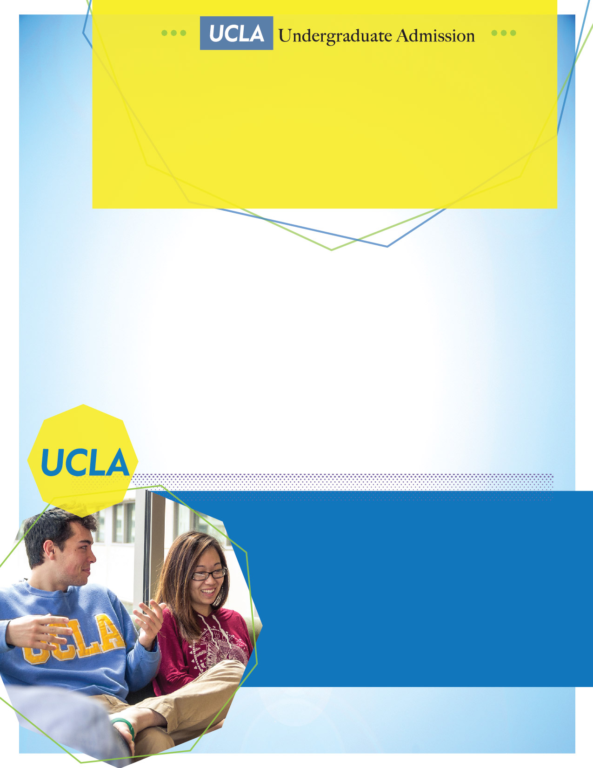

**UCLA Visit to Glendale Community College**

**March 30, 2020**

**9:00am–3:00pm**

**Glendale Community College**

**Transfer Center**

**\*April 6, 2020\***

**April 27, 2020**

Meet with UCLA’s Transfer Admission representative to learn more about transfer admission to UCLA!

**Glendale Community College**

**Transfer Center  
Sierra Vista Building, 3rd Floor**

**\*UCLA Transfer Admission Workshop**

**Monday, April 6th 12pm-1pm**