National Association  for the Education  of Young Children  https://www.naeyc.org/ | Has online classes for teachers and other resources.
https://www.ccrcca.org/ | Is a referral agency that offers help for child care, on-line training for teachers and many other resources.
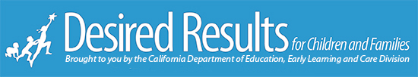  https://www.desiredresults.us/ | Has training webinars for DRDP instruction.
https://zoom.us/   | Has educational webinars that instruct on how to use Zoom for your classroom.
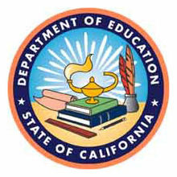California Department of Education  https://www.cde.ca.gov/ | Has webinars that provide mandates for the state of California.
Community Care licensing  https://www.cdss.ca.gov/inforesources/community-care-licensing | Has webinars, videos and other resources.
Resources for teachers

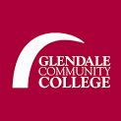  https://www.glendale.edu/ | Has many ongoing resources for teachers and students.
TED talks  https://www.ted.com/talks | Has many inspiring videos that spread ideas.

