# SZP Facilitator Cover V3.pngVersion 3

|  |
| --- |
| Version 3.0 |

Group Norms

# 1. Be Smarter than Your Phone

No matter how good you are at multi-tasking, we ask you to put away your phone, resist from texting and all that jazz. We will take a break and you can send a quick text, snap, tweet, insta, etc. at that point. If you are expecting a phone call you cannot miss we will not judge!

# 2. Questions, Questions, Questions

Please feel free to ask questions at any time throughout this training. Unless someone is mid-sentence, it is always an appropriate time to ask questions. Even if it isn’t relevant to the topic, throw it out there – get it off your mind and onto ours.

# 3. Vegas Rule

*Slightly modified!* So during the training someone may share something really personal, may ask a question, may say something that they wouldn’t want attached to their name outside this space. So remember that **what is said here stays here and what is learned here should leave here.** You’re welcome to share anything that we say in this space with others and attach it to our name but we respectfully request that you take away the message from others’ shares and not their names.

# 4. LOL

We really appreciate it if, at some point, y’all could laugh! This training is going to be fun, and we’ll do our best to keep it upbeat, so just know… it’s ok to laugh! Laughter indicates that you’re awake, that you’re paying attention, and that we haven’t killed your soul. So yeah… go ahead and do that!

# 5. Share the Airtime

If you are someone who participates often and is really comfortable talking – awesome! Do it. Also we ask that you try to remain aware of your participation and after you’ve shared a few times to leave space for other people to also put their ideas out there. If you usually wait to share… jump in!

# 6. Reserve the Right to Change Your Mind

If you say something and then later disagree with yourself, that is a-okay! This is a safe space to say something and then later feel differently and change your mind. We even encourage it. As a wise Safe Zone participant once said, “Stop, rewind, I changed my mind.”

First Impressions of LGBTQ People - Participant Sheet

Answer the following questions to the best of your ability:

1. When’s the first time you can remember learning that some people are lesbian, gay, bisexual, or queer?

2. Where did most of the influence of your initial impressions/understanding of lesbian, gay, bisexual, and queer people come from? (e.g., family, friends, television, books, news, church)

3. When’s the first time you can remember learning that some people are transgender?

4. Where did most of the influence of your initial impressions/understanding of transgender people come from? (e.g., family, friends, television, books, news, church)

5. How have your impressions/understanding of LGBTQ (lesbian, gay, bisexual, transgender, and queer/questioning) people changed or evolved throughout your life?

Core Vocabulary

**ESSENTIAL TERMS**

**Ally** – (noun; pronounced “al-lie”) a (typically straight- or cis-identified) person who supports and respects members of the LGBTQ community. While the word doesn’t necessitate action, we consider people to be active allies who take action upon this support and respect, this also indicates to others that you are an ally.

* “Coming out” as an ally is when you reveal (or take an action that reveals) your support of the LGBTQ community. Being an active supporter can, at times, be stigmatizing, though it is not usually recognized, many allies go through a “coming out process” of their own.

**Asexual** – (adj) having a lack of (or low level of) sexual attraction to others and/or a lack of interest or desire for sex or sexual partners. Asexuality exists on a spectrum from people who experience no sexual attraction or have any desire for sex to those who experience low levels and only after significant amounts of time, many of these different places on the spectrum have their own identity labels.

* Another term used within the asexual community is “ace,”meaning someone who is asexual. Or “aro” for someone who is aromantic.
* Asexuality is different than celibacy in that it is a sexual orientation whereas celibacy is an abstaining from a certain action.
* Not all asexual people are aromantic.

**Biological Sex** – (noun) a medical term used to refer to the chromosomal, hormonal and anatomical characteristics that are used to classify an individual as female or male or intersex. Often referred to as simply “sex,” “physical sex,” “anatomical sex,” or specifically as “sex assigned [or designated] at birth.”

* Often seen as a binary but as there are many combinations of chromosomes, hormones, and primary/secondary sex characteristics, it’s more accurate to view this as a spectrum (which is more inclusive of intersex people as well as trans*-identified people).
* Is commonly conflated with gender.

**Biphobia** – (noun) a range of negative attitudes (e.g., fear, anger, intolerance, invisibility, resentment, erasure, or discomfort) that one may have or express towards bisexual individuals. Biphobia can come from and be seen within the queer community as well as straight society. Biphobic – (adj) a word used to describe an individual who harbors some elements of this range of negative attitudes towards bisexual people.

* Example of bi-invisibility and bi-erasure would be the assumption that any man in a relationship with a woman is straight or anyone dating someone of the same gender means you’re gay. In neither case do we assume anyone could be bisexual.
* Really important to recognize that many of our “stereotypes” of bisexual people - they’re overly sexual, greedy, it’s just a phase - have harmful and stigmatizing effects (and that gay, straight, and many other queer individuals harbor these beliefs too).

**Bisexual** – (adj) a person emotionally, physically, and/or sexually attracted to male/men and females/women. This attraction does not have to be equally split or indicate a level of interest that is the same across the genders or sexes an individual may be attracted to. Other individuals may use this to indicate an attraction to individuals who identify outside of the gender binary as well and may use bisexual as a way to indicate an interest in more than one gender or sex (i.e. men and genderqueer people).

* Can simply be shortened to bi.
* Many people who recognize the limitations of a binary understanding of gender may still use the word bisexual as their sexual orientation label, this is often because many people are familiar with the term bisexual (while less are familiar to the term pansexual).

**Cisgender** – (adj; pronounced “siss-jendur”) a person whose gender identity and biological sex assigned at birth align (e.g., man and assigned male at birth). A simple way to think about it is if a person is not transgender, they are cisgender. The word cisgender can also be shortened to “cis.”

* “Cis” is a latin prefix that means “on the same side [as]" or "on this side [of].”

**Coming Out** – (1) the process by which one accepts and/or comes to identify one’s own sexuality or gender identity (to “come out” to oneself). (2) The process by which one shares one’s sexuality or gender identity with others (to “come out” to friends, etc.).

* This is a continual, life-long process. Everyday, all the time, one has to evaluate and re-evaluate who they are comfortable coming out to, if it is safe, and what the consequences might be.

**Gay** – (adj) (1) a term used to describe individuals who are primarily emotionally, physically, and/or sexually attracted to members of the same sex and/or gender. More commonly used when referring to males/men-identified ppl who are attracted to males/men-identified ppl, but can be applied to females/women-identified people as well. (2) An umbrella term used to refer to the queer community as a whole, or as an individual identity label for anyone who does not identify as heterosexual.

* “Gay” is a word that’s had many different meanings throughout time. In the 12th century is meant “happy,” in the 17th century it was more commonly used to mean “immoral” (describing a loose and pleasure-seeking person), and by the 19th it meant a female prostitute (and a “gay man” was a guy who had sex with female prostitutes a lot). It wasn’t until the 20th century that it started to mean what it means today. Interesting, right?

**Gender Expression** – (noun) the external display of one’s gender, through a combination of dress, demeanor, social behavior, and other factors, generally made sense of on scales of masculinity and femininity. Also referred to as “gender presentation.”

**Gender Identity** – (noun) the internal perception of an one’s gender, and how they label themselves, based on how much they align or don’t align with what they understand their options for gender to be. Common identity labels include man, woman, genderqueer, trans, and more.

* Generally confused with biological sex, or sex assigned at birth.

**Genderqueer** - (adj) a gender identity label often used by people who do not identify with the binary of man/woman; or as an umbrella term for many gender non-conforming or non-binary identities (e.g., agender, bigender, genderfluid).

* not having a gender or identifying with a gender (genderless, agender);
* moving between genders (genderfluid);
* third gender or other-gendered; includes those who do not place a name to their gender having an overlap of, or blurred lines between, gender identity and sexual and romantic orientation.

**Heteronormativity** – (noun) the assumption, in individuals or in institutions, that everyone is heterosexual, and that heterosexuality is superior to all other sexualities. Leads to invisibility and stigmatizing of other sexualities. Often included in this concept is a level of gender normativity and gender roles, the assumption that individuals *should* identify as men and women, be masculine men and feminine women, and finally that men and women are a complimentary pair.

**Homophobia** – (noun) an umbrella term for a range of negative attitudes (e.g., fear, anger, intolerance, resentment, erasure, or discomfort) that one may have towards members of LGBTQ community. The term can also connote a fear, disgust, or dislike of being perceived as LGBTQ. Homophobic – (adj) a word used to describe an individual who harbors some elements of this range of negative attitudes towards gay people.

* The term can be extended to bisexual and transgender people as well; however, the terms biphobia and transphobia are used to emphasize the specific biases against individuals of bisexual and transgender communities.
* May be experienced inwardly by someone who identifies as queer (internalized homophobia).

**Homosexual** – (adj) a [medical] term used to describe a person primarily emotionally, physically, and/or sexually attracted to members of the same sex/gender. This term is considered stigmatizing due to its history as a category of mental illness, and is discouraged for common use (use gay or lesbian instead).

* Until 1973 “Homosexuality” was classified as a mental disorder in the DSM Diagnostic and Statistical Manual of Mental Disorders. This is just one of the reasons that there are such heavy negative and clinical connotations with this term.
* There was a study done prior to DADT (Don’t Ask, Don’t Tell) being revoked about peoples’ feelings towards open queer service members. When asked, “How do you feel about open gay and lesbian service members,” there was about 65% support (at the time).” When the question was changed to, “How do you feel about open homosexual service members,” the same demographic of people being asked - support drops over 20%. There are different connotations to the word homosexual then there are to gay/lesbian individuals for both straight and queer people.

**Intersex** – (adj) someone whose combination of chromosomes, gonads, hormones, internal sex organs, and genitals differs from the two expected patterns of male or female. In addition to “intersex,” the initialism DSD (“Differences of Sex Development”) is also used, often in the medical care of infants. Formerly known as **hermaphrodite** (or hermaphroditic), but these terms are now considered outdated and derogatory.

* Often seen as a problematic condition when babies or young children are identified as intersex, it was for a long term considered an “emergency” and something that doctors moved to “fix” right away in a newborn child. There has been increasing advocacy and awareness brought to this issue and many individuals advocate that intersex individuals should be allowed to remain intersex past infancy and to not treat the condition as an issue or medical emergency.

**Lesbian** – (noun/adj) a term used to describe females/women-identified people attracted romantically, erotically, and/or emotionally to other females/women-identified people.

* The term lesbian is derived from the name of the Greek island of Lesbos and as such is sometimes considered a Eurocentric category that does not necessarily represent the identities of Black women and other non-European ethnic groups.
* Many individual women from diverse ethnic groups, including Black women, embrace the term “lesbian” as an identity label.
* While many women use the term lesbian, many women also will describe themselves as gay, this is a personal choice. Many prefer the term gay because of its use in adjective form.

**LGBTQ / GSM / DSG** -(adj) initialisms used as shorthand or umbrella terms for all folks who have a non-normative (or queer) gender or sexuality, there are many different initialisms people prefer. **LGBTQ** is Lesbian Gay Bisexual Transgender and Queer and/or Questioning (sometimes people at a + at the end in an effort to be more inclusive); **GSM** is Gender and Sexual Minorities; **DSG** is Diverse Sexualities and Genders. Other options include the initialism GLBT or LGBT and the acronym QUILTBAG (Queer [or Questioning] Undecided Intersex Lesbian Trans* Bisexual Asexual [or Allied] and Gay [or Genderqueer]).

* There is no “correct” initialism or acronym — what is preferred varies by person, region, and often evolves over time.
* The efforts to represent more and more identities led to some folks describe the ever-lengthening initialism as “Alphabet Soup,” which was part of the impetus for GSM and DSG.

**Pansexual** – (adj) a person who experiences sexual, romantic, physical, and/or spiritual attraction for members of all gender identities/expressions. Often shortened to “pan”.

**Passing** – (verb) (1) a term for trans* people being accepted as, or able to “pass for,” a member of their self-identified gender identity (regardless of sex assigned at birth) without being identified as trans*. (2) An LGB/queer individual who is believed to be or perceived as straight.

* Passing is a controversial term because it often is focusing on the person who is observing or interacting with the individual who is “passing” and puts the power/authority in observer rather than giving agency to the individual.
* While some people are looking to “pass” or perhaps more accurately be accepted for the identity that they feel most aligns with who they are “passing” is not always a positive experience.
* Some individuals experience a sense of erasure or a feeling of being invisible to their own community when they are perceived to be part of the dominant group.

**Queer** – (adj) used as an umbrella term to describe individuals who don’t identify as straight. Also used to describe people who have non-normative gender identity or as a political affiliation. Due to its historical use as a derogatory term, it is not embraced or used by all members of the LGBTQ community. The term queer can often be use interchangeably with LGBTQ.

* If a person tells you they are not comfortable with you referring to them as queer, don’t. Always respect individual’s preferences when it comes to identity labels, particularly contentious ones (or ones with troubled histories) like this.
* Use the word queer only if you are comfortable explaining to others what it means, because some people feel uncomfortable with the word, it is best to know/feel comfortable explaining why you choose to use it if someone inquires.

**Questioning** - (verb & adjective) an individual who or time when someone is unsure about or exploring their own sexual orientation or gender identity.

**Romantic Attraction** - (noun) an affinity for someone that evokes the want to engage in relational intimate behavior (e.g., flirting, dating, marriage), experienced in varying degrees (from little-to-none, to intense). Often conflated with **sexual attraction or emotional/spiritual attraction.**

**Sexual Attraction** - (noun) an affinity for someone that evokes the want to engage in physical intimate behavior (e.g., kissing, touching, intercourse), experienced in varying degrees (from little-to-none, to intense). Often conflated with **romantic attraction or emotional/spiritual attraction.**

**Sexual Orientation** – (noun) the type of **sexual**, **romantic**, **emotional**/**spiritual** **attraction** one feels for others, often labeled based on the gender relationship between the person and the people they are attracted to (often mistakenly referred to as sexual preference).

**Straight** – (adj) a person primarily emotionally, physically, and/or sexually attracted to people who are not their same sex/gender. A more colloquial term for the word **heterosexual**.

[**Trans\***](http://itspronouncedmetrosexual.com/2012/05/what-does-the-asterisk-in-trans-stand-for/)**/Transgender** – (adj) (1) An umbrella term covering a range of identities that transgress socially defined gender norms. Trans with an * is often used to indicate that you are referring to the larger group nature of the term. (2) A person who lives as a member of a gender other than that expected based on anatomical sex.

* Because sexuality labels (e.g., gay, straight, bi) are generally based on the relationship between the person's gender and the genders they are attracted to, trans* sexuality can be defined in a couple of ways. Some people may choose to self-identify as straight, gay, bi, lesbian, or pansexual (or others, using their gender identity as a basis), or they might describe their sexuality using other-focused terms like gynesexual, androsexual, or skoliosexual (see full list for definitions for these terms.
* A trans person can be straight, gay, bisexual, queer, or any other sexual orientation.

**Transphobia** – (noun) the fear of, discrimination against, or hatred of trans* people, the trans* community, or gender ambiguity. Transphobia can be seen within the queer community, as well as in general society. Transphobia is often manifested in violent and deadly means. While the exact numbers and percentages aren't incredibly solid on this, it's safe to say that trans* people are far more likely than their cisgender peers (including LGB people) to be the victims of violent crimes and murder. Transphobic - (adj) a word used to describe an individual who harbors some elements of this range of negative attitudes, thoughts, intents, towards trans* people. **FULL LIST OF TERMS**

**Advocate** – (noun) (1) a person who actively works to end intolerance, educate others, and support social equity for a marginalized group. (verb) (2) to actively support/plea in favor of a particular cause, the action of working to end intolerance, educate others, etc.

**Ally** – (noun) a (typically straight- or cis-identified) person who supports, and respects for members of the LGBTQ community. While the word doesn’t necessitate action, we consider people to be active allies who take action upon this support and respect, this also indicates to others that you are an ally.

**Androgyny/ous** – (adj; pronounced “an-jrah-jun-ee”) (1) a gender expression that has elements of both masculinity and femininity; (2) occasionally used in place of “intersex” to describe a person with both female and male anatomy.

**Androsexual/Androphilic** – (adj) attraction to men, males, and/or masculinity.

**Aromantic** - (adj) is a person who experiences little or no romantic attraction to others and/or a lack of interest in forming romantic relationships.

**Asexual** – (adj) having a lack of (or low level of) sexual attraction to others and/or a lack of interest or desire for sex or sexual partners. Asexuality exists on a spectrum from people who experience no sexual attraction or have any desire for sex to those who experience low levels and only after significant amounts of time, many of these different places on the spectrum have their own identity labels. Another term used within the asexual community is “ace,”meaning someone who is asexual.

**Bigender –** (adj) a person who fluctuates between traditionally “woman” and “man” gender-based behavior and identities, identifying with both genders (and sometimes a third gender).

**Bicurious –** (adj) a curiosity about having attraction to people of the same gender/sex (similar to questioning).

**Biological Sex** – (noun) a medical term used to refer to the chromosomal, hormonal and anatomical characteristics that are used to classify an individual as female or male or intersex. Often referred to as simply “sex,” “physical sex,” “anatomical sex,” or specifically as “sex assigned [or designated] at birth.”

**Biphobia** – (noun) a range of negative attitudes (e.g., fear, anger, intolerance, resentment, erasure, or discomfort) that one may have/express towards bisexual individuals. Biphobia can come from and be seen within the queer community as well as straight society. Biphobic – (adj) a word used to describe an individual who harbors some elements of this range of negative attitudes towards bisexual people.

**Bisexual** – (adj) a person emotionally, physically, and/or sexually attracted to male/men and females/women. Other individuals may use this to indicate an attraction to individuals who identify outside of the gender binary as well and may use bisexual as a way to indicate an interest in more than one gender or sex (i.e. men and genderqueer people). This attraction does not have to be equally split or indicate a level of interest that is the same across the genders or sexes an individual may be attracted to.

**Butch** – (noun & adj) a person who identifies themselves as masculine, whether it be physically, mentally or emotionally. ‘Butch’ is sometimes used as a derogatory term for lesbians, but is also be claimed as an affirmative identity label.

**Cisgender** – (adj; pronounced “siss-jendur”) a person whose gender identity and biological sex assigned at birth align (e.g., man and male-assigned). A simple way to think about it is if a person is not trans*, they are cisgender.

**Cisnormativity** – (noun) the assumption, in individuals or in institutions, that everyone is cisgender, and that cisgender identities are superior to trans* identities or people. Leads to invisibility of non-cisgender identities.

**Closeted** – (adj) an individual who is not open to themselves or others about their (queer) sexuality or gender identity. This may be by choice and/or for other reasons such as fear for one’s safety, peer or family rejection or disapproval and/or loss of housing, job, etc. Also known as being “in the closet.” When someone chooses to break this silence they “come out” of the closet. (See coming out)

**Coming Out** – (1) the process by which one accepts and/or comes to identify one’s own sexuality or gender identity (to “come out” to oneself). (2) The process by which one shares one’s sexuality or gender identity with others (to “come out” to friends, etc.)

**Constellation** - (noun) a way to describe the arrangement or structure of a polyamorous relationship.

**Cross-dresser** – (noun) someone who wears clothes of another gender/sex.

**Demisexual** – (noun) an individual who does not experience sexual attraction unless they have formed a strong emotional connection with another individual. Often within a romantic relationship.

**Down low** - (adj) typically referring to men who identify as straight but who secretly have sex with men. Down low (or DL) originated in, and is most commonly used by communities of color.

**Drag King** – (noun) someone who performs masculinity theatrically.

**Drag Queen** – (noun) someone who performs femininity theatrically.

**Dyke** – (noun) a term referring to a masculine presenting lesbian. While often used derogatorily, it can is adopted affirmatively by many lesbians (both more masculine and more feminine presenting lesbians not necessarily masculine ones) as a positive self-identity term.

**Emotional/Spiritual Attraction** - (noun) an affinity for someone that evokes the want to engage in emotional intimate behavior (e.g., sharing, confiding, trusting, interdepending), experienced in varying degrees (from little-to-none, to intense). Often conflated with **romantic attraction and sexual attraction.**

**Fag(got)** – (noun) derogatory term referring to a gay person, or someone perceived as queer. Occasionally used as an self-identifying affirming term by some gay men, at times in the shortened form ‘fag’.

**Feminine Presenting; Masculine Presenting** - (adj) a way to describe someone who expresses gender in a more feminine or masculine way, for example in their hair style, demeanor, clothing choice, or style. Not to be confused with Feminine of Center and Masculine of Center, which often includes a focus on identity as well as expression.

**Feminine of Center; Masculine of Center** - (adj) a word that indicates a range of terms of gender identity and gender presentation for folks who present, understand themselves, relate to others in a more feminine/masculine way. Feminine of center individuals may also identify as femme, submissive, transfeminine, or more; masculine of center individuals may also often identify as butch, stud, aggressive, boi, transmasculine, or more.

**Femme –** (noun & adj) someone who identifies themselves as feminine, whether it be physically, mentally or emotionally. Often used to refer to a feminine-presenting queer woman.

**Fluid(ity)** – (adj) generally with another term attached, like gender-fluid or fluid-sexuality, fluid(ity) describes an identity that may change or shift over time between or within the mix of the options available (e.g., man and woman, bi and straight).

**FtM / F2M; MtF / M2F** – (adj) abbreviation for female-to-male transgender or transsexual person; abbreviation for male-to-female transgender or transsexual person.

**Gay** – (adj) (1) a term used to describe individuals who are primarily emotionally, physically, and/or sexually attracted to members of the same sex and/or gender. More commonly used when referring to males/men-identified ppl who are attracted to males/men-identified ppl, but can be applied to females/women-identified people as well. (2) An umbrella term used to refer to the queer community as a whole, or as an individual identity label for anyone who does not identify as heterosexual.

**Gender Binary** – (noun) the idea that there are only two genders – male/female or man/woman and that a person must be strictly gendered as either/or.

**Gender Expression** – (noun) the external display of one’s gender, through a combination of dress, demeanor, social behavior, and other factors, generally measured on scales of masculinity and femininity. Also referred to as “gender presentation.”

**Gender Fluid** - (adj) gender fluid is a gender identity best described as a dynamic mix of boy and girl. A person who is gender fluid may always feel like a mix of the two traditional genders, but may feel more man some days, and more woman other days.

**Gender Identity** – (noun) the internal perception of an one’s gender, and how they label themselves, based on how much they align or don’t align with what they understand their options for gender to be. Common identity labels include man, woman, genderqueer, trans, and more.

**Gender non-conforming (**adj) (1) a gender expression descriptor that indicates a non-traditional gender presentation (masculine woman or feminine man) (2) a gender identity label that indicates a person who identifies outside of the gender binary. Often abbreviated as “GNC.”

**Gender Normative / Gender Straight** – (adj) someone whose gender presentation, whether by nature or by choice, aligns with society’s gender-based expectations.

**Genderqueer** - (adj) a gender identity label often used by people who do not identify with the binary of man/woman; or as an umbrella term for many gender non-conforming or non-binary identities (e.g., agender, bigender, genderfluid). Genderqueer people may think of themselves as one or more of the following, and they may define these terms differently:

* may combine aspects man and woman and other identities (bigender, pangender);
* not having a gender or identifying with a gender (genderless, agender);
* moving between genders (genderfluid);
* third gender or other-gendered; includes those who do not place a name to their gender having an overlap of, or blurred lines between, gender identity and sexual and romantic orientation.

**Gender Variant**– (adj) someone who either by nature or by choice does not conform to gender-based expectations of society (e.g. transgender, transsexual, intersex, gender-queer, cross-dresser, etc).

**Gynesexual/Gynephilic** – (adj; pronounced “guy-nuh-seks-shu-uhl”) attracted to woman, females, and/or femininity.

**Heteronormativity** – (noun) the assumption, in individuals or in institutions, that everyone is heterosexual, and that heterosexuality is superior to all other sexualities. Leads to invisibility and stigmatizing of other sexualities. Often included in this concept is a level of gender normativity and gender roles, the assumption that individuals *should* identify as men and women, and be masculine men and feminine women, and finally that men and women are a complimentary pair.

**Heterosexism** – (noun) behavior that grants preferential treatment to heterosexual people, reinforces the idea that heterosexuality is somehow better or more “right” than queerness, or makes other sexualities invisible.

**Heterosexual** – (adj) a person primarily emotionally, physically, and/or sexually attracted to members of the opposite sex. Also known as **straight**.

**Homophobia** – (noun) an umbrella term for a range of negative attitudes (e.g., fear, anger, intolerance, resentment, erasure, or discomfort) that one may have towards members of LGBTQ community. The term can also connote a fear, disgust, or dislike of being perceived as LGBTQ. The term is extended to bisexual and transgender people as well; however, the terms biphobia and transphobia are used to emphasize the specific biases against individuals of bisexual and transgender communities.

**Homosexual** – (adj) a [medical] term used to describe a person primarily emotionally, physically, and/or sexually attracted to members of the same sex/gender. This term is considered stigmatizing due to its history as a category of mental illness, and is discouraged for common use (use gay or lesbian instead).

**Intersex** – (noun) someone whose combination of chromosomes, gonads, hormones, internal sex organs, and genitals differs from the two expected patterns of male or female. In the medical care of infants the initialism DSD (“Differing/Disorders of Sex Development”). Formerly known as **hermaphrodite** (or hermaphroditic), but these terms are now considered outdated and derogatory.

**Lesbian** – (noun) a term used to describe women attracted romantically, erotically, and/or emotionally to other women.

**LGBTQ / GSM / DSG / +** - (noun) initialisms used as shorthand or umbrella terms for all folks who have a non-normative (or queer) gender or sexuality, there are many different initialisms people prefer. **LGBTQ** is Lesbian Gay Bisexual Transgender and Queer (sometimes people at a + at the end in an effort to be more inclusive); **GSM** is Gender and Sexual Minorities; **DSG** is Diverse Genders and Sexualities. Other popular options include the initialism GLBT.

**Lipstick Lesbian** – (noun) Usually refers to a lesbian with a feminine gender expression. Can be used in a positive or a derogatory way. Is sometimes also used to refer to a lesbian who is assumed to be (or passes for) straight.

**Metrosexual** – (noun & adj) a man with a strong aesthetic sense who spends more time, energy, or money on his appearance and grooming than is considered gender normative.

**Masculine of Center** - (adj) a word that indicates a range personal understanding both in terms of gender identity and gender presentation of lesbian/queer women who present, understand themselves, relate to others in a more masculine way. These individuals may also often identify as butch, stud, aggressive, boi, trans-masculine among other identities.

**MSM / WSW -** (noun) initialisms for “men who have sex with men” and “women who have sex with women,” to distinguish sexual behaviors from sexual identities (e.g., because a man is straight, it doesn’t mean he’s not having sex with men). Often used in the field of HIV/Aids education, prevention, and treatment.

**Mx.** - (typically pronounced mix) is an title (e.g. Mr., Ms., etc.) that is gender neutral. It is often the option of choice for folks who do not identify within the cisgender binary.

**Outing** – (verb) involuntary or unwanted disclosure of another person’s sexual orientation, gender identity, or intersex status.

**Pansexual** – (adj) a person who experiences sexual, romantic, physical, and/or spiritual attraction for members of all gender identities/expressions.

**Passing** – (verb) (1) a term for trans* people being accepted as, or able to “pass for,” a member of their self-identified gender/sex identity (regardless of birth sex). (2) An LGB/queer individual who can is believed to be or perceived as straight.

**Polyamory/Polyamorous**– (noun/adj) refers to the practice of, desire to, or orientation towards having ethically, honest, consensually non-monogamous relationships (i.e. relationships that may include multiple partners). This may include open relationships, polyfidelity (which involves more than two people being in romantic and/or sexual relationships which is not open to additional partners), amongst many other set ups. Some poly(amorous) people have a “primary” relationship or relationship(s) and then “secondary” relationship(s) which may indicate different allocations of resources, time, or priority.

**Questioning** - (verb; adjective) - exploring one’s own sexual orientation or gender identity; or an individual who is exploring their own sexual orientation and gender identity.

**Queer** – (adj) used as an umbrella term to describe individuals who don’t identify as straight. Also used to describe people who have non-normative gender identity or as a political affiliation. Due to its historical use as a derogatory term, it is not embraced or used by all members of the LGBTQ community. The term queer can often be use interchangeably with LGBTQ.

**QPOC / QTPOC -** (noun) initialisms that stand for queer people of color and queer and/or trans people of color.

**Romantic Attraction** - (noun) an affinity for someone that evokes the want to engage in relational intimate behavior (e.g., flirting, dating, marriage), experienced in varying degrees (from little-to-none, to intense). Often conflated with **sexual attraction or emotional/spiritual attraction.**

**Same Gender Loving / SGL** – (adj) a term sometimes used by members of the African-American / Black community to express an alternative sexual orientation without relying on terms and symbols of European descent.

**Sexual Attraction** - (noun) an affinity for someone that evokes the want to engage in physical intimate behavior (e.g., kissing, touching, intercourse), experienced in varying degrees (from little-to-none, to intense). Often conflated with **romantic attraction or emotional/spiritual attraction.**

**Sexual Orientation** – (noun) the type of **sexual**, **romantic**, **emotional**/**spiritual** **attraction** one feels for others, often labeled based on the gender relationship between the person and the people they are attracted to (often mistakenly referred to as sexual preference).

**Sexual Preference** – (1) the types of sexual intercourse, stimulation, and gratification one likes to receive and participate in. (2) Generally when this term is used, it is being mistakenly interchanged with “sexual orientation,” creating an illusion that one has a choice (or “preference”) in who they are attracted to.

**Sex Reassignment Surgery / SRS** – A term used by some medical professionals to refer to a group of surgical options that alter a person’s biological sex. “**Gender confirmation surgery**” is considered by many to be a more affirming term. In most cases, one or multiple surgeries are required to achieve legal recognition of gender variance. Some refer to different surgical procedures as “top” surgery and “bottom” surgery to discuss what type of surgery they are having without having to be more explicit.

**Skoliosexual** – (adj) attracted to genderqueer, transgender, transsexual, and/or non-binary people.

**Stud** – (noun) a term most commonly used to indicate a Black/African-American and/or Latina masculine lesbian/queer woman. Also known as ‘butch’ or ‘aggressive’.

**Stealth** - (adj) a term to describe a trans person who is not “out” as trans, and is perceived by others as cisgender.

**Third Gender** - (noun) a term for a person who does not identify with either man or woman, but identifies with another gender. This gender category is used by societies that recognise three or more genders, both contemporary and historic, and is also a conceptual term meaning different things to different people who use it, as a way to move beyond the gender binary.

**Top Surgery** – (noun) this term refers to surgery for the construction of a male-type chest or breast augmentation for a female-type chest.

[**Trans\***](http://itspronouncedmetrosexual.com/2012/05/what-does-the-asterisk-in-trans-stand-for/)**/Transgender** – (adj) (1) An umbrella term covering a range of identities that transgress socially defined gender norms. Trans with an * is often used to indicate that you are referring to the larger group nature of the term. (2) A person who lives as a member of a gender other than that expected based on sex assigned at birth.

**Transition(ing)** – (noun & verb) this term is primarily used to refer to the process a trans* person undergoes when changing their bodily appearance either to be more congruent with the gender/sex they feel themselves to be and/or to be in harmony with their preferred gender expression.

**Transman ; Transwoman** – (noun) An identity label sometimes adopted by female-to-male transgender people or transsexuals to signify that they are men while still affirming their history as assigned female sex at birth. (sometimes referred to as transguy) (2) Identity label sometimes adopted by male-to-female transsexuals or transgender people to signify that they are women while still affirming their history as assigned male sex at birth.

**Transphobia** –(noun) the fear of, discrimination against, or hatred of trans* people, the trans* community, or gender ambiguity. Transphobia can be seen within the queer community, as well as in general society.

**Transsexual** – (noun & adj) a person who identifies psychologically as a gender/sex other than the one to which they were assigned at birth. Transsexuals often wish to transform their bodies hormonally and surgically to match their inner sense of gender/sex.

**Transvestite** – (noun) a person who dresses as the binary opposite gender expression (“cross-dresses”) for any one of many reasons, including relaxation, fun, and sexual gratification (often called a “cross-dresser,” and should not be confused with transsexual).

**Two-Spirit** – (noun) is an umbrella term traditionally used by Native American people to recognize individuals who possess qualities or fulfill roles of both genders.

**Ze / Hir** – alternate pronouns that are gender neutral and preferred by some trans* people.

Pronounced /zee/ and /here/ they replace “he” and “she” and “his” and “hers” respectively.

Alternatively some people who are not comfortable/do not embrace he/she use the plural pronoun “they/their” as a gender neutral singular pronoun.

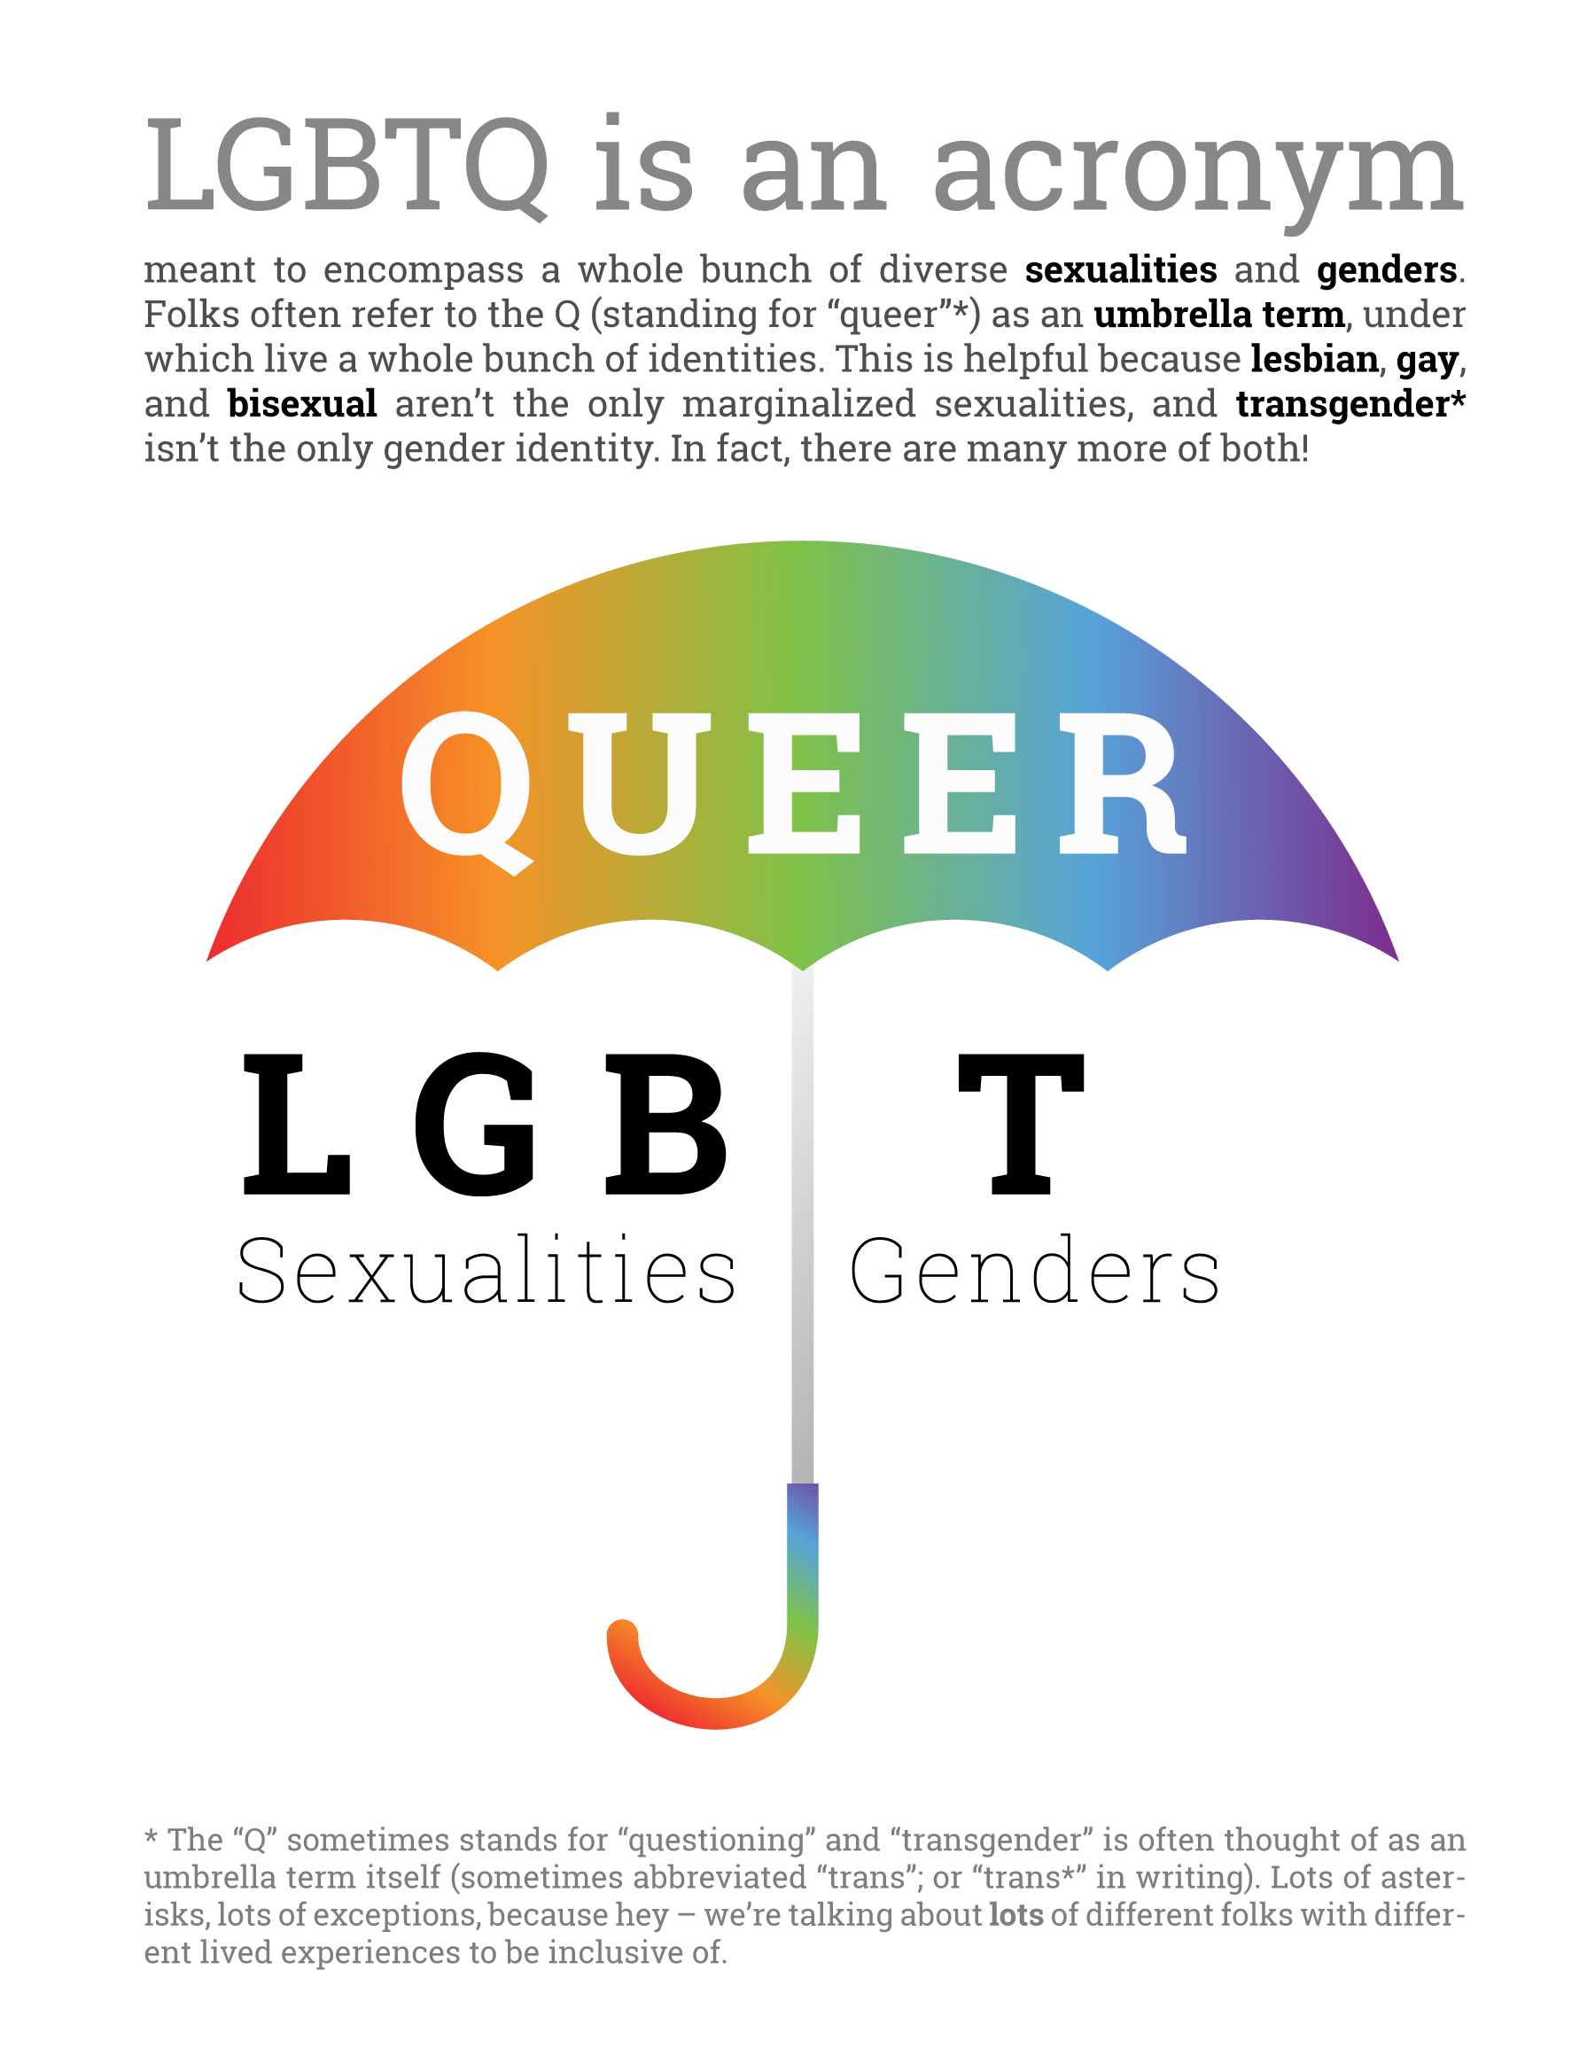

Genderbread Person - Participant’s 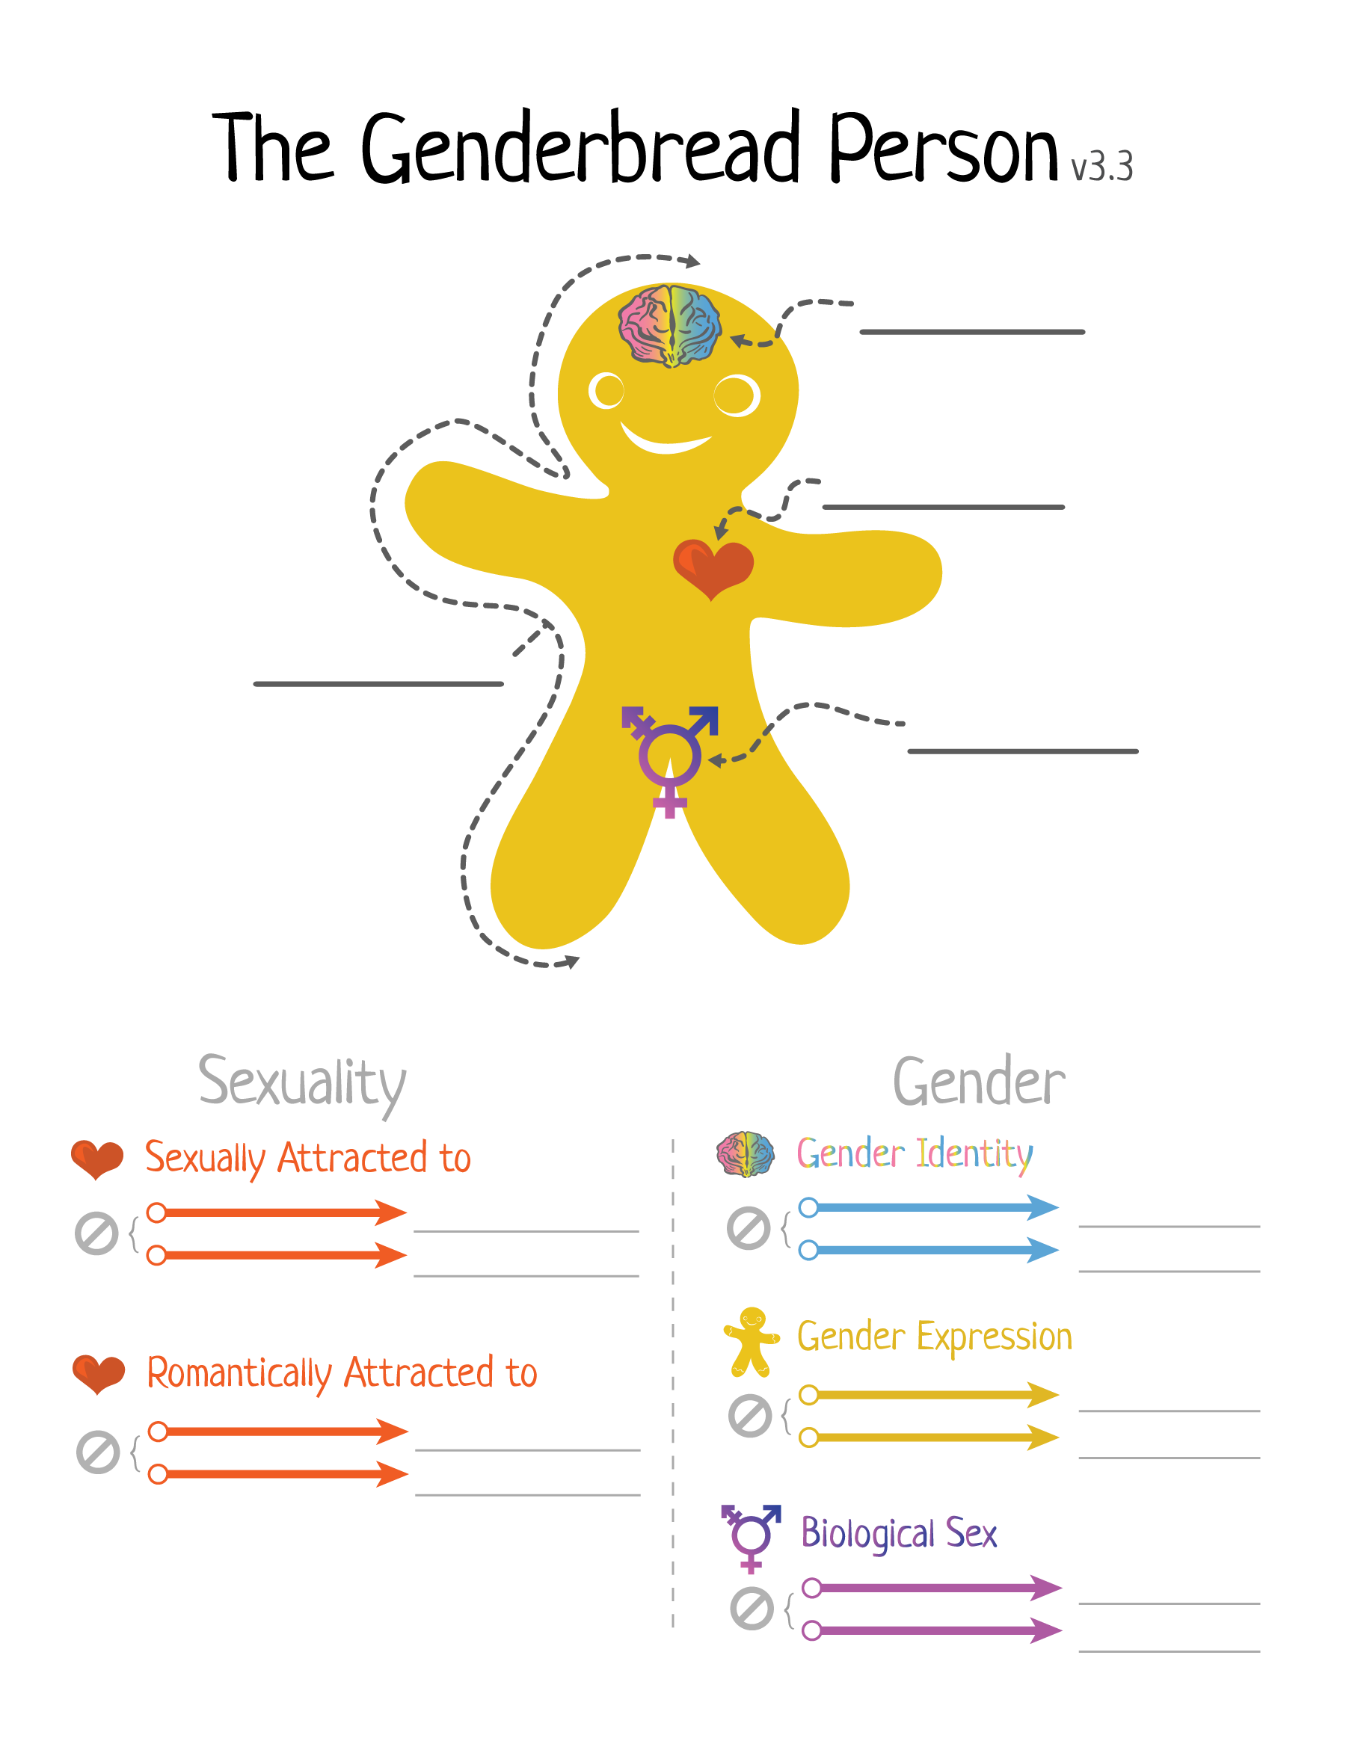

Privileges for Sale

Please look at the following list of privileges; each privilege costs $100 to purchase. As a group, please purchase as many privileges as your money allows.

1. Celebrating your marriage(s) with your family, friends, and coworkers.
2. Paid leave from your job when grieving the death of your partner(s).
3. Inheriting from your partner(s)/lover(s)/companion(s) automatically after their death.
4. Having multiple positive TV role models.
5. Sharing health insurance with your partner(s).
6. Being able to find role models of the same sexual orientation.
7. Being able to see your partner(s) immediately if in an accident or emergency.
8. Not being subjected to scrutiny in your job and not being able to be promoted without your sexuality being questioned
9. Adopting your children.
10. Filing joint tax returns.
11. Able to obtain child custody.
12. Being able to complete forms and paperwork with the information you feel most clearly communicates who you are.
13. Being able to feel unthreatened/safe in your interactions with authority figures/police officers.
14. Kissing/hugging/being affectionate in public without threat or punishment.
15. Being able to discuss and have access to multiple family planning options.
16. Not questioning normalcy both sexually and culturally.
17. Reading books or seeing movies about a relationship you wish you could have.
18. Receiving discounted home-owner insurance rates with your recognized partner(s).
19. Raising children without worrying about state intervention.
20. Having others comfort and support you when a relationship ends.
21. Being a foster parent.
22. Using public restrooms without fear of threat or punishment.
23. Being employed as a preschool or elementary school teacher without people assuming you will “corrupt” the children.
24. Dating the person you desired in your teens.
25. Raising children without worrying about people rejecting your children because your sexuality.
26. Living openly with your partner(s).
27. Receiving validation from your religious community.
28. Being accepted by your neighbors, colleagues, and new friends.
29. Being able to go to a doctor visit and have them understand your sexual orientation.
30. Being able to call/access social services without fear of discrimination around your gender and/or sexual orientation.
31. Sponsoring your partner(s) for citizenship.
32. Being open and having your partner(s) accepted by your family.

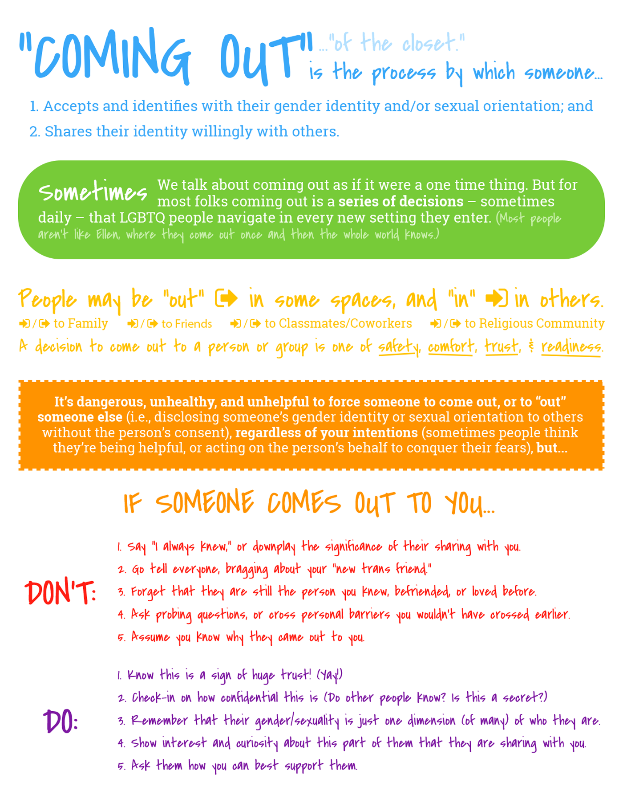

F(earfully) Asked Questions

# Sample Fearfully Asked Questions

1. What bathroom does a transgender person use?
2. How do lesbians have sex?
3. Are all transgender people gay?
4. Is bisexuality real?
5. Why is there a LGBTQ community, but not a straight community?
6. Why are gay men more promiscuous?
7. Don’t all these labels actually make it worse not better?
8. In a gay relationship, who is the man?
9. Can I ask someone how they identify?
10. Is a man who dates a transgender woman actually gay?

Scenarios

Questions for Staff, Faculty, Employees

1. You have gotten to know this new person in your life (could be a student, a peer, a coworker) and they said they really needed to talk to someone about something and then they tell you, “So I just wanted to let you know, I’m gay.” What do you do to support that person?
2. You meet someone new, they introduce themselves as Alex and they present in an androgynous way. You’re not really sure what pronouns to use - what should you do?
3. You bring up the idea of doing a diversity training at your new job or within the school that you attend with your peers. There is a lot of eye rolling and no one really says anything positive or affirming about the idea. What are some ways you could talk about your interest in diversity training that may get others interested?

*ALT: When you bring up the idea people say, “but we are all really accepting here, why would we need to spend time doing a training?”*

1. A young person you are working with comes to you and shares that they have been questioning their gender identity and that they identify as a boy (this person was assigned female at birth) and would like to come out to everyone as a boy, start using a male-name/pronouns, and that they aren’t sure how to tell their parents. How might you support this person?
2. You’ve been promoting your school, workplace, or group as really LGBTQ friendly. A lot of the people involved are very aware of gay issues and are completely welcoming and accepting of other sexualities. You are part of the recruitment weekend for a new student or hire in your office or cohort and this individual identities as trans*. While speaking with them you realize that your group/workplace doesn’t have gender neutral bathrooms, a lot of people were confusing this person’s gender pronouns all day, and generally not reaching out to this individual as much as others. How do you proceed when you notice this?
3. A staff member shares at a staff meeting that they are trans* and would like everyone to use a new name and the pronouns “they/them/theirs,” while everyone at the staff meeting is very positive and affirming there is a lot of confusion and hesitancy about how to proceed. People aren’t sure how to let others know, what to do when they mess up pronouns/names, what other types of support this person may want/need. How might you proceed?
4. A supervisor or manager of yours who has shared with you that they are totally great with LGBTQ people continues to make little jokes, using language/phrasing that makes you uncomfortable, and generally saying small non-affirming things about LGBTQ people. Because they are your boss you’re not sure how to handle the situation in the most appropriate manner. How might you proceed?

Scenarios

Student/Youth Focused Questions

1. You are becoming friends with this guy named Alex. One day you’re hanging out Alex gets oddly quiet and finally after you ask them repeatedly if anything is bothering them they come out and tell you they’re bi. Alex says he’s totally comfortable with it, has known for a long time, but doesn’t really feel like they know how to tell other people at school even though they really want to. What do you do?
2. You leave your dorm room one morning and you notice something on your friend José’s whiteboard on his door just across the hall. José is one of your friends, is gay, and has been out to you since you’ve known him. The whiteboard says, “Hey fag – give me a call later today, we have to pregame that party. Jess.” You know Jess is one of José’s best friends, but you don’t know her that well. What do you do?
3. You and a group of friends are waiting in line for food and you overhear someone behind you say, “Dude you’re still playing on a XBOX360, that’s so gay dude, seriously, soooo gay.” What do you do?
4. One of your teachers/mentors (who you know quite well) is talking about sexuality or gender in class. When the discussion goes quiet they turn to you and ask if you have anything additional to add. What do you do?
5. One of your new friends, Dee, who you don’t know that well, meets you and a group of mutual friends for lunch. They start talking about their roommate and how weird and annoying they always are. Dee goes onto say, “She also told me that she’s bisexual, I don’t actually really have a problem with bisexuals but I don’t know how comfortable I am, like, changing in the same room as her, I mean that’s weird right? Like I don’t know it just kind of weirds me out.” What do you do.
6. You suggest to your LGBTQ student/youth group that they all do a training on LGBTQ identity. You’ve noticed a lot of internalized homophobia as well as biphobia/transphobia within the group and you’re hoping that the training would be a good way to start getting at those things. There is a lot of discomfort with the idea and 2-3 people in the group express confusion and annoyance at the idea, “It’s straight people who need to be educated not us.” What might you do?
7. One of your friends recently came out to you as genderqueer. They want you to use they/them/their pronouns and let you know their new name is Jay. You find yourself really struggling with pronouns and find yourself stressed about messing up Jay’s name/pronouns with others. You want to be affirming and are really worried you’re not being a good ally. If you were friends with this person what might you do.

Feedback Form

Please answer honestly :).

## What is one thing that you learned from the training today? What did you enjoy about today’s training?

_____________________________________________________________________________________________________________________________________________________________________________________________________________________________________________________________________

_______________________________________________________________________________________

_______________________________________________________________________________________

## What could be improved for the next time this training is facilitated? How do you think this training could be improved?

_____________________________________________________________________________________________________________________________________________________________________________________________________________________________________________________________________

_______________________________________________________________________________________

_______________________________________________________________________________________

## Who would you recommend this training to? What would you say to get them interested?

_____________________________________________________________________________________________________________________________________________________________________________________________________________________________________________________________________

_______________________________________________________________________________________

______________________________________________________________________________________________________________________________________________________________________________

## Additional feedback for the facilitators? This could be in regards to material covered or the facilitation process.

_____________________________________________________________________________________________________________________________________________________________________________________________________________________________________________________________________

_______________________________________________________________________________________

_______________________________________________________________________________________

_______________________________________________________________________________________

Resource Page

There are many organizations, news, and blog communities for you to continue to explore gender and sexuality. These are just a few of our favorite places to continue learning!

**Full List of Vocab Terms** *-* [*bit.ly/SZP_VocabFULL*](http://bit.ly/SZP_VocabFULL)

# Websites for Learning More About Gender, Sexuality, & Social Justice

* Asexual Visibility and Education Network — www.asexuality.org — "The world's largest online asexual community as well as a large archive of resources on asexuality."
* Bitch Magazine — www.bitchmagazine.org — "Provide and encourage an engaged, thoughtful feminist response to mainstream media and popular culture."
* Bisexual.org — www.bisexual.org — "A voice to the bisexual community, share accurate information, answer questions, and provide resources for further learning."
* Everyday Feminism — www.everydayfeminism.com — "Learn how to heal from and stand up to everyday violence, discrimination, and marginalization," with plenty of articles about class, gender, LGBTQIA issues, and race.
* Get Real — www.getrealeducation.org — "Comprehensive Sex Education That Works."
* It's Pronounced Metrosexual — www.itspronouncedmetrosexual.com — an online resource educating on issues of identity, sexuality, gender, privilege, and oppression, but in a fun, approachable way (by Safe Zone Project co-creator, Sam Killermann).
* Salacious — www.salaciousmagazine.com — "A Queer Feminist Sex Magazine"
* Soul Force – http://soulforce.org/ – Family that travels and does speaking events, have a ton of materials on their site, and do an “equality ride” (super cool), all from a Christian perspective
* TransWhat? — www.transwhat.org — "A Guide Towards [Trans] Allyship"
* We Are The Youth — www.wearetheyouth.org — "Sharing stories of LGBTQ youth in the United States."
* WikiQueer — www.wikiqueer.org — "The free encyclopedia and resource for the queer communities that you can edit.”

# Organizations Doing Good

*Consider these orgs and projects to have the SZP-check-mark-of-approval. We strongly encourage you give them your support — whether that's in time, donations, or just spreading awareness.*

* GLAAD — www.glaad.org — Gay & Lesbian Alliance Against Defamation. "GLAAD works with print, broadcast and online news sources to bring people powerful stories from the LGBT community that build support for equality."
* GLSEN — www.glsen.org — Gay, Lesbian, and Straight Education Network. "Every day GLSEN works to ensure that LGBT students are able to learn and grow in a school environment free from bullying and harassment."
* Family Acceptance Project — www.familyproject.sfsu.edu — "Research, intervention, education and policy initiative that works to prevent health and mental health risks for lesbian, gay, bisexual and transgender (LGBT) children and youth, including suicide, homelessness and HIV – in the context of their families."
* God Loves the Gays – http://godlovesthegays.org – a queer son of a pastor who writes and shares resources with the goal of making people feel okay being queer and Christian
* It Gets Better Project — www.itgetsbetter.org — "The It Gets Better Project's mission is to communicate to lesbian, gay, bisexual and transgender youth around the world that it gets better, and to create and inspire the changes needed to make it better for them."
* National Gay and Lesbian Task Force — http://www.thetaskforce.org/ — "The mission of the National Gay and Lesbian Task Force is to build the power of the lesbian, gay, bisexual and transgender (LGBT) community from the ground up." They also run Creating Change the "largest annual gathering of LGBTQ activists, organizers, and leaders within the LGBT movement" in the US.
* The “Not All Like That” (NALT) Project – http://notalllikethat.org – videos of (awesome) Christians (mostly families) explaining how they fully support LGBTQ people and that being Christian shouldn’t mean being anti-gay.
* The Religious Institute - <http://www.religiousinstitute.org/> - Religious Institute is a multifaith organization dedicated to advocating for sexual health, education, and justice in faith communities and society.
* The Transcending Gender Project: http://www.transcendinggender.org
* PFLAG — www.pflag.org — "Parents, Families, Friends, and Allies United with LGBT People to Move Equality Forward."
* Transgender Law Center — www.transgenderlawcenter.org — "Transgender Law Center works to change law, policy, and attitudes so that all people can live safely, authentically, and free from discrimination regardless of their gender identity or expression."
* The Trevor Project — www.thetrevorproject.org — "Crisis intervention and suicide prevention for LGBTQ youth."

# Want even more Resources?

Head to [www.thesafezoneproject.com/resources](http://www.thesafezoneproject.com/resources) to find more!