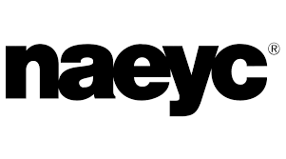  NAEYC FOR Families | Find research-based resources on child Development to reading, writing, music, math and more.
  California Schools Employee to Website | Find some educational materials to keep you healthy both mentally and physically.  Learn new recopies from quick meals to more involved cooking projects with your family.
  Kids can learn at home with fun activities | Find food and salad recopies.

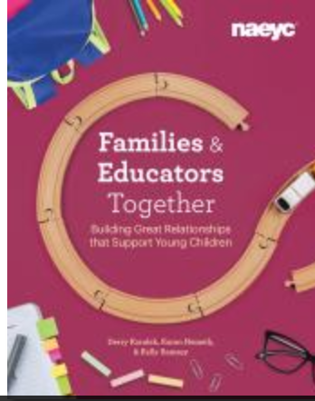  Families and Educators Together | Home–school relationships have always been a cornerstone of children’s success and well-being. But cultivating positive, supportive partnerships between educators and families is an ongoing process, one that requires reciprocal respect and communication to grow.
  Stem activities at home | Museum from home with Academy to help you stay learning and engaged
  Family Blog Link  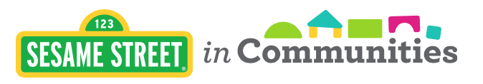  sesame Street in the Community | Family blogs, articles comments, videos and  Photographs.  Find articles and resources about healthy lifestyle.

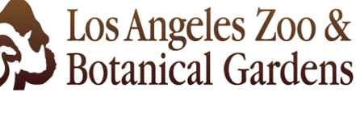  Bringing the Zoo to You | Find cool views of the Zoo to keep you informed  and engaged while social distancing.
  The Basic Principals of Healthy Eating | Find webinars about healthy eating and stress management.

  pediatric Research Partners | Find researched based articles.

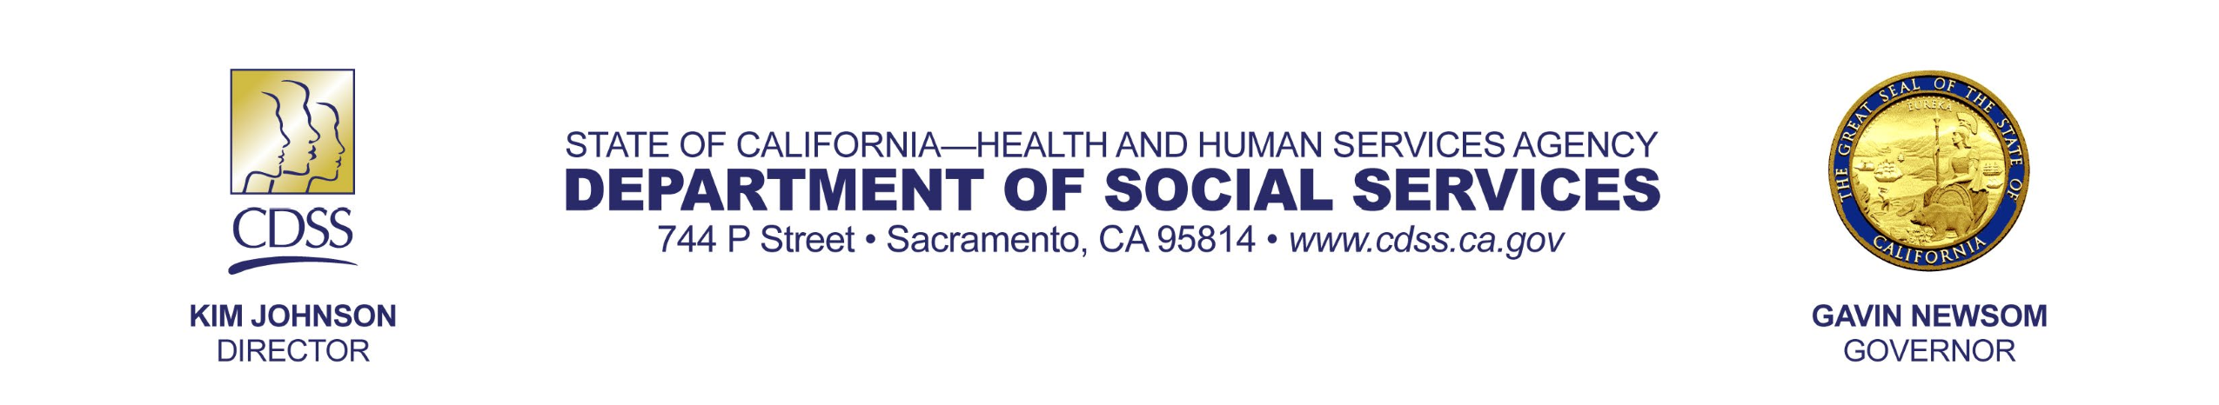 | To find childcare: Go to:  The MyChildCare.ca.gov is a mobile-friendly web application, accessible by going to MyChildCare.ca.gov and available in English and Spanish.

Additional Resources
- Pandemic EBT (P-EBT) benefits will be available for eligible California families soon!
- Access California Department of Education child care provider emergency response training and tools at MyChildCare.ca.gov
- OnWardCA One-stop resource for the people of California impacted by job loss during the COVID-19 Pandemic
- Angeleno Card – Applications Now Open through Thursday, April 16, 4:30 PM.
For Phone applications or more information please call 213-252-3040
- Free Meals at LA Grab n Go Food Centers
- Community Care Licensing
- Child Care Licensing Division (CCLD)
- California Department of Social Services
- Centers for Disease Control – Covid-19 Updates
- Tax deadline extended to July 15
- CDE Covid-19 Guidance for K-12 Schools (includes a section on child care)

