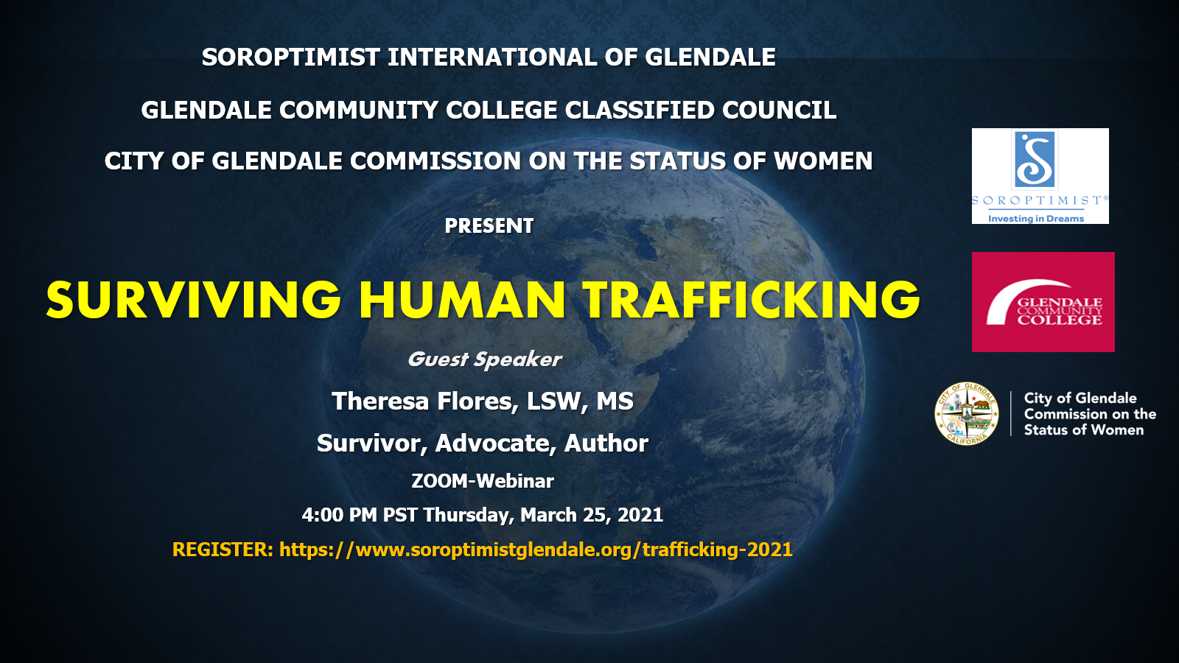

After Surviving the Horrors of Human Trafficking Theresa Flores Now Leads the Fight to Heal, Educate and Eradicate this Silent Epidemic jschwartze@recoilweb.com(9/3/20)

There is a popular misconception that sex and labor Human Trafficking are primarily third world concerns. Theresa Flores is living proof that Human Trafficking is very much a first world concern and has been happening in our United States for a long time.

Her incredible true story is that of an all- American teenager, who survived two years of being a sex slave while living at home in an upper middle class Michigan suburb. She was stalked, intimidated, sold and broken in mind and body. Out of shame, guilt, and fear of what would happen to the rest of her family, Theresa stayed silent.

Her escape from her ordeal is detailed in her first of five books *The Slave Across the Street.*

Now, thirty years later she is a licensed Social Worker with a Master’s in Education and has become a recognized and respected authority on Human Trafficking. She speaks out on the reality of how this is a silent epidemic across the U.S., even in “nice” neighborhoods…. like ours.

Her speaking and teaching resumes are extensive, having presented at TEDx, at hundreds of universities, trained law enforcement, medical personnel, worked with the U.S. Attorney General's office, and testified before the Senate and House for several states.

**Join us, hear her story, learn what we as a community, what you as an individual can do to combat Human Trafficking!**

**REGISTER AT:** **https://www.soroptimistglendale.org/trafficking-2021**