**Instructional Hiring Allocation Committee Manual**

Glendale Community College Academic Senate

November 2020

Statement of Intent  
IHAC Composition and Procedures Appendix

**Statement of Intent**

The Instructional Hiring Allocation Committee (IHAC) will be formed to prioritize all instructional hire requests on behalf of the Academic Senate. The program review documents will provide the data and the narrative necessary to complete this process.

The committee is expected to function independent of the concerns of any campus constituency. The decision of the committee must be based on the published criteria contained in the Instructional Hiring Allocation Procedures. Deliberations of the committee, including discussion and voting, will remain confidential. Results will be forwarded to the Academic Senate President and the Office of Instruction.

This process is intended to produce decisions that are aligned with the college’s Mission Statement and Educational Master Plan. Members of this committee must align their decisions with the global concerns of the college. Committee members must avoid the influence of individual advocacies and biases.

Taskforce members: Yvette Ybarra, Cindy Pollack, Shant Shahoian, Cameron Hastings

Revision taskforce members: Cindy Pollack, Andrew Young, Paul Mayer, Zo Kaye, Dana Marterella, Sandy Somo, Piper Rooney, Roger Dickes

**Instructional Hiring Allocation Committee Composition and Procedures**

**Committee Composition**

1. The Vice President of Instruction will provide a history of the committee’s composition to the Division Chairs and the Academic Senate Executive.
2. Three tenured, non-division chair, instructional faculty appointed by Division Chairs.
3. Four tenured, non-division chair, instructional faculty selected by the Academic Senate Executive (after Division Chair appointments).
4. The committee will appoint a chair for one year. This position will rotate each year. In the case that the committee cannot decide on a chair, the Academic Senate Executive will pick a chair.

Note - Committee members are expected to conduct themselves in a professional and collegial manner. Committee conflicts will be referred to the Academic Senate Executive.

**Terms of Committee Members**

These standards are prioritized

1. Each committee member will serve two years. In order to stagger committee member terms, one of the initial appointments made by the Division Chairs and two of the initial appointments made by the Academic Senate Executive will be appointed for one year.
2. No instructional division may have more than one representative serving on this committee at the same time.
3. Members of IHAC may not advocate for their own areas and should maintain awareness of the needs of both credit and noncredit disciplines.
4. It is recommended that all faculty divisions/departments and constituencies, including Noncredit and CTE, be represented on IHAC within each six-year cycle.
5. No individual may serve more than once on this committee in a 6-year cycle. (There must be a four-year interval between terms.)

**Instructional Hiring Allocation Procedures**

All IHAC Request Forms for proposed positions will contain the following information:

* Description of Position - Include the description used to advertise for the position.
* Division/Department/Program that this position serves.
* Criteria - The source of this information is Program Review. Updated information will be sent to all programs each year by the Vice President of Instruction.

1. Full-time/Part-time ratio (See Appendix for ratio calculation)
   * All requests are placed in a preliminary order by their full-time/part-time ratio.
2. Student Demand
   * WSCH/Positive Attendance- Number of students in the program.
   * FTES-Number of full-time equivalent students in program.
   * Fill-rate - Computed by dividing the total seats available by the enrollment.
3. Faculty load
   * Computed by comparing the FTEF (full-time equivalent faculty) to the total enrollment showing a three-year trend
4. Status of released-time faculty in program
5. Division or Department efforts to achieve equitable student outcomes
6. The narrative of each request form, which includes pertinent information not included in other fields, for example, anticipated or effected retirements, new buildings coming online which increase classroom capacity, labor market data indicating emergent industry needs, or new degrees or certificates
7. Further examples of additional factors to consider (see Appendix)  
   page4image7891984

**IHAC Timeline**

November

**November/December:** Division Chairs select and submit to the Academic Senate representatives for Instructional Hiring Allocation Committee. These representatives must be non-division chair, full-time tenured faculty. They may not come from the same division, and must represent divisions not currently represented on the committee. The Academic Senate selects and submits representatives for the Instructional Hiring Allocation Committee. These representatives must be non-division chair, full-time tenured faculty. The individuals must represent instructional division/departments not currently represented on the committee or nominated by Division Chairs.

**December:** New hire requests are due in Program Review documents. Program Review delivers requests to chair of IHAC by December 31.

**Late February/early March**: Instructional Hiring Allocation Committee meets to review procedures. The committee receives hiring requests from Office of Instruction ordered based on full time/ part time ratio.

**March/April**: Committee meets to finalize procedures.

Instructional Hiring Allocation Committee Retreat. Committee prioritizes hires and submits prioritization to College President and Vice President of Instruction. The committee may reconvene to consider concerns of the President and Vice-President at their request. The committee submits final prioritization to Campus Executive.

**First Senate Meeting of September:** Vice President of Instruction provides a written summary to the Academic Senate, and attends session upon the request of the Academic Senate. This summary should include the ordered list with the original IHAC rankings presented to the Campus Executive by IHAC, a list of the positions to be hired, an explanation for any deviation from IHAC’s ordered list, and any additional information that is relevant to the IHAC process which should be documented for future committees.

**APPENDIX**

**1. Computing FT/PT Ratio**

First, to compute the FTEF, divide the total hours taught per week in the program by the hourly load of a full-time faculty member.

Then compute the FT/PT Ratio by dividing the FTF by the FTEF.  
After computing the ratio, positions should be ordered as seen below:

Note: Full-time is defined as the number of full-time faculty assigned to a program. Faculty on released time are credited as teaching full-time in the program.

The following table provides an example of how the FT/PT ratio might change under this computation. The actual table for each IHAC cycle will list all the Divisions/Departments requesting new positions. A newly computed table, using current data, will be provided for each IHAC cycle.

|  |  |  |  |
| --- | --- | --- | --- |
| Division/ Department | FT/PT ratio | New ratio after first hire | New ratio after 2nd hire |
| Formula | Current FTF FTEF | FTF+1 FTEF | FTF+2 FTEF |
| History | page7image7904256.37 | page7image7905088.43 | .57 |
| English | page7image7908416.26 | .32 | .39 |
| Math | .38 | .45 | .51 |
|  |  |  |  |
|  |  |  |  |
|  |  |  |  |
|  |  |  |  |
|  |  |  |  |

If multiple positions are requested by a Division/Department, they will be ranked separately. The first position considered will use the second column of the table (labeled “FT/PT ratio”) and the **Criteria Point Scale** table provided below. The second position considered will use the third column of the table (labeled “New ratio after first hire”), etc.

**2. Considerations for Subjective Criteria**

How does this position relate or contribute to the Mission Statement of Glendale College?

How does this position relate to the objectives and functions of the College?

* Associate in Arts/Associate in Science
* Transfer requirements
* Vocational education or occupational certification
* Pre-collegiate basic skills
* Personal improvement
* Noncredit adult education

How does this position relate to the college’s Master Plan?  
  
How does this position relate to the Program Goals listed in the department’s program review?

How does this position relate to the overall discipline or to other disciplines, and does this position meet specific instructional skill needs?

Does this position cover classes that are currently being taught by part-time staff or does it involve program expansion?

Are there community or industry needs that relate directly to this position? If yes, how?

How does this position contribute to currency in state-of-the-art technical education?

What implications does the addition of this position have for the following:

* Budget
* Staffing
* Facilities
* Equipment

Discuss any benefits your program may lose from not receiving the requested hire. Are their special concerns that are not addressed in this document?

**3. Considerations for Subjective Criteria on Equity Efforts**

How does this position contribute to Glendale College’s efforts to create equitable educational outcomes for all students?

The types of evidence that may appear in a division/department’s narrative submitted to Program Review in an application for a new hire include:

* Division/Department committee work to create authentic assessments, a working definition of which is as follows: “An authentic assignment is one that requires application of what students have learned to a new situation, and that demands judgment to determine what information and skills are relevant and how they should be used. Authentic assignments often focus on messy, complex real-world situations and their accompanying constraints; they can involve a real-world audience of stakeholders” ([CITL](https://citl.indiana.edu/teaching-resources/assessing-student-learning/authentic-assessment/index.html));
* Agendized Division/Department discussions of disaggregated differences in achievement among various student groups in addition to action plans that resulted from those discussions, and the ongoing implementation of those action plans;
* Work within the Division/Department to revise course outlines of record to decolonize the curricula, introducing significant contributors and contributions to disciplines from outside the predominantly white Eurocentric epistemology;
* Documented work with HR to increase the diversity of the Adjunct and Full-Time teaching pools;
* Documented work with HR (emails, notes based on in-person or telephone conversations, minutes of convened meetings) to widen the range of outlets in which employment opportunities are advertised;
* Department/Division review of hiring practices, including the composition of hiring committees, and holistic revisions of job postings and interview questions to increase equity and diversity;
* Participation in the Faculty Diversity Internship Program or comparable existing programs, and/or the creation of such internship opportunities at the Department/Division level;
* Recent Division/Department hiring choices that demonstrate awareness and efforts to diversify the ranks of faculty through a broadened range of academic preparation (types of degrees, professional experience), as well as demographic diversity that increases faculty reflection of student demographics; individual preparation and/or perspectives of hires that broaden and/or complement the Division/Department.
* Any additional evidence of equity efforts not already mentioned, that help to demonstrate the Division/Department’s commitment to equity and diversity.

**4. Criteria Score Sheet**

|  |  |  |  |  |  |
| --- | --- | --- | --- | --- | --- |
|  | **CRITERION 1**  FT/PT RATIO  **0-10 Points** | **CRITERION 2**  Fill Rate/Positive Attendance*  **0-10 Points** | **CRITERION 3**  Equity Efforts  **0-10 Points** | **CRITERION 4**  Subjective  **0-10 Points** | **CRITERION 5**  State Mandated Position **(if currently known)**  **Yes or No** |
| Dept./Division |  |  |  |  |  |
| Dept./Division |  |  |  |  |  |
| Dept./Division |  |  |  | page9image5785472 |  |
| Dept./Division |  |  | page9image5792336page9image5792960 | page9image5793376page9image5794416 |  |
| Dept./Division |  |  |  |  |  |
| Dept./Division |  |  | page9image5803152page9image5803776 | page9image5804192page9image5805232 |  |
| Dept./Division |  |  |  |  |  |

*If no other plan for computing Positive Attendance for Criteria 3 is approved before the next IHAC cycle, the value "Average Daily Attendance (ADA) divided by Number of Seats in the Class" shall be used.

**5. Criteria Point Scale (Point Scale Needs Adjustment)**

|  |  |  |  |  |
| --- | --- | --- | --- | --- |
| **CRITERION 1**  FT/PT RATIO  **0-10 Points** | **CRITERON 2**  Fill Rate/Positive Attendance*  **0-10 Points** | **CRITERION 3**  Equity Efforts (Refer to Equity portion of IHAC Request Form)  **0-10 Points** | **CRITERION 4**  Subjective (Refer to IHAC Request Form)  **0-10 Points** | **CRITERION 5**  State Mandated Position **(if currently known)**  **Yes or No** |
| < 20% = 10 | ≥ 100% = 10 | Points assigned at the discretion of each IHAC member | Points assigned at the discretion of each IHAC member |  |
| 20 - 29.9% = 9 | 98 - 99.9% = 9 |  |  |  |
| 30 - 34.9% = 8 | 96 - 97.9% = 8 | page10image5863056 |  |  |
| 35 - 39.9% = 7 | 94 - 95.9% = 7 | page10image5867840 |  |  |
| 40 - 44.9% = 6 | 92 - 93.9% = 6 | page10image5872624 |  |  |
| 45 - 49.9% = 5 | 90 - 91.9% = 5 | page10image5877408 |  |  |
| 50 - 54.9% = 4 | 88 - 89.9% = 4 | page10image5882192 |  |  |
| 55 - 59.9% = 3 | 85 - 87.9% = 3 | page10image5887808page10image5889264 | page10image5893424 |  |
| 60 - 64.9% = 2 | 75 - 84.9 = 2 |  |  |  |
| 65 - 69.9% = 1 | 60 - 74.9 = 1 | page10image5896544 |  |  |

*If no other plan for computing Positive Attendance for Criteria 2 is approved before the next IHAC cycle, the value "Average Daily Attendance (ADA) divided by Number of Seats in the Class" shall be used.

1. **Two -Year Timeline**

|  |  |  |  |  |  |  |
| --- | --- | --- | --- | --- | --- | --- |
| **Year 1** | **July** | **August** | **September** | **October** | **November** | **December** |
|  |  |  | Program Review Conducted | Program Review Conducted | Program Review documents due  New Hire Requests due  Division Chairs Academic Affairs fills IHAC position(s)  Academic Senate fills IHAC positions | Program Review completed and validated  IHAC receives hiring requests from Program Review |
| **Year 1** | **January** | **February** | **March** | **April** | **May** | **June** |
|  |  | First Meeting of Hiring Allocation Committees  Establish norms and procedures | Second meeting of Hiring Allocation Committees  Complete selection standards  Third meeting of IHAC (Retreat)  Prioritize hires & submit to VPI and Sup/Pres & College Executive  OR | Third meeting of Hiring Allocation Committees (Retreat)  Hires prioritized & submitted to VPI and Sup/Pres & College Executive | May Revise  Budget approves number of new hires  College Exec. review/ Admini-stration determines its hiring allocations | Job announce-ments reviewed by Divisions & HR |
| **Year 2** | **July** | **August** | **September** | **October** | **November** | **December** |
|  | Job announce-ments reviewed by Divisions & HR | Board approves positions  Emergency hiring process | VPI visits Academic Senate | Job announce-ments flown  Hiring committees assembled | Hiring Process  Emergency hiring process | Hiring Process |

2013 HIRING TIMELINE _ REVISED ABOVE

Timeline below to be cut

~~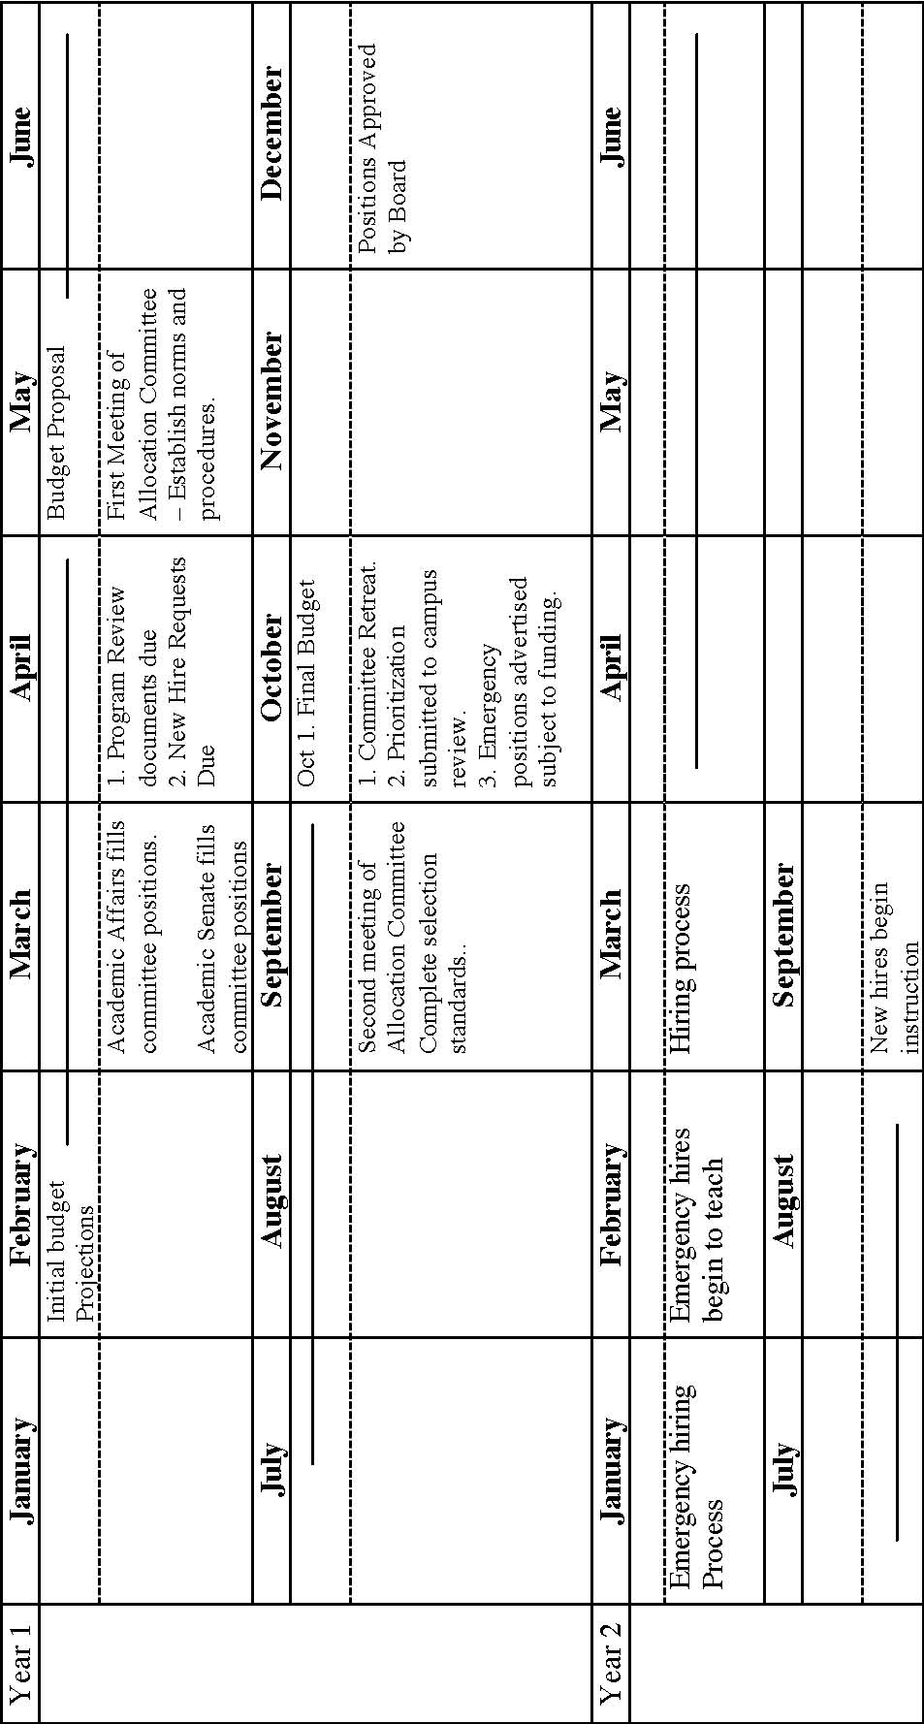~~

**6. Instructional Services Flow Chart**

