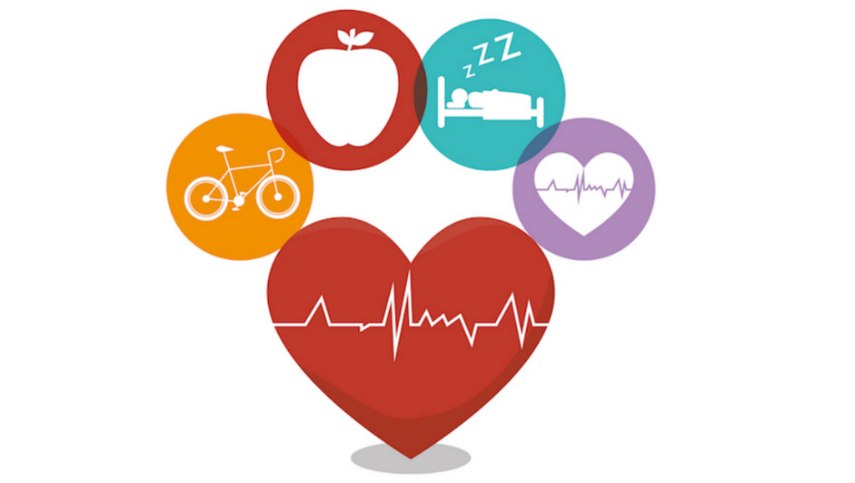

**Despite your best efforts to live a healthy lifestyle, illnesses and injuries occur. But with a Glendale Community College health benefits plan, you and your family will always be covered! Don’t miss our upcoming open enrollment period, so you can take advantage of the great benefits we have to offer.**

**We will be doing our annual Health Fair virtually again this year!**

Meetings will be held for each of the below insurance carriers during the week of November 15, 2021.

Friday, November 19, 2021, we will have an hour set up for you to call in and ask about any of the benefits being offered by the college! Each of our insurance representatives will create a video or a presentation that will be available for viewing. Below is the timetable of calls for each of our carrier partners.

|  |  |  |  |  |  |
| --- | --- | --- | --- | --- | --- |
|  | **Monday, November 15, 2021** | **Tuesday, November 16, 2021** | **Wednesday, November 17, 2021** | **Thursday, November 18, 2021** | **Friday, November 19, 2021** |
| Blue Shield | 12:30 to 1:30 p.m. |  |  |  |  |
| Kaiser |  |  |  | 12:30 to 1:30 p.m. |  |
| Brina Campbell (Medicare) |  |  | 12:30 to 1:30 p.m. |  |  |
| Delta Dental |  | 12:30 to 1:00 p.m. |  |  |  |
| New York Life (CIGNA) |  | 1:00 to 1:30 p.m. |  |  |  |
| Knight Insurance Services (to answer questions about medical, dental, vision, life, etc.. |  |  |  |  | 12:30 to 1:30 p.m. |
| Vivian Hermiz – Mindfulness Workshop |  |  | 3:00 p.m. to 4:00 p.m. |  |  |

**Blue Shield of California**

**Monday, November 15, 2021 from 12:30 P.M. to 1:30 P.M.**

|  |  |  |  |  |  |  |  |  |  |  |  |  |  |  |  |  |  |  |  |  |  |  |  |  |  |  |  |  |  |  |  |  |  |  |  |  |  |
| --- | --- | --- | --- | --- | --- | --- | --- | --- | --- | --- | --- | --- | --- | --- | --- | --- | --- | --- | --- | --- | --- | --- | --- | --- | --- | --- | --- | --- | --- | --- | --- | --- | --- | --- | --- | --- | --- |
| |  |  |  |  |  |  |  |  |  |  |  |  |  |  |  |  |  |  |  |  |  |  |  |  |  |  |  |  |  |  |  |  |  |  |  |  |  | | --- | --- | --- | --- | --- | --- | --- | --- | --- | --- | --- | --- | --- | --- | --- | --- | --- | --- | --- | --- | --- | --- | --- | --- | --- | --- | --- | --- | --- | --- | --- | --- | --- | --- | --- | --- | --- | | |  |  | | --- | --- | | **Karena Bradshaw is inviting you to a scheduled Zoom meeting.** | | | [Join Zoom Meeting](https://blueshieldca.zoom.us/j/87371723663?pwd=eklpTW0vV0Fwd3RFUm56RUtMUlpHUT09) | | | One tap mobile: | US: [+16699009128,,87371723663#,,,,*4285031509#](tel:+16699009128,,87371723663#,,,,*4285031509#) or [+13462487799,,87371723663#,,,,*4285031509#](tel:+13462487799,,87371723663#,,,,*4285031509#) | | Meeting URL: | <https://blueshieldca.zoom.us/j/87371723663?pwd=eklpTW0vV0Fwd3RFUm56RUtMUlpHUT09> | | Meeting ID: | 873 7172 3663 | | Passcode: | Glendale!2 | | **Join by Telephone** | | | For higher quality, dial a number based on your current location. | | | Dial: | US: +1 669 900 9128 or +1 346 248 7799 or +1 253 215 8782 or +1 312 626 6799 or +1 646 558 8656 or +1 301 715 8592 or 833 548 0282 (Toll Free) or 877 853 5247 (Toll Free) or 888 788 0099 (Toll Free) or 833 548 0276 (Toll Free) | | Meeting ID: | 873 7172 3663 | | Passcode: | 4285031509 | | [International numbers](https://blueshieldca.zoom.us/u/kvhNLKLio) | | | **Join from an H.323/SIP room system** | | | H.323: | 162.255.37.11 (US West) 162.255.36.11 (US East) | | Meeting ID: | 873 7172 3663 | | Passcode: | 4285031509 | | SIP: | [87371723663@zoomcrc.com](mailto:87371723663@zoomcrc.com) | | Passcode: | 4285031509 | | |

**Kaiser**

**Thursday , November 18, 2021 from 12:30 P.M. to 1:30 P.M.**

Microsoft Teams meeting

**Join on your computer or mobile app**

[Click here to join the meeting](https://teams.microsoft.com/l/meetup-join/19%3ameeting_MzE4ZDA5ZTgtZDVkOC00MTViLTgxMDQtOTY2N2ViZmQ5OWIy%40thread.v2/0?context=%7b%22Tid%22%3a%223f8a7bc4-e337-47a5-a0fc-0d512c0e05f1%22%2c%22Oid%22%3a%224e26e006-2fec-40af-a4c3-09be3337737c%22%7d)

**Join with a video conferencing device**

[teams@evc.kp.org](mailto:teams@evc.kp.org)

Video Conference ID: 114 582 511 3

[Alternate VTC instructions](https://evc.kp.org/teams/?conf=1145825113&ivr=teams&d=evc.kp.org&test=test_call&w)

**Or call in (audio only)**

[+1 213-533-9530,,423603046#](tel:+12135339530,,423603046# )   United States, Los Angeles

Phone Conference ID: 423 603 046#

**Delta Dental**

**Tuesday, November 16, 2021 from 12:30 P.M. to 1:00 P.M.**

|  |
| --- |
| Join Zoom Meeting  <https://deltadentalins.zoom.us/j/93821586330?pwd=ZXBwWlpzb2FEL1M0SW8veFlRSFR4dz09>  Password: 556652  Dial by your location          +1 669 900 6833 US (San Jose)          +1 253 215 8782 US (Tacoma)          +1 346 248 7799 US (Houston)          +1 301 715 8592 US (Washington DC)          +1 312 626 6799 US (Chicago)          +1 646 558 8656 US (New York)   Meeting ID: 938 2158 6330  Recording Disclaimer:   All non-Business-Related recordings in the workplace are prohibited. Inform participants if a meeting is being recorded. Internal participants see the Legal link for Audio Recording Conference Calls and Meetings Policy for additional information. |

**New York Life (Formerly CIGNA)**

**Tuesday, November 16, 2021 from 1:00 P.M. to 1:30 P.M.**    
    
[**Join WebEx Meeting**](https://cigna.webex.com/cigna/j.php?MTID=m467cfd2a051e27b1434932bb5e250469) from PC or Mobile  
Meeting Number  |   1798 27 2130   
  
Meeting password: ugNNJDhz788    
  
**OR**   
  
**Tap to join from a mobile device (attendees only)**    
[+1-650-479-3208,,1798272130##](tel:%2B1-650-479-3208,,*01*1798272130%23%23*01*) United States Toll    
[1-844-621-3956,,1798272130##](tel:1-844-621-3956,,*01*1798272130%23%23*01*) United States Toll Free    
  
**Join by phone**    
+1-650-479-3208 United States Toll    
1-844-621-3956 United States Toll Free    
[Global call-in numbers](https://cigna.webex.com/cigna/globalcallin.php?MTID=md641cd74c32f32d10171b130908ac38c)  |  [Toll-free calling restrictions](https://cigna.webex.com/cigna/customer_tollfree_restrictions.pdf)     
    
Meeting Number (Access Code): 1798 27 2130

**Brina Campbell – Medicare**

**Wednesday, November 17, 2021 from 12:30 P.M. to 1:30 P.M.**

|  |  |  |  |  |  |  |  |  |
| --- | --- | --- | --- | --- | --- | --- | --- | --- |
| |  | | --- | |  | | **Join from the meeting link** | | <https://warnerpacific.webex.com/warnerpacific/j.php?MTID=m97f7d0bd6c5ae10910fd828694755553> |  |  | | --- | | **Join by meeting number** | | Meeting number (access code): 2599 960 8521 | | Meeting password: qMD3P4Sreu3 | |  |   **Tap to join from a mobile device (attendees only)**  [1-844-621-3956,,25999608521##](tel:1-844-621-3956,,*01*25999608521%23%23*01*) United States Toll Free  [+1-415-655-0001,,25999608521##](tel:%2B1-415-655-0001,,*01*25999608521%23%23*01*) US Toll   **Join by phone**  1-844-621-3956 United States Toll Free  +1-415-655-0001 US Toll  [Global call-in numbers](https://warnerpacific.webex.com/warnerpacific/globalcallin.php?MTID=md746fe4d9faa730d233093a6fcfd786d) | [Toll-free calling restrictions](https://www.webex.com/pdf/tollfree_restrictions.pdf)   |  | | --- | |  |   **Join from a video system or application** Dial [25999608521@warnerpacific.webex.com](sip:25999608521@warnerpacific.webex.com)  You can also dial 173.243.2.68 and enter your meeting number.  **Knight Insurance Services**  **Friday, November 19, 2021 from 12:30 P.M. to 1:30 P.M.**  Please call (209) 389-3257  Conference ID 738720 |

**Vivian Hermiz [She/Her] is inviting you to a scheduled Zoom meeting.**

**Wednesday, November 17, 2021 from 3:00 P.M. to 4:00 P.M.**

**Mindfulness Workshop**

Join Zoom Meeting

<https://us02web.zoom.us/j/86219478232?pwd=SEtFN2lPaXdRalBuVzNZdFpzVEMzZz09>

Meeting ID: 862 1947 8232

Passcode: 975211

One tap mobile

+16699006833,,86219478232#,,,,*975211# US (San Jose)

+12532158782,,86219478232#,,,,*975211# US (Tacoma)

Dial by your location

        +1 669 900 6833 US (San Jose)

        +1 253 215 8782 US (Tacoma)

        +1 346 248 7799 US (Houston)

        +1 929 205 6099 US (New York)

        +1 301 715 8592 US (Washington DC)

        +1 312 626 6799 US (Chicago)

Meeting ID: 862 1947 8232

Passcode: 975211

Find your local number: <https://us02web.zoom.us/u/kdDcc8M2gG>

**During the calls, you will have the opportunity to ask questions of each of the representatives. Please be considerate of others on these calls.**

**If you do not feel like you want to ask certain questions in this forum, you will be able to ask questions on the call Friday with Knight Insurance Services. Or you can contact Kimbra Fossen at Knight Insurance. She will be able to assist you with specific questions that you have. Kimbra can be reached at (818) 662-4217. Or you can email her at** [**Kimbraf@knightins.net**](mailto:Kimbraf@knightins.net)**. Thank you everyone for your understanding. We are hoping that our annual Health Fair will be in person next year!!**