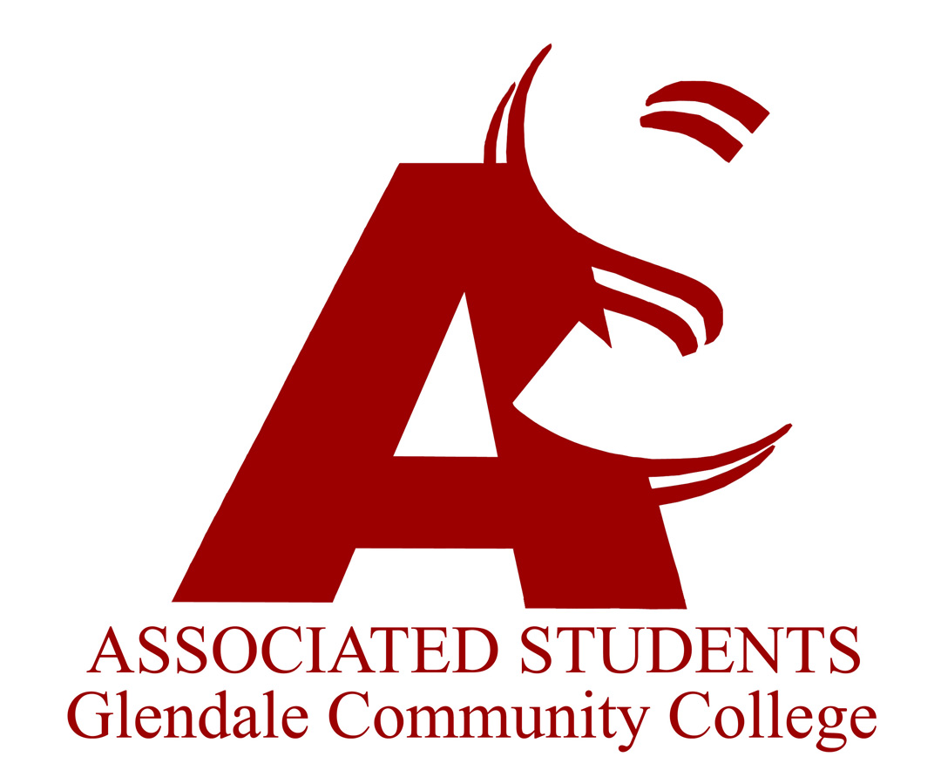 |  | Associated Students of Glendale Community College  Executive Committee Agenda  May 5, 2023  7:00 am  Zoom ID: glendale

I. | Call to Order at 7:03
II. | Flag Salute
III. | Roll Call  Present: Natalie Dawoodi, Ayk Petrosyan, Shirak Karabedian, Maggie Guymdzhyan, Tara Tazian, Talar Chadarevian
IV. | Approval of Minutes – May 5, 2023  MSC: Ayk Petrosyan/Shirak Karabedian
V. | Approval of Agenda – May 12, 2023  MSC: Ayk Petrosyan/ Talar Chadarevian
VI. | Report of President/Student Trustee – Natalie Dawoodi  - No New Report
VII. | Report of Administration Committee – Ayk Petrosyan  - Continuing on working on second educational initiative in collaboration with Scholars
VIII. | Report of Finance Committee – Shirak Karabvedian  - No New Report
IX. | Report of Activities Committee – Maggie Guyumdzhyan  - No New Report
X. | Report of Relations Committee – Tara Tazian  - No New Report
XI. | Report of Organizations Committee – Talar Chadarevian  - No New Report
XII. | Report of Officers
XIII. | Reports of Governance/Special Committee Meetings  - Campus Development  - Environment and Sustainability
XIV. | Guest Speakers
XV. | Old Business
XVI. | New Business  - Review of the Legislature Agenda – Discussion Item
XVII. | Reports of Advisors
XVIII. | Announcements/Information
XIX. | Adjournment 7:36 pm  MSC: Talar Chadarevian/Maggie Guyumdzhyan

