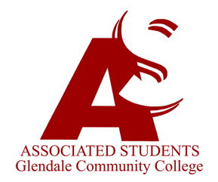 |  | Associated Students of Glendale Community College  Executive Committee Agenda  July 28, 2023  8:00 AM  Location: GCC Verdugo Campus, Student Center (SC 208)

I. | Call to Order
II. | Flag Salute
III. | Roll Call
IV. | Approval of Minutes – July 21, 2023
V. | Approval of Agenda – July 28, 2023
VI. | Report of President/Student Trustee
VII. | Report of Administration Committee
VIII. | Report of Finance Committee
IX. | Report of Activities Committee
X. | Report of Relations Committee
XI. | Report of Organizations Committee
XII. | Report of Officers
XIII. | Reports of Governance/Special Committee Meetings
XIV. | Guest Speakers
XV. | Old Business
XVI. | New Business  - Orientation Slideshow – Discussion Item  - Senator List – Discussion Item  - Breakfast By Executive Team – Discussion Item  - Orientation Day Activities – Discussion Item
XVII. | Reports of Advisors
XVIII. | Announcements/Information
XIX. | Adjournment

