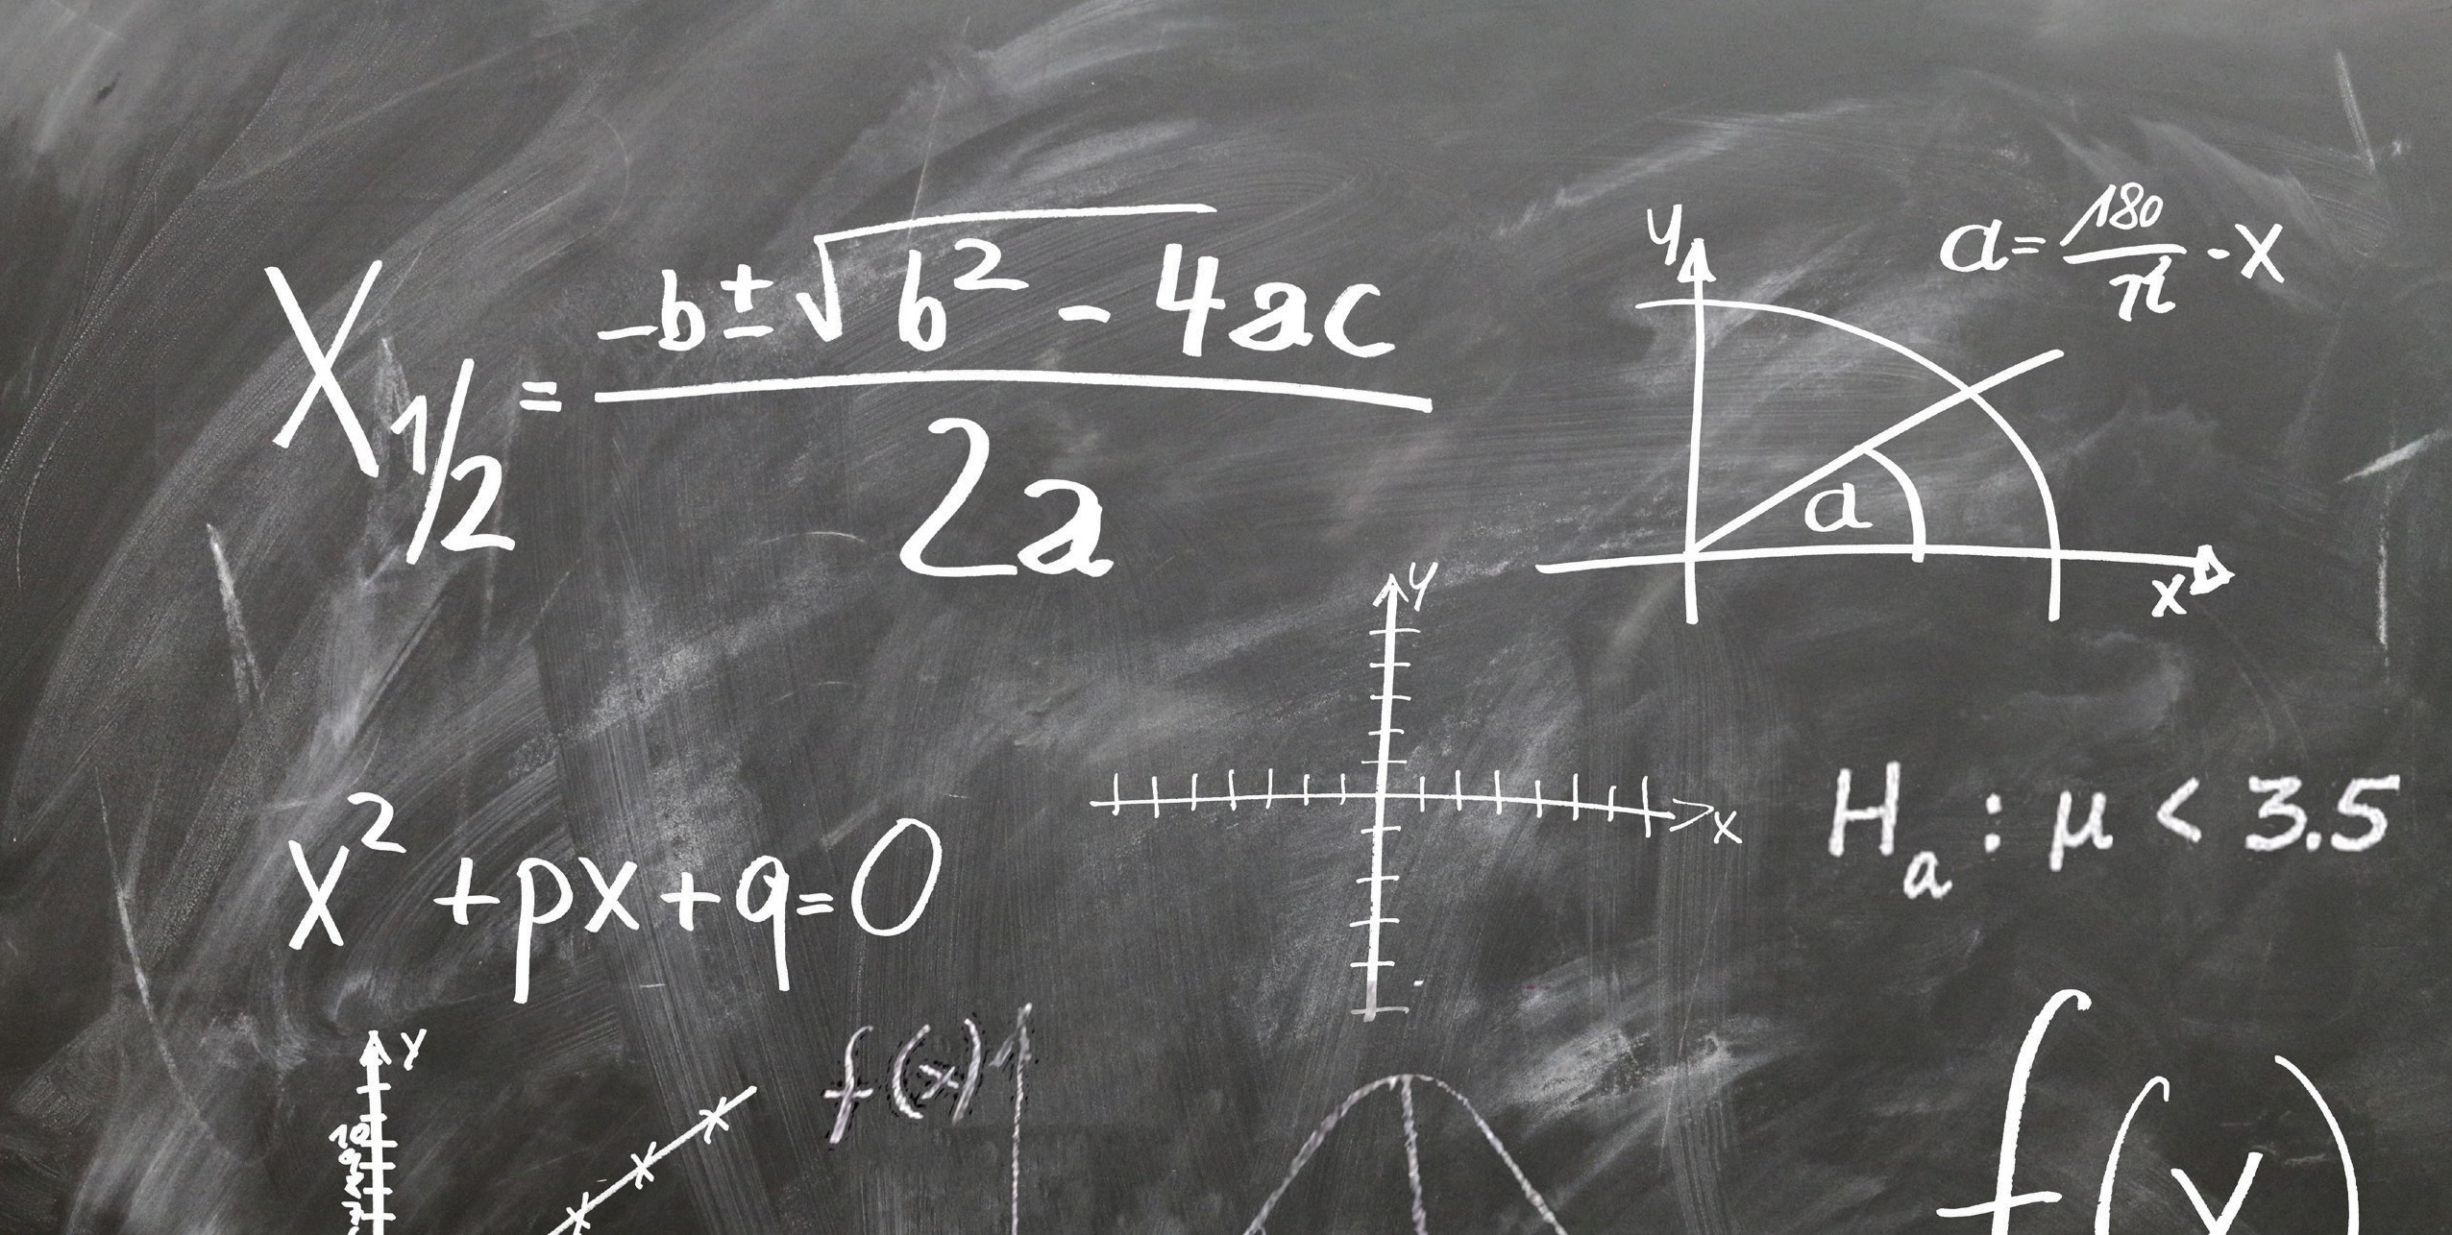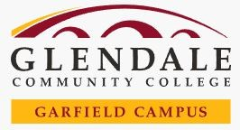

**IMPROVE YOUR BASIC ALGEBRA OR STATISTICS SKILLS FOR FREE!**

Has it been a while since you have taken Algebra or Statistics?

Do you wish to improve your math skills?

**SIGN UP NOW!**

**BASIC STATISTICS REVIEW** ABSE 122

Tuesday/Thursday 4pm-5:30pm February 20th- April 11th / April 23rd- June 11th

**BASIC ALGEBRA REVIEW** ABSE 121

Monday/Wednesday 4pm-5:30pm

February 21st- April 10th/ April 22nd- June 12th

**All Classes will be held in AD 221**

To enroll or find out more, contact our Student Services Assistants: Alisa Abraamyan: [alisas@glendale.edu](mailto:alisas@glendale.edu)

Ivet Ovsepyan: [iovsepya@glendale.edu](mailto:iovsepya@glendale.edu) Phone: (818) 240-1000 ext. 5686 or 5050