1. The following instruments are available in your laboratory. What would be the absolute uncertainties in the measurements done by these instruments?
a. Ruler 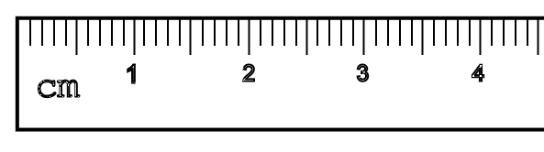 | b. Protractor 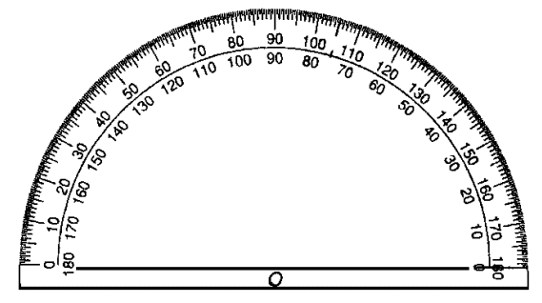
c. Watch 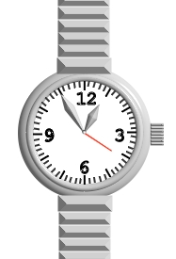 | d. Scale 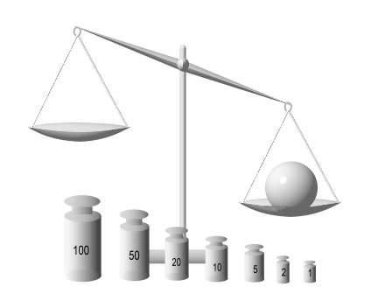

Answer:
a) Half of the smallest increment is 0.5mm=0.05cm=0.0005m. The answer 1mm is also can be considered as correct
b) Half of the smallest increment is 0.5°
c) Half of the smallest increment is 0.5sec
d) Half of the smallest increment is half of the smallest weight. Assuming the weights are in grams it is 0.5g.

2. Measure the length of the pencil. Estimate the relative uncertainty in the measurement.
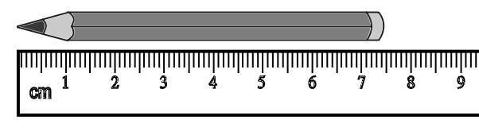
Answer: The length of the pencil is 7.4cm. Absolute uncertainty can be evaluated as 0.5mm or 1mm. Relative uncertainty is 0.05cm/7.4cm = 0.0068 = 0.68% or 0.1cm/7.4cm = 0.014 = 1.4%
3. By using the instruments from the task 1, you have determined that it takes 3 s for a toy car to travel through the distance of 162 cm. What are the relative uncertainties of the distance and time measurements? Which measurement is more accurate?
Answer: The relative uncertainty of the distance measurement is 0.05cm/162cm = 0.03%. The relative uncertainty of the time measurement is 0.5sec/3sec = 16.7%. Distance measurement is much more accurate.
What is the percent uncertainty in the length measurement 2.35 ± 0.25 m?
Answer: The percent (relative) uncertainty of this measurement is 0.25m/2.35 = 10.6%
4. Suppose that after a hike in the mountains, a friend asks how fast you walked. You recall that the trail was about 6 miles long and that it took between two and three hours. What is your average speed if you assume the average time of 2.5 h?
Assume that absolute uncertainty in your distance measurement is 0.1 mile. Estimate the relative (percentage) uncertainty in your distance measurement?
What is an absolute uncertainty in your time measurement? What is its relative uncertainty?
Compare the relative uncertainties in time and distance. Which measurements are more accurate? Determine whether you can use the weakest link rule. Determine the relative and absolute uncertainties in the speed estimation.
Answer: The average speed is 6mi/2.5hr = 2.4 mph. The percent (relative) uncertainty of the distance measurement is 0.1mi/6mi = 1.7%. The absolute uncertainty in time measurement is 0.5hr, and the percent (relative) uncertainty in time is 0.5hr/2.5hr = 20%. Since 1.7% is much less than 20% the distance measurement is much more accurate, so we can use the weakest link rule. That means that the relative uncertainty in the speed evaluation is also 20%, and the absolute uncertainty is 2.4mph × 20% = 2.4mph × 0.2 = 0.48mph
5. Suppose you want to measure time for the ball falling from a height of 1 m. You took three measurements of the time interval and obtained 0.5 s, 0.6 s, and 0.4 seconds. What is average time of the fall? What is an absolute value of the random uncertainty in the time measurement? What is the relative uncertainty?
Answer: The average time of the fall is (0.5+0.6+0.4)/3 = 0.5s. The absolute uncertainty is (0.6-0.4)/2 = 0.1s. The relative uncertainty is 0.1/0.5 = 20%
6. Suppose now that you measured the time interval for the ball to fall from a 10m height and got 1.5s, 1.7s, and 1.6s. Estimate the relative uncertainty assuming the absolute value is the same as in the previous task. Compare the relative uncertainties in tasks 2 and 3. Make a conclusion.
Answer: The average time of the fall is (1.5+1.7+1.6)/3 = 1.6s. The absolute uncertainty is (1.5-1.7)/2 = 0.1s. The relative uncertainty is 0.1/1.6 = 6.3%

