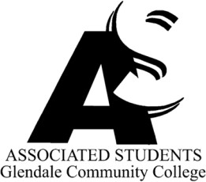 | Associated Students of Glendale Community College  ASGCC Executive Agenda  June 28, 2024  1:30 – 3:30 PM  Student Center 208 – Verdugo Campus

I. | Call to Order
II. | Flag Salute
III. | Roll Call
IV. | Approval of Minutes – June 21, 2024
V. | Approval of Agenda – June 28, 2024
VI. | Report of President/Student Trustee
VII. | Report of Administration Committee
VIII. | Report of Finance Committee
IX. | Report of Activities Committee
X. | Report of Relations Committee
XI. | Report of Organizations Committee
XII. | Report of Officers
XIII. | Reports of Governance/Special Committee Meetings
XIV. | Guest Speakers
XV. | Old Business
XVI. | New Business  - Appointment of Iren Abelian as Vice President of Activities for 2024–2025 academic year – Action Item  - Summer Calendar – Discussion Item  - Police Advisory Committee – Discussion Item  - Shakespeare at the Park with GCC – Discussion Item  - Student Senate Delegate – Discussion Item
XVII. | Reports of Advisors
XVIII. | Announcements/Information
XIX. | Adjournment

