Intro to Board Docs

To get there go to Faculty and Staff

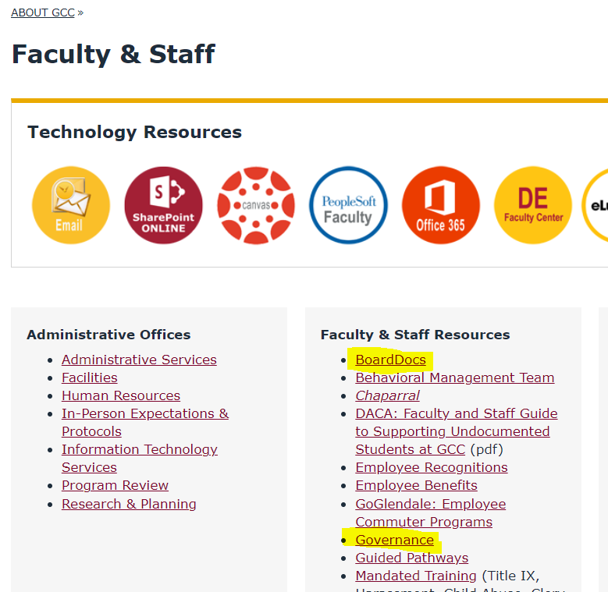

After selecting the “Board Docs” link, you will go to this screen:

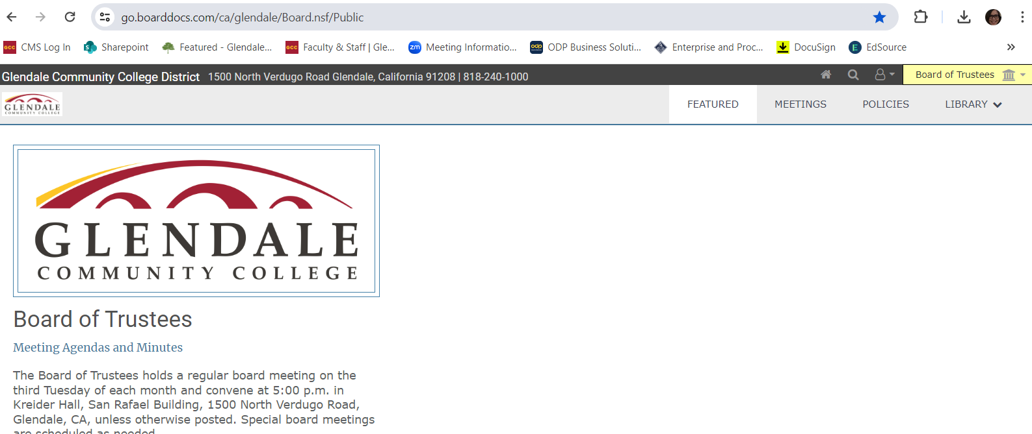

You have landed on the “Featured” page. Any upcoming or current meetings will be listed here.

If you do not see the committee meeting that you seek, go to the upper right, use the pull-down arrow to access the list of all Senate and Governance committees.

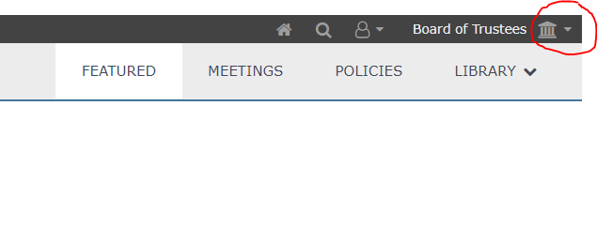

A chronological list of meetings is available on the left side of the screen. Select the date that you need.

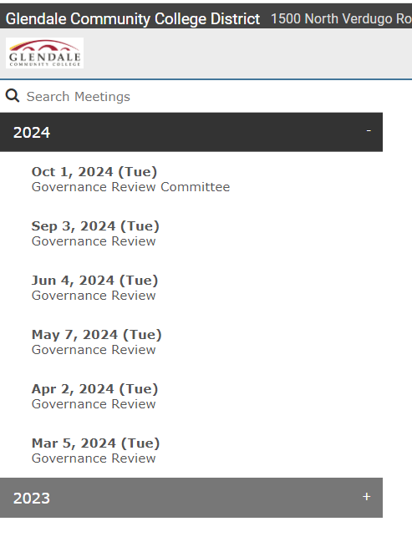

Next you will be see 3 or 4 icons in the middle or body of the screen, select “View the Agenda”

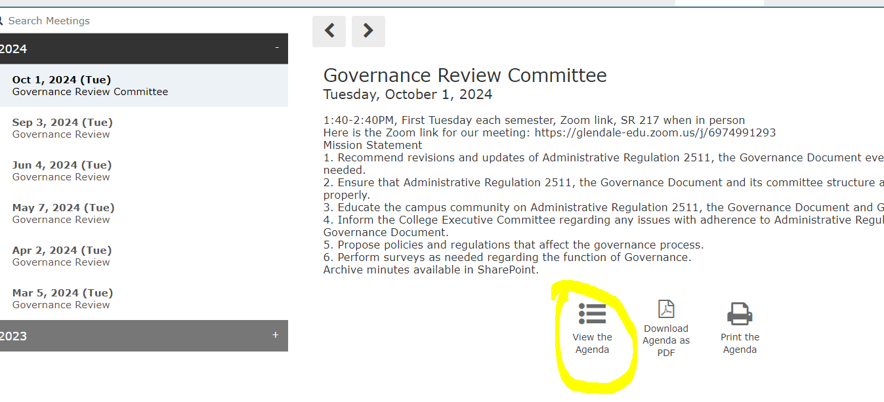

The agenda will open, it is on the left of the screen. It takes getting used to (does not look like a Word file at all!)

