1. The following represents an velocity-time graph for an object. Sketch the graph of acceleration versus time to represent the object’s motion during the same time interval?
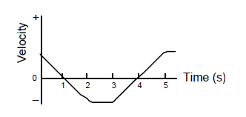

Solution:
t
0
a

2. The following represents an position-time graph for an object. Sketch the graph of velocity versus time to represent the object’s motion during the same time interval?
Solution:
t
0
v

