Turbine Experiment

and much more

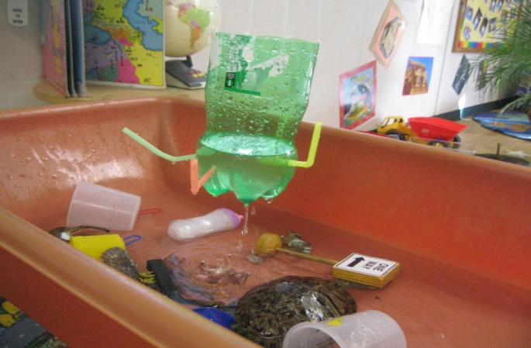

This activity was developed because some students showed interest in objects that spin. To encourage and challenge their curiosity we attempted to design a water turbine using a soda bottle and straws. We began by putting the straws in straight, but when water was added to the bottle it would not turn. We then tried bending all the straws in such a way that water exited the container in the same direction. Within a few minutes the bottle began turning. When the children learned to turn the straws they discovered they could turn the water on and off by simply turning the straws. While observing all this the younger children discovered that different objects float and sink, and that water will come out of the bottle like a fountain if you put some in the top. This experiment is so versatile that all age groups can experiment with the outcomes. 2011

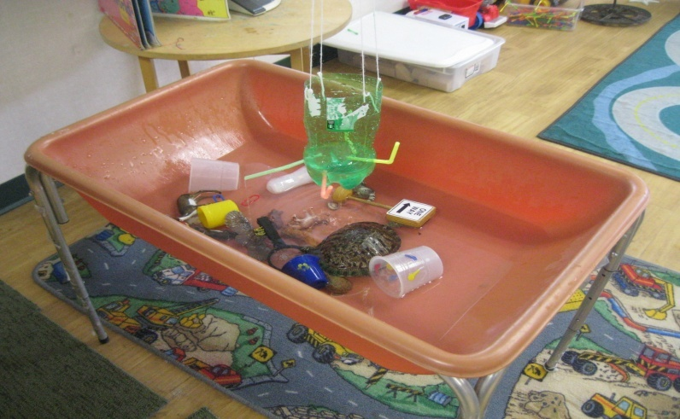

That is a turtle shell, but there is no turtle in it.