- To start setting up Office 365, visit the GCC home page and click on the Menu option in the upper right corner. From there, click on ‘Academics’ and then under ‘Academic Support’, choose ‘Student Labs’.
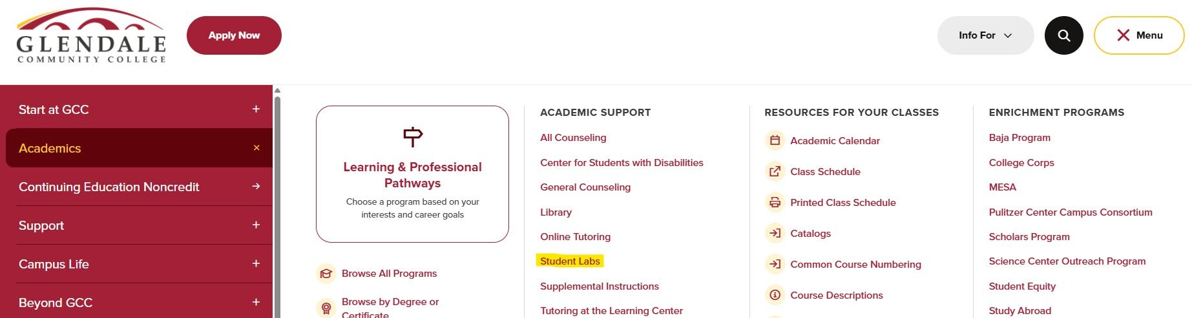
- Click on ‘Sierra Vista Learning Commons.
https://www.glendale.edu/students/learning-commons/index.html
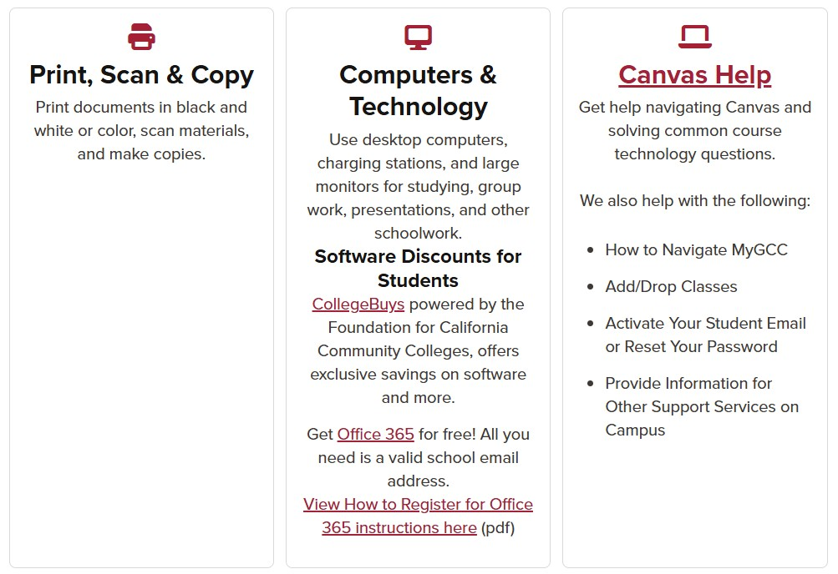

▪

Scroll down to ‘Computers & Technology’.

- Click on the hyperlink that will take you to the Office 365 set up page. https://www.microsoft.com/en-us/education/products/office

- Do NOT click ‘Get started for students’.

- Scroll down to the Office 365 A1 (Free) card and click ‘Get started’.

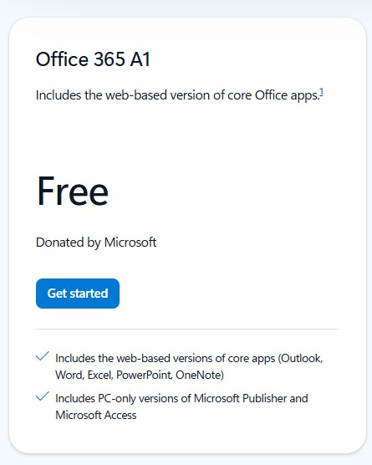

- Enter your GCC student email address and click ‘Next’.

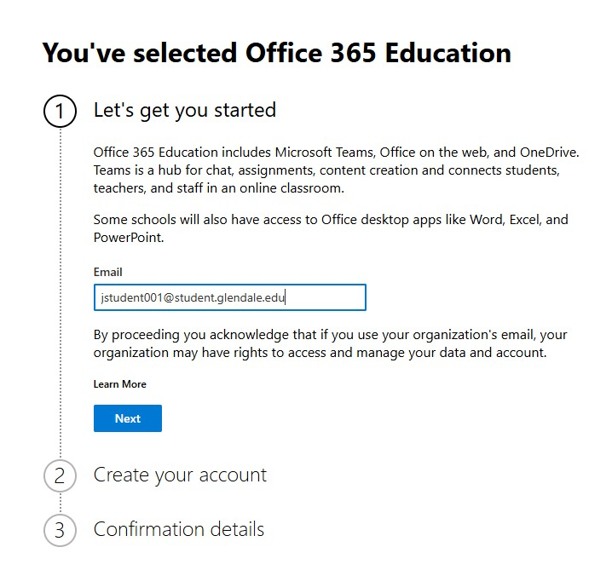

- Click ‘I’m a student’.
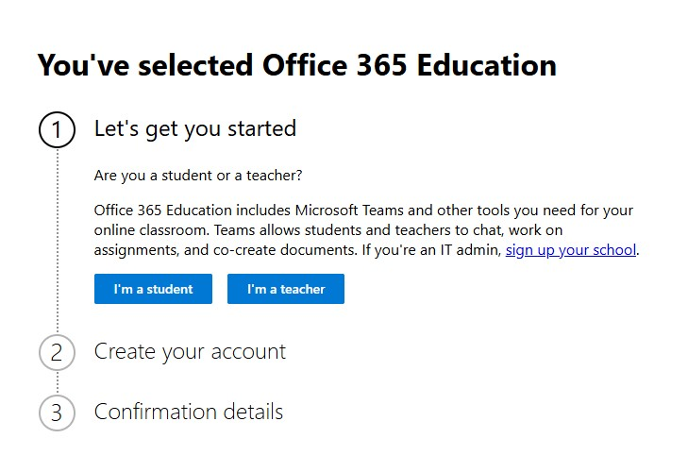
- Fill out the form to create an account and click ‘Next’. You must use your GCC student email to create the account. 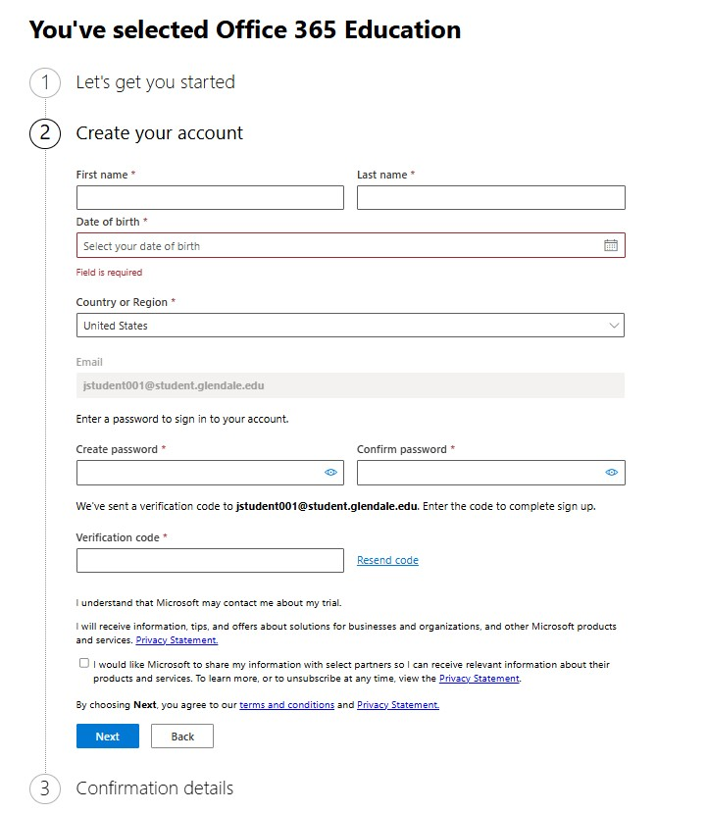
- Once your account has been created, follow the prompts for accessing Office 365 virtually or installing to your device. You may install it on up to five devices.

If you need further assistance, please come to the Sierra Vista Learning Commons
(Sierra Vista Building, Room 132):

Mon-Thurs: 7 am - 9 pm
Saturday: 10 am - 2 pm

Or

Join our Canvas Live Help Zoom meeting https://glendale-edu.zoom.us/j/83216032970:

Mon-Thurs: 4 pm - 10 pm
Saturday: 10:00 am - 2:00 pm (Fill out the Canvas Issues Form https://www.glendale.edu/canvas/issue-form.html to get assistance via email during these hours)

